# **HTML INPUT ELEMENTS**

## **TEXT BOXES AND RADIO BUTTONS**

  <!—Below are html-markup generated text-box controls-->

 <form action="">

        <label for="username">Enter username</label>

        <input type="text" id="username" name ="username">

        <label for="email">Enter email: </label>

        <input type="email" id="email" name ="email">

        <br><br>

        <label for="password">password</label>

        <input type="password" id="password" name="password">

    </form>

<form action="">

<!—Below are html generated radio button controls-->

<!-- Labels are different from <p> as they are always associated with input tags-->

        <input type="radio" name="age" value="0-25" id="Option-1">

        <label for="Option-1">0-25</label>

        <input type="radio" name="age" value="26-50" id="Option-2">

        <label for="Option-2">26-50</label>

        <input type="radio" name="age" value="51+" id="Option-3">

        <label for="Option-3">51+</label>

    </form>

Input elements are entered in form tags, and form tags are created to enable actions “server side”, that is on the back-end, that use the input data entered into the browser input controls.

Of these controls we have <input> tags. These tags contain various attributes. “Type” attribute defines what type of input-control it is. “id” attribute defines the name of the control within html/css, for refferencing (in the above image example we used “id” to reference labels to their respective input controls. “Name” input attribute is what is used server-side, think (back-end name property for windows forms controls), and this attribute field helps the back-end code, identify the browser control. “Name” attributes are usually named same as their “id” attributes, as they generally represent the same idea, just in the different scope, “name”🡪 server-side, “id” 🡪html/css –side. “Value” attribute will represent the specific value that a back-end programer can get from the respective input control. So if a back-end programmer wants to take input data from an <input> tag radio(type)control element and assign it’s value to a local variable, he would simply do the following: **string localVar = name.Value;**

In the assignment, name refers to a set of radio button controls and .Value returns the value attribute defined within the html control tag.

## **COMBO BOX**

  <!-- Below we are creating an html comboBox with a <select> tag -->

    <label for="question">Security question</label>

    <select name="question" id="question">

        <option value="q1">Favorite color?</option>

        <option value="q2">What vegetable would you be?</option>

        <option value="q3">What is your best security question?</option>

    </select>

</body>

</html>

For comboBox-like controls we simply use the <select> tag, which nests various <option> tags, these option tags represent the comboBox-item elements, and their value attribute will be what data the <select> tag comboBox control returns when it is accessed in order to assign it’s value to a local variable. For example, if we want to enter data into a local variable: **string localVar = Question.Value;** for users sellecting option “Favorite color” the value field of the “Question” ComboBox will be “q1”.

## **TEXTAREA AND SUBMIT_BUTTON**

<!-- RichTextBox-like Control via <textarea> tag-->

        <label for="bio">Your bio</label><br>

    <textarea name="bio" id="bio" cols="30" rows="10" placeholder="About you..."></textarea>

    <br><br>

    <input type="submit" id="submitButton" name="submit">

Text-area is a richTextBox-like control created in html markup, with the difference that it only accepts text input, and is generally used when the user needs to enter a lenghthy set of text inside an input form online document, for which this <textarea> input control is most appropriate. Its attributes are quite self explanatory. On the other hand the submit button is a bit more specific, as it is not a “button” input type, but in fact a very specific type of input [type = “submit”]. This type of input is generally automatically pre-set in the back-end to generate submit-type events and so is an excellent short-hand for when you need to easily generate a functional submit button on your online form-documents.

***Exercise(1) Create the followng form using pure html markup:***

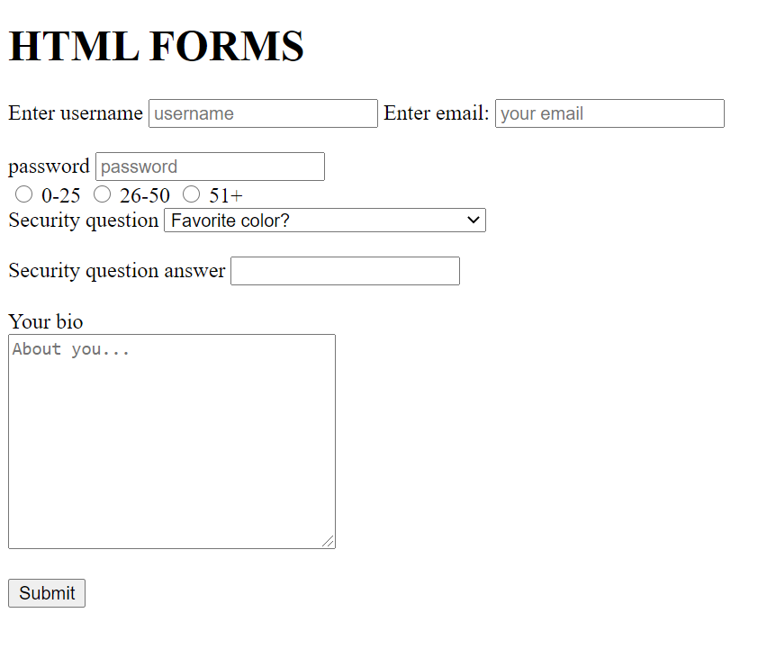

**EXERCISE SOLUTION EXAMPLE**

<!DOCTYPE html>

<html>

<head>

    <title>HTML Forms</title>

</head>

<body>

    <h1>HTML FORMS</h1>

    <form action="">

        <label for="username">Enter username</label>

        <input type="text" id="username" name ="username" placeholder="username"  required>

        <label for="email">Enter email: </label>

        <input type="email" id="email" name ="email" placeholder="your email" required>

        <br><br>

        <label for="password">password</label>

        <input type="password" id="password" name="password" placeholder="password" required>

        <!-- required attribute is automatically initialized with the value "true" -->

    </form>

    <form action="">

         <!-- Labels are different from <p> as they are always associated with input tags-->

        <input type="radio" name="age" value="0-25" id="Option-1">

        <label for="Option-1">0-25</label>

        <input type="radio" name="age" value="26-50" id="Option-2">

        <label for="Option-2">26-50</label>

        <input type="radio" name="age" value="51+" id="Option-3">

        <label for="Option-3">51+</label>

    </form>

    <!-- Below we are creating an html comboBox with a <select> tag -->

    <label for="question">Security question</label>

    <select name="question" id="question">

        <option value="q1">Favorite color?</option>

        <option value="q2">What vegetable would you be?</option>

        <option value="q3">What is your best security question?</option>

    </select>

    <br><br>

    <!-- Answer textBox control for the above created security question-->

    <label for="answer">Security question answer</label>

    <input type="text" id="answer" name="answer">

    <br><br>

    <!-- RichTextBox-like Control via <textarea> tag-->

        <label for="bio">Your bio</label><br>

    <textarea name="bio" id="bio" cols="30" rows="10" placeholder="About you..."></textarea>

    <br><br>

    <input type="submit" id="submitButton" name="submit">

</body>

</html>

# **CSS OVERVIEW**

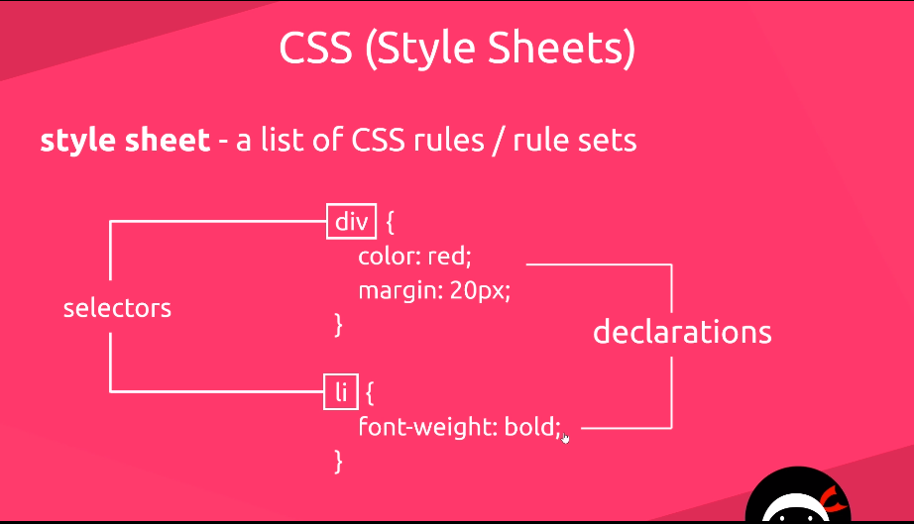

Selectors define which html tag-element we wish to write a style/rule for. Declarations represent individual rule elements.(all declarations for a selector define the css rules said selector will follow when displayed on page.

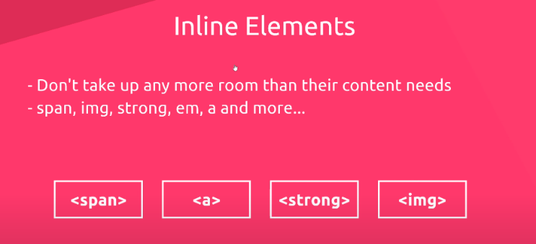Inline elements sit next to each other, by default in a line from left -> to right. Now when there is no more space on the page for the line, the last inline element will be placed under the the first inline element from the left.

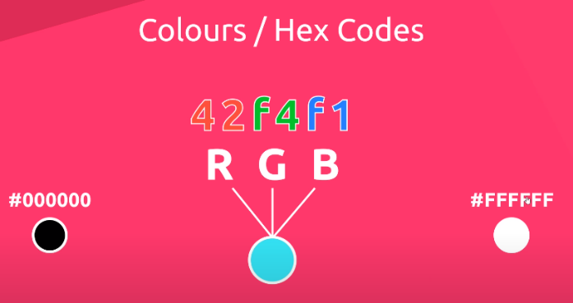Colors can generally be defined by their **keyword,** their **hex cod**e #FFFFFF where the first two letters represent the hue of red, second two, the hue of green and the last one the hue of black in the color, or rgb code rgb(255,255,255) for red, green and blue, respectively

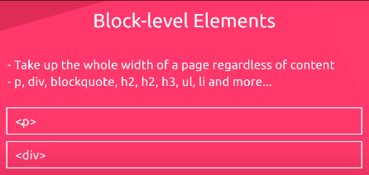Block level elements cannot be nested within Inline elements, but block level elements can and sometimes should be nested within other block level elements. With that in mind, note that Inline elements are practically designed to be easily nested into block level elements. So block level elements alwys take up the full width of the page and stack under the last written element.

***Exercise (2) Design a webpage that looks like the example below and style it using a separate css folder.***

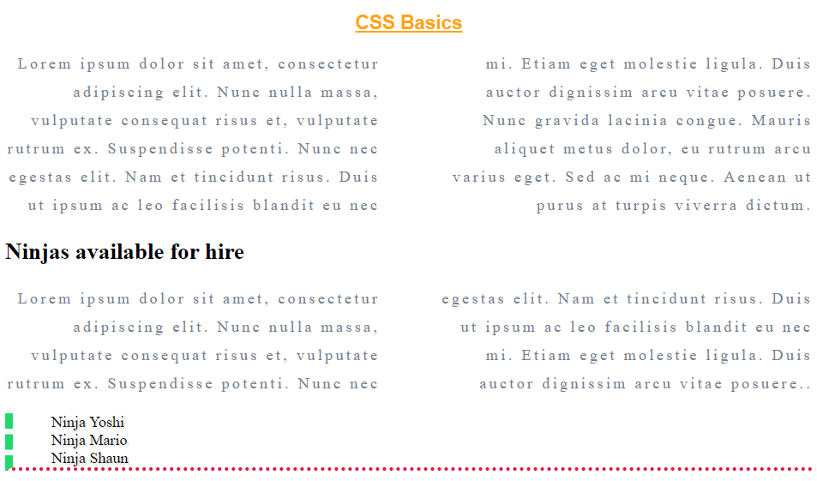

***Solution example:***

***HTML Markup solution***

<!DOCTYPE html>

<html>

<head>

     <link rel="stylesheet" href="styles.css">

    <title>CSS Basic</title>

</head>

<body>

    <h1>CSS Basics</h1>

    <!-- Alt+Z to enable text wrapping-->

    <p>Lorem ipsum dolor sit amet, consectetur adipiscing elit. Nunc nulla massa, vulputate consequat risus et, vulputate rutrum ex. Suspendisse potenti. Nunc nec egestas elit. Nam et tincidunt risus. Duis ut ipsum ac leo facilisis blandit eu nec mi. Etiam eget molestie ligula. Duis auctor dignissim arcu vitae posuere. Nunc gravida lacinia congue. Mauris aliquet metus dolor, eu rutrum arcu varius eget. Sed ac mi neque. Aenean ut purus at turpis viverra dictum.</p>

    <div>

        <h2>Ninjas available for hire</h2>

        <p>Lorem ipsum dolor sit amet, consectetur adipiscing elit. Nunc nulla massa, vulputate consequat risus et, vulputate rutrum ex. Suspendisse potenti. Nunc nec egestas elit. Nam et tincidunt risus. Duis ut ipsum ac leo facilisis blandit eu nec mi. Etiam eget molestie ligula. Duis auctor dignissim arcu vitae posuere..</p>

    </div>

    <ul>

        <li>Ninja Yoshi</li>

        <li>Ninja Mario</li>

        <li>Ninja Shaun</li>

    </ul>

    <h2></h2>

</body>

</html>

***CSS rules solution***

h1{

    color:orange;

    background-color: sategray;

    font-size: 20px;

    text-decoration: underline;

    font-family: 'Arial','Courier New', Courier, monospace;

    text-align: center;

}

p{

    color:slategray;

    text-align: right;

    line-height:30px;

    letter-spacing: 3px;

    column-count: 2;

    column-gap: 60px;

}

ul{

  /*

    border: 4px solid crimson;

    border-width: 4px;

    border-style: solid;

    border-color: crimson;*/

    border-bottom: 4px dotted crimson;

    border-left: 8px dashed rgb(32, 216, 109);

}

li{

    list-style-type: none;  /*gets rid of dots on list elements*/

    /*text-shadow: 2px 2px lightgray;*/

    text-shadow: 2px 2px #E9E9E9;

}

# **INLINE AND BLOCK LEVEL ELEMENTS**

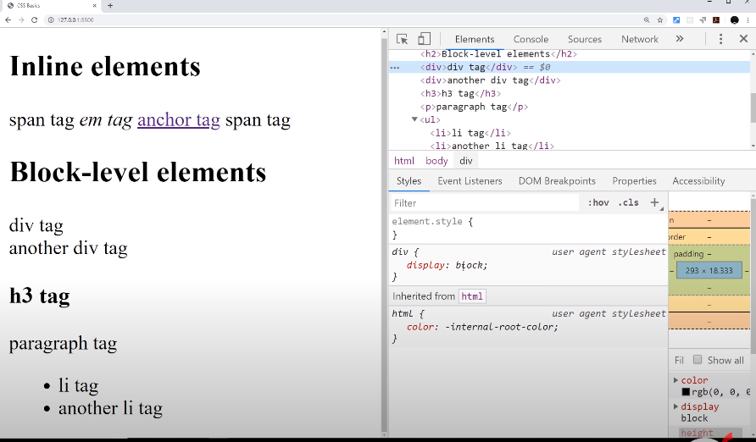

Notice how block level elements by-default, on their creation come with a pre-dettermined css “display” property. This property defines whether an html element is a block level element or an inline level element. Seeing as ths is the case, were we to wish to change an inline element to a block level or vice versa, we can absolutely do so, using the “display: inline / display: block; “ CSS property

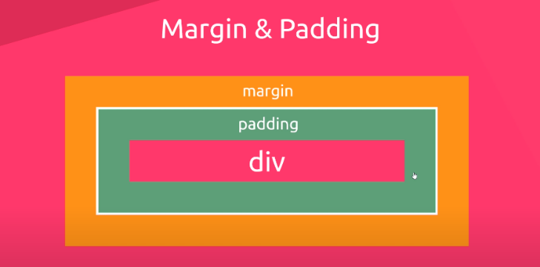Here we see that ***margins*** represent the buffer(empty space) on the outside of an element, while ***padding*** represents the empty space on the inside of the element, between the element borders and element content. On the block level elements like <div> margin and padding are applied on all four directions.

1“Margin & Padding on block elements"

But as we can see on the image “Margin & Padding on inline elements”, margin can only be applied on the left and right of inline an inline element, like <span>, while padding can is still applied in all four directions.

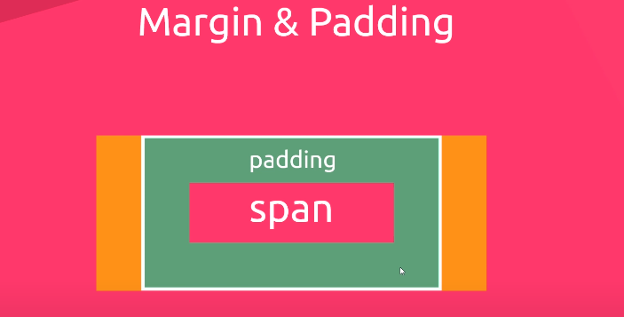

“Margin & Padding on inline elements"

Inline elements have padding that, in case that they don’t have any space on the horizontal axis, collapses on the top and bottom, so two inline elements with padding on the top and bottom would sit on top of each other with padding collapsing on a vertical axis.

## **BROWSER DEFAULT STYLES**

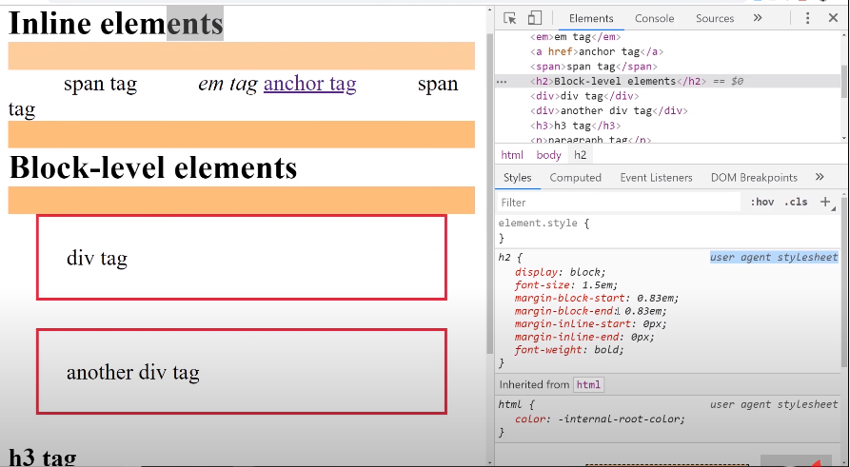CSS styles applied to various elements that happens by default ( automatically on their creation) ***via “user agent stylesheet”***  aka the browser.

Default rules are automatically overwritten by any user defined CSS rules applied to the same elements.

# **CLASS ATTRIBUTES**

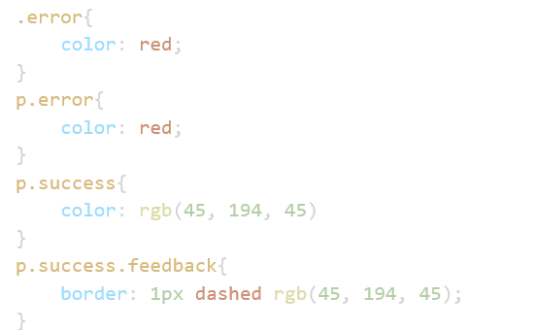.error{} is a class that applies to all html elements that contain [class = “error”]

p.error{} is a class that applies only to the <p>html elements that contain [class =”error”]

p.success{} is a class that applies only to the <p>html elements that contain [class =”success”]

p.success.feedback{} is a class that applies only to <p> that have both the class success and feedback in the following manner [class = “success feedback”]

ID attributes are mostly used when referencing elements by the back-end programmers. They can be used to anchor elements to css selectors, but you can go by using just classes for your general front-end programming. One constraint and disadvantage of using ID’s is that they follow the rule of referential integrity, meaning only one ID-name can exist on a document, Ie, you may not create duplicate ID names on one page. To specify again, you cannot use the same ID more than once. As a rule of thumb, use ID’s for JAVASCRIPT and classes for CSS styling.

Note that ***a space between selectors is used to declare entering inside an element to find the targeted selection (like in Russian dolls***) and selecting its child element/s. For example “**div p{}**” enters into all div elements and selects all <p> child elements within them. “**div .images{}”** enters into all <div> elements and selects only the child elements that have the “.images” class assigned to them. Note the difference a lack of space between selectors can make: If we were to declare two selectors without a space between them, one for an element tag, and the other one for the class we would get the following:

“**div.images{}”. 🡪 This targets all div elements that belong to an “ .images” class .**

**“div. images{}” 🡪 This targets all “images” class elemens that exist within a <div> element.**

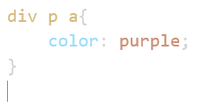***Descendant selectors example:***

This will color purple all <a> tags that are within a <p> tag that is within a <div>. Note that a descendant selector is made by creating a row of selectors with a space between them. So in this case, again, this selector searches and applies a style ***to all*** <a> tags, which exist within a <p> tag that is nested within a <div> tag.

3Example of descendant selector

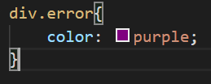The following is a selector that gives a purple color to all div elements that have a class attribute of “error”.

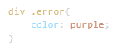

On the left, there is a space between the div and .error selectors, and this means, Enter each div, and color any element with the attribute class “error” the color purple.

Below we can se that we can also use attributes as an anchor for a selector, so for example we may select all image tags with the attribute alt, and this will apply css to all image tags that posses the attribute we selected. Also we may do a validation of the value input in said attribute, so that the css rules would only apply on the tags that posses a particular attribute which has the value equal to the value stated in the brackets, as can be seen down below.

/* The following will look for every anchor tag with the href attribute which has the value equal to the link-->*/

a[href="https://www.thenetninja.co.uk"]{

    background-color: rgb(48, 175, 48);

}

/* The following code adds a border color rule to all <img> tags where alt = “” attribute field is not null, or in other words, where we inserted the attribute in the image tag <img src=”” alt=””> */

img alt

    border-color: rgb(48, 175, 48);

Below we can see that [*=] means any href that has this the data entered after the equal sign included somwhere in the value of the attribute.

a[href*="ninja"]{}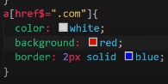

Whereas if there is a dollar sign, it means that the CSS rules apply only to those <a> tags where href attributes contain “.com” at the end of the input value.

a[href$=".com"]{

    color: white;

    background: redl;

    border: 2px solid blue;

# **THE CASCADE**

It means to pour downwards. (Imagine a bunch of nested waterfalls) ***Things like margins, padding, background style and borders are not inherited. Mainly font-related properties are inherited.***

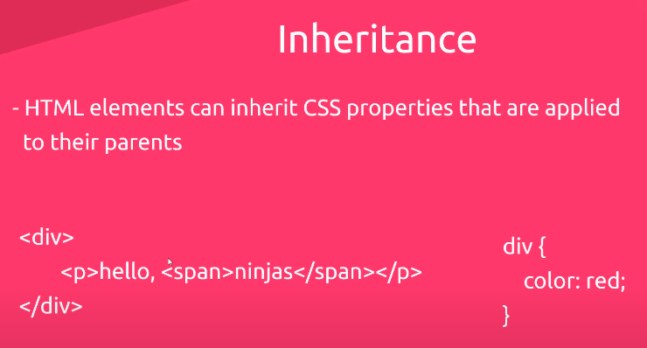If there is a css rule that applies to a block level element that can have other child elements nested within, all elements within the <tag> on which the CSS rule applies, will inherit the rule fom their parent element. So, in the case of the example on the left, both the <p> and the <span> which is nested within <p> will be colored “red”, inheriting the parent CSS style rule. More specifically the <p> inherited the rule from it’s parent, while the <span>inherited the rule from its grandparent.

**Explicitly inhereting attributes which are by default not inherited by child elements(border/padding/etc…)**

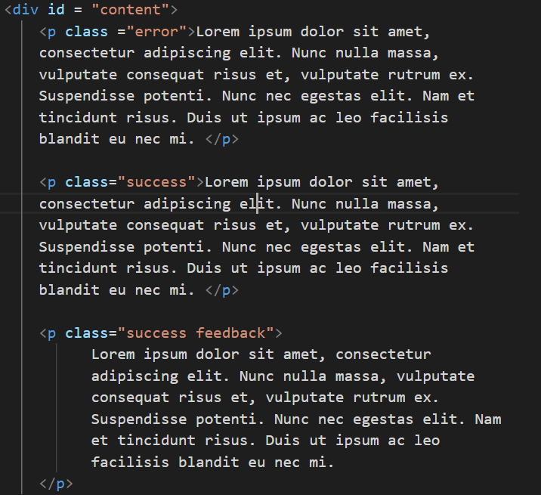Below we have various <p> tags within a <div> tag:

div{

    color:lightcoral;

    border: 1px solid gray;

    margin: 40px;

    font-weight: bold;

}

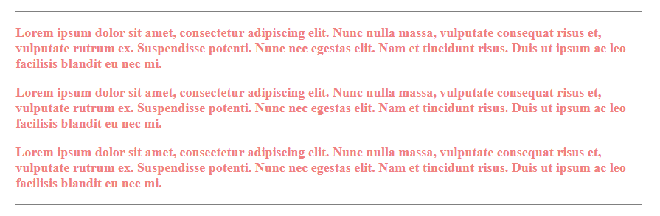The above code applies border and margin only to the div element, because it’s child elements don’t by default inherit those types of CSS attributes.

CSS styled div, whereas the P tags did not inherit border properties

# INHERITANCE AND PRIORITY

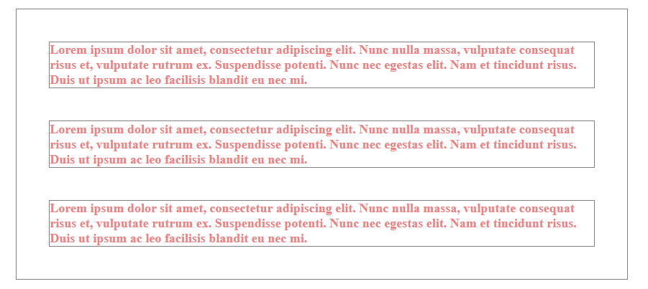div{

    color:lightcoral;

    border: 1px solid gray;

    margin: 40px;

    font-weight: bold;

}

p{

    border:inherit;

    margin:inherit;

}

For the <p> tags to inherit those attributes, you have to explicity define those attributes for the <p> tags, or simply state the attribute and assign “inherit” as their value. “Inherit” assigns the value of the parent element to the child element, for said stated properties. We can see the inherit css attributes in effect in the picture above.

*/

div{

    color:lightcoral;

    border: 1px solid gray;

    margin: 40px;

    font-weight: bold;

}

div p{

    /*This is the most specific selector, and the more specifically you define a selector the higher priority it is*/

    border:inherit;

    margin:inherit;

    color: crimson;

}

p{

    border:inherit;

    margin:inherit;

    color: crimson; /*this is a more specific selector and it overrides the inherited style in the sense that we are not styling the parent, but the particular child*/

}

p{

    color: orange;/* When there is a conflict between two or more of the same tipes of selectors the last defined selector(last being the one furthest to the bottom) is going to have the highest priority*/

}

/*To summerize, selector priority focuses on specificity and cascade(Ie: the further down a css rule is the higher it's priority over other rules for the same selector) The highest specificity(IE: the most detailed path in the selector) the hihger the priority. Just note that it may be the case that selector [div p{} ]that selects app <p> tags within any <div> tag within a document, may indeed select the very same <p> tag elements that a simple [p{}] selector selects. Yet the rules in the more specific one of the two will override the rules of the one more generally defined.

Hope it makes sense. Cheers! By Adam. Yes, I'm not copying what I hear in the courses word for word, this is, after all, my notebook and in it are my notes on the subject as I understand it.  */

# **HTML5 Semantic Tags**

Semantic tags bring more specificity for the browser in order for it to understand what type of written content your webpage contains. So semantic tags are used instead of a <div>, do feine specificly to the browser exactly what type of content that div contains, from the standpoint of a web-page Semantic, Ie what type of web content is within it.

<main>

For the main content of a webpage, unique to that page

<section>

Defines a certain section of a webpage( blog list, contact intfo)

<article>

Defines a bit of content whicch makes up an article (e.g. a blog post)

<aside>

Defines some content related to something else(digresija, vezana za glavni artikal)

<header>

For the header of a website – contains the nav, title,

<footer>

For the footer of the website.

# **POSITION AND LAYOUT**

Represents the desired position relative to the original position of the element. In the yellow we can se the original position of the element in normal document flow, while the checked block represents the new position relative to the old one. When defining a relative position we are declaring how many pixels the element should move (top, bottom, left and right) relative to it’s original location.

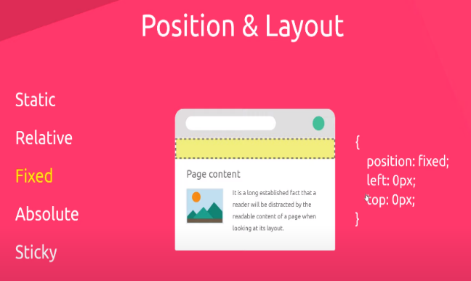Fixed position positions an element relative to the current viewport of the website. (viewport being the size of the screen in which the content is being displayed. In other words, these are the elements that always stay in the same position no matter how far up or down you scrool, they are fixed to a place on your screen when you’re displaying fixed elements on a website.

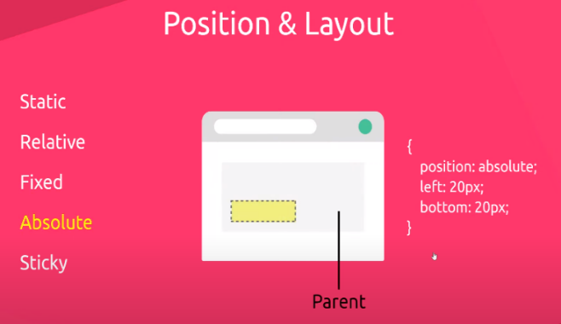

Absolute fixes and element in an absolute position relative to its parent element, as long as the parent element’s position is non-static, ie: has the position property applied to it.

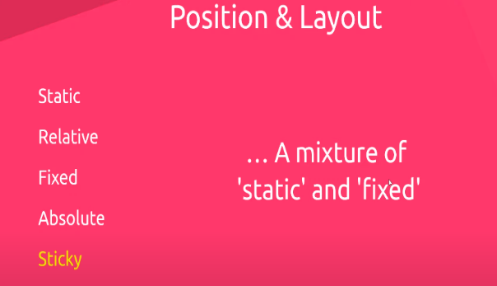The Sticky position acts as a static element, then when the scrol level reaches a certain point it becomes fixed. It works same as the default static position, with the added feature of becoming fixed on the viewport (fixed-position) once its scroll buffer zone has reached the maximum number of pixels. We usually define the static-buffer-to-fixed in the following manner:

position: sticky;

top:100px;

The above allows for 100px of content to be scrolled above the “sticky” element (achieved by scrolling down, as the content moves up), before it becomes fixed to the viewport. It is usually used to keep the navigation bar on the beginning of the page visible and fixed to the screen, while the user scrolls down to see the content on the bottom of the page.

## **ASIDE-STATIC POSITON**

*Not mentioned in further detail above, static position is a default alloted position for each html element, and it basically has no special features, and with this position assigned, the elements act according to normal HTML rules for stacking block and/or inline level elements, or in other words static elements follow the normal document flow*

## **ABSOLUTE POSITION**

The important takeaways are that the element we wish to give an absolute position to, has to have a parent that is in a non-static position, ie, has to have a parent that is given a non-static position property value.

We use the position absolute to define where we wisht to position the element inside their parent. Then we use the combination of ‘left, top, right, bottom’ positions to set the desired location relative to the parent element.

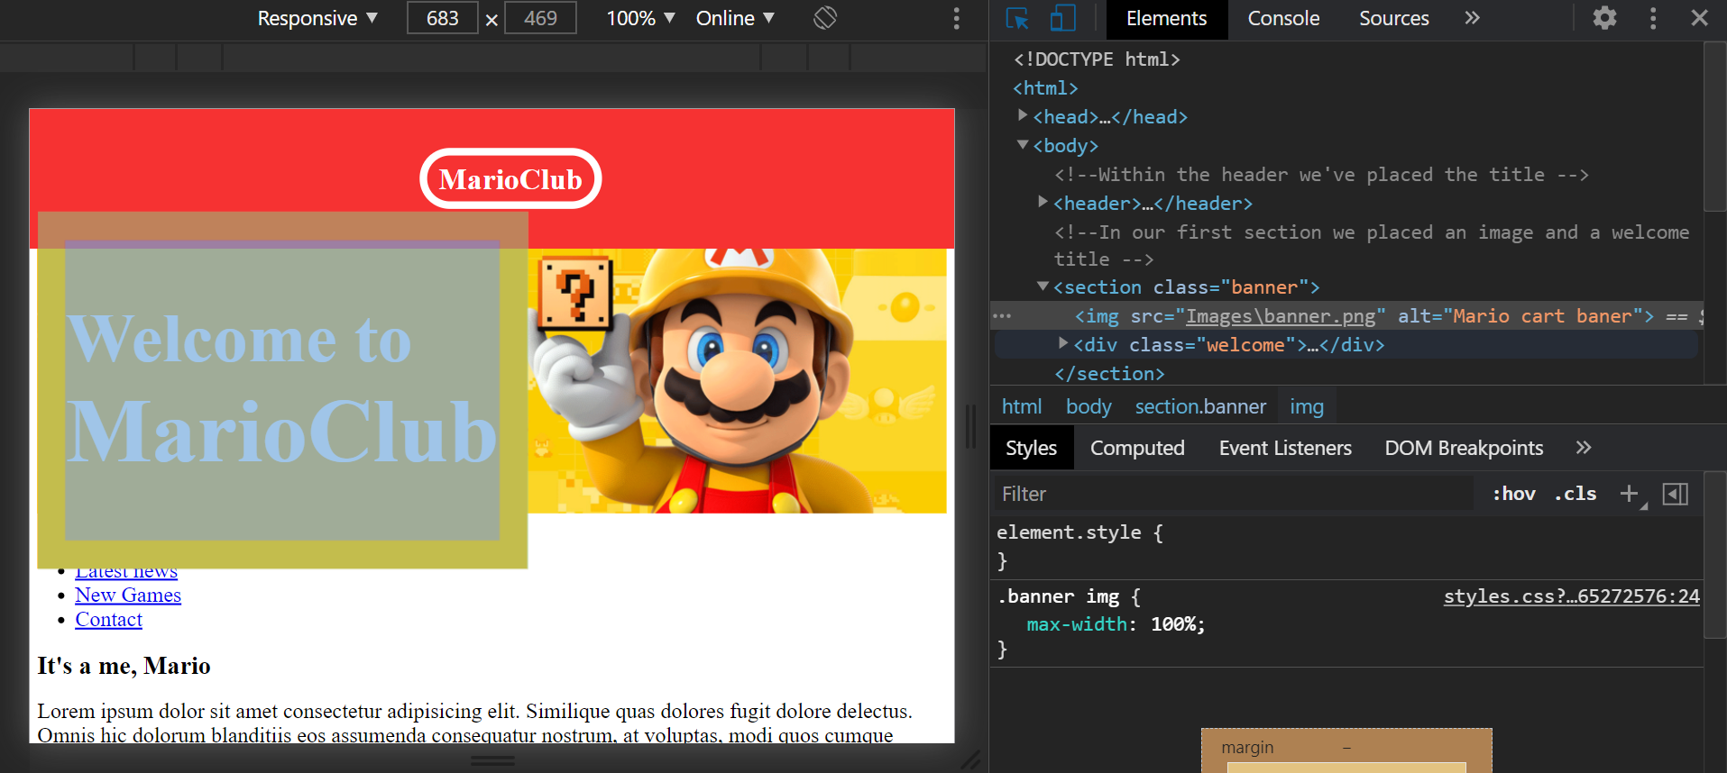

The "welcome" div is positioned relative to the "banner" div.

## **FIXED POSITION**

**Z-index**, is the property which sets the display priority for various elements on the viewport. Seeing as elements may be positioned in such a way as to overlap, Z-index of eache element determines whether it will be positioned above or below the object it overlaps with.

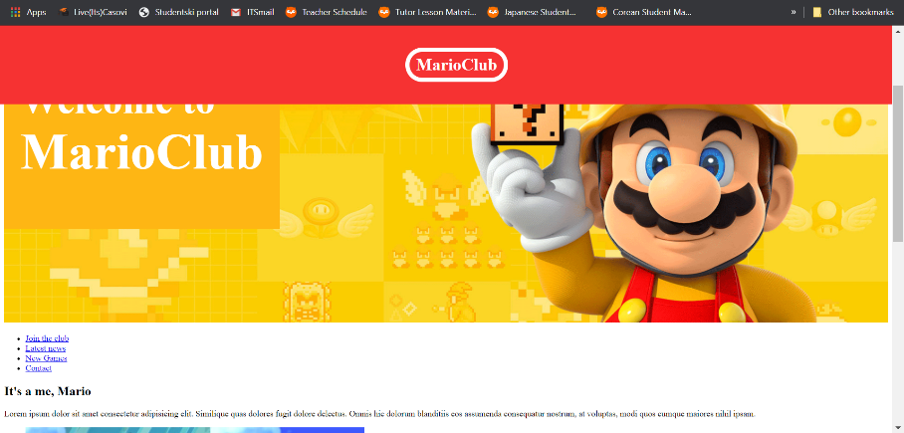 By default, theses elements are set to **Z-index: 0;**

Here we se the Fixed position being used in order to keep the header and the website name "MarioClub" fixed on the viewport no matter how far up or down the user scrolls

***Exercise (3)*** Create and style a webpage replicating the following website example.

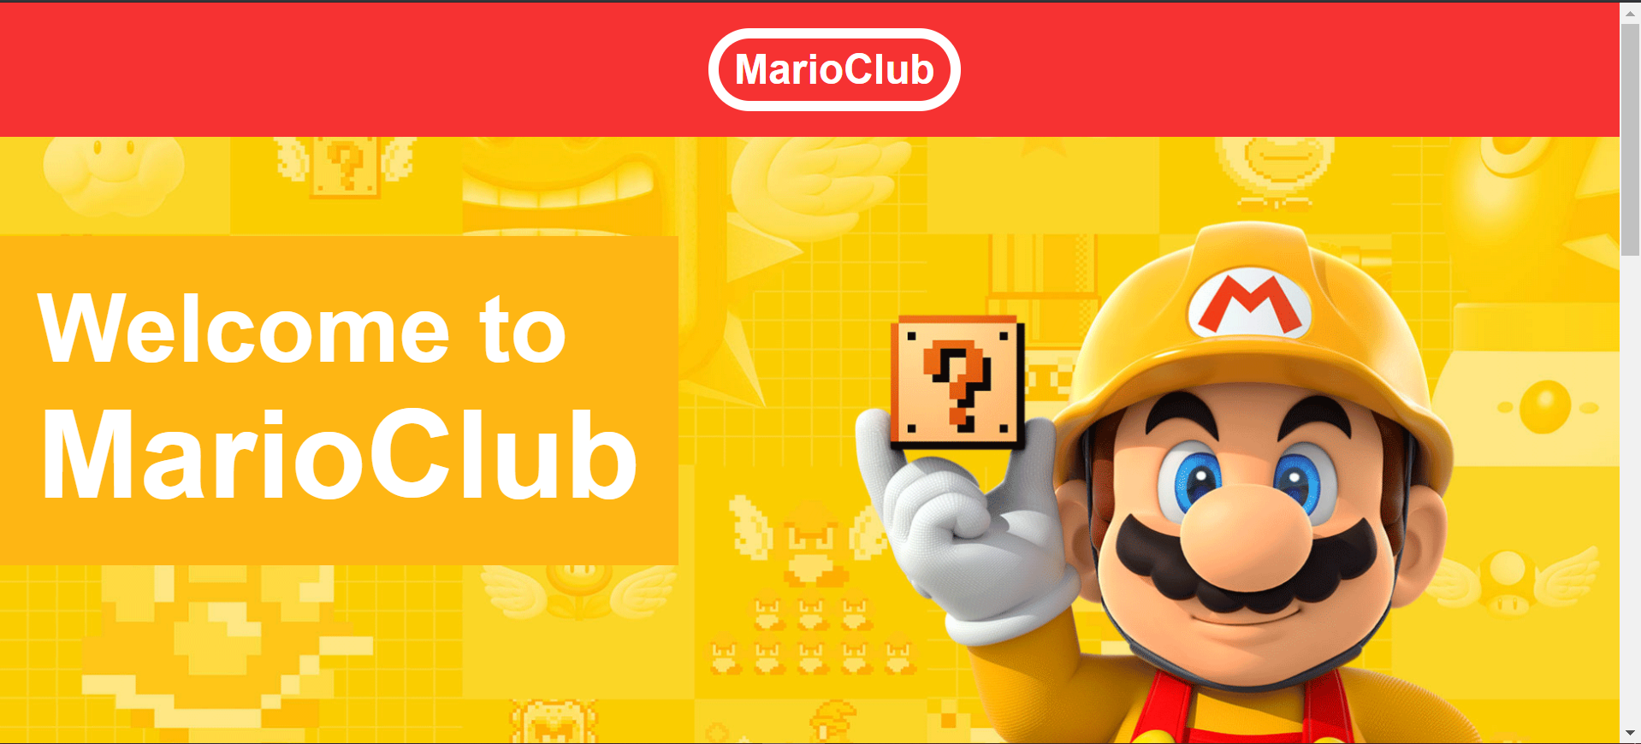

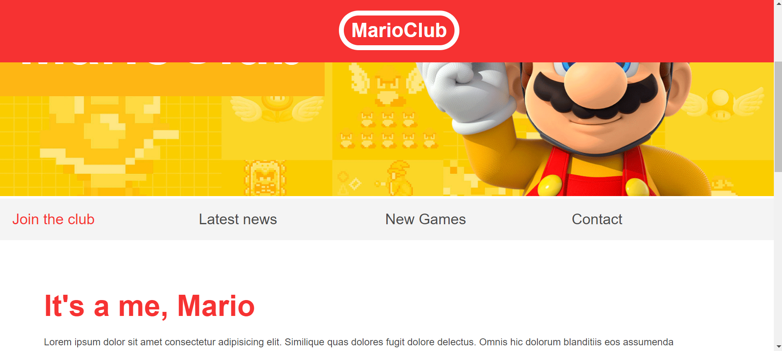

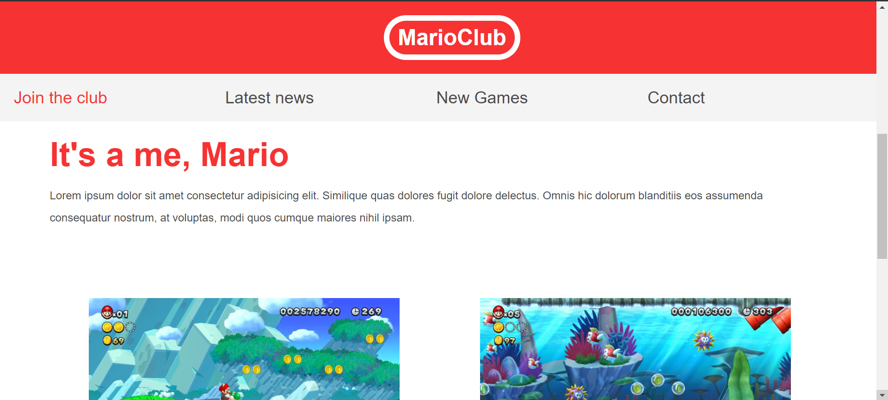

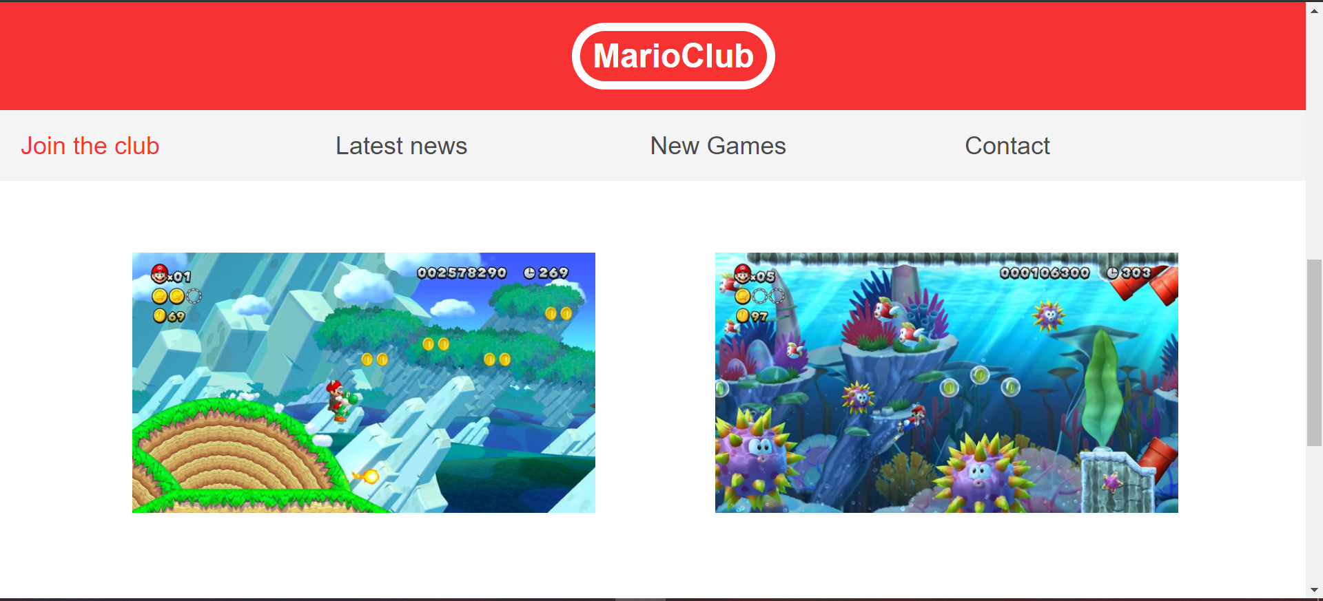

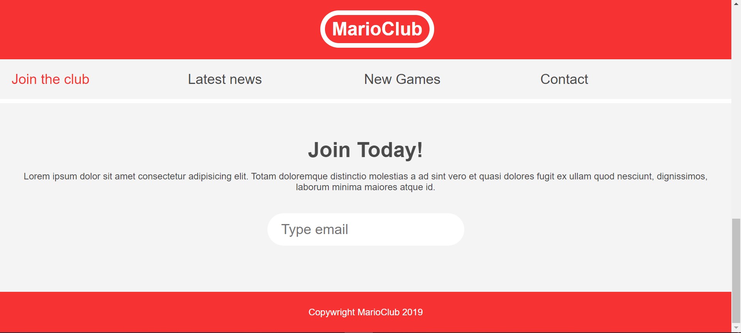

***SOLUTION HTML***

<!DOCTYPE html>

<html>

<head>

     <link rel="stylesheet" href="styles.css">

    <title>Mario Club </title>

</head>

<body>

    <!--Within the header we've placed the title -->

    <header>

        <h1>MarioClub</h1>

    </header>

    <!--In our first section we placed an image and a welcome title -->

    <section class="banner">

        <img src ="Images\banner.png" alt="Mario cart baner">

        <div class="welcome">

            <h2>Welcome to <br><span>MarioClub</span></h2>

        </div>

    </section>

    <!--After the welcome title we've created a nav bar using an html semantic tag -->

    <nav class="main-nav">

        <ul>

            <li><a href="/join.html" class="join">Join the club</a></li>

            <li><a href="/news.html">Latest news</a></li>

            <li><a href="/games.html">New Games</a></li>

            <li><a href="/contact.html">Contact</a></li>

        </ul>

    </nav>

    <!--We are creating our first article within the <main> section on the page(a thematic whole)-->

    <main>

        <article>

            <h2>It's a me, Mario</h2>

            <p>Lorem ipsum dolor sit amet consectetur adipisicing elit. Similique quas dolores fugit dolore delectus. Omnis hic dolorum blanditiis eos assumenda consequatur nostrum, at voluptas, modi quos cumque maiores nihil ipsam.</p>

        </article>

        <!--Notice how lists are used to create nav-bars, lists of images, links, etc...-->

        <ul class="images">

            <li><img src="Images\thumb-1.png" alt="thumb1"></li>

            <li><img src="Images\thumb-2.png" alt="thumb2"></li>

        </ul>

    </main>

    <section class="join">

        <h2>Join Today!</h2>

        <p>Lorem ipsum dolor sit amet consectetur adipisicing elit. Totam doloremque distinctio molestias a ad sint vero et quasi dolores fugit ex ullam quod nesciunt, dignissimos, laborum minima maiores atque id.</p>

    <form >

        <!--if there is no submit button, browser interprets typing enter when an input is in focus, as a submit action-->

        <input type="email" name="email" placeholder="Type email" required>

    </form>

    </section>

    <footer>

        <p class="copywright">Copywright MarioClub 2019</p>

    </footer>

</body>

</html>

***SOLUTION CSS***

/*Below we are going to apply the so called "css reset" rule

in other words, we are going to reset the userAgent default styles for most of the elements and layout. The practice of css reset varies from user to user, but in general it means setting up custom-template parameters that will be the new default styles for most html elements, so that we don't have to style each container and it's elements specifically in our stylesheet*/

body, ul, li, h1, h2, a{

    margin: 0;

    padding: 0;

    font-family: arial;

}

header{

    background-color: #F63232;

    padding:20px;

    text-align:center;

    /*notice how we first declare all other properties and leave position for last*/

    position: fixed;

    width: 100%;

    z-index:1;

    top: 0;

    left:0;

    right:0;

}

header h1{

    color: white;

    border: 8px solid white;

    padding: 6px 12px;

    display: inline-block;

    border-radius:36px;

    /*If using 2 values,the first topBttm, second leftRight*/

}

.banner{

    position: relative;

}

.banner img{

    max-width: 100%;

}

.banner .welcome{

    background-color: #FEB614;

    color: white;

    padding: 30px;

    position: absolute;

    left: 0px;

    top: 30%;/* relative values work with rescaling screens*/

    /* when we position something apsolutely, we remove it from the normal document flow and by doing that, we free up any space that it previously occupied and the freed up space is eaten up by the rest of the content beneith it*/

}

.banner h2{

    font-size: 74px;

}

.banner h2 span{

    font-size:1.3em;

    /*(em) takes the value the element currently has inherited from its parent and it times it (mnozi) by 1.3, so in this case, the font-size will be by around a third larger than it had previously been*/

}

nav{

    background-color: #f4f4f4;

    padding: 20px;

    position: sticky;

    top: 105px; /*The top value determines how many pixels this element allows to have above itself, after which it sticks to the display. In other words, after how many pixels of scrolling "From the top, down" do you want the element to become sticky*/

}

nav ul{

    white-space: nowrap;

    max-width: 1200px;

    margin: 0, auto;

    /*stops the ul from wrapping on to the next line*/

}

nav li{

    font-size: 24px;

    width: 25%; /*if 2li elements its 50% if 5 its 20% etc.*/

    display: inline-block;

    /*sometimes inline blocks don't stack up to 100% in one line, so if an inline block element gets pushed over to the next line, adjust the white-space wrap for its parent element as seen above" white-space: nowrap;*/

}

nav li a{

    text-decoration: none;

    color: #4B4B4B;

}

nav li a.join{

    color: #F63232;

}

main{

    max-width: 100%;/*makes sure it's not wider than the page*/

    width: 1200px;

    /*If the maximum width of a viewport is 800px, then the content will take up 100% of the viewport*/

    /*but it is default 1200px on larger screens.1200+px*/

    /*this sets us up to define the default width 1200px, and the max width 100% for the devices with less then 1200px;*/

    margin: 80px auto;

    /*the above means that the margin is top and bottom 80px but if we, for example have a 2000px viewport*/

    /*the margin will be equally distributed(auto property value) left and right, depending on the viewport size.*/

    padding: 0 40px;

    box-sizing: border-box;

    /*the above incorporates the padding of the element into its total width value*/

    /*width + padding = total element space, but in this case the padding will not*/

    /*push the element above its total defined width. */

    /*in this case the width will be 100% or 1200px including the padding*/

}

article h2{

    color: #F63232;

    font-size: 48px;

}

article p{

    line-height: 2em;

    /*this takes the current font size of the <p> tag and sets the line hight */

    /* to: 2*currentFontSize. So the line height is now double the font size, or 200% of it.*/

    color: #4B4B4B;

}

.images{

    text-align: center; /*aligns the unordered list containing images in its <li> tags to center*/

    margin: 80px 0;

    white-space: nowrap;

    /*whenever we see our inline-Block elements stack on top of each other instead of next to each other*/

    /*we simply go to the parent element and tell it not to wrap our child elements(it removes the extra margin)*/

}

.images li{

    display: inline-block; /*so that the <li> elements sit next to each other in a single row */

    width: 40%; /* 40% of its parent element*/

    margin: 20px 5%; /*width+margin totals up to a 100% of the viewport*/

}

.images li img{

    max-width: 100%; /*This will be 100% of its parent container, so 40% of the page*/

}

section.join{

    background: #F4F4F4;

    text-align:center;

    padding:60px 20px;

    color:#4B4B4B;

}

.join h2{

    font-size: 36px;

}

.join form input{

    margin: 20px 0;

    padding: 10px 20px;

    font-size: 24px;

    border-radius: 28px;

    border: 4px solid white;

}

footer{

    background: #f63232;

    color: white;

    padding: 10px;

    text-align: center;

}

***END OF EXERCISE (3)***

# **PSEUDO CLASSES**



We can se that the image to the left is slightly nudged up by 4px, relative to its normal position, when hovered over by the user. This is achieved using the :hover pseudo class, which targets and modifies an element when a certain condition is met, in this particular case, the element is targeted when a hover action is excecuted over it.

.images li:hover{

    position: relative;

top: 4px;

}

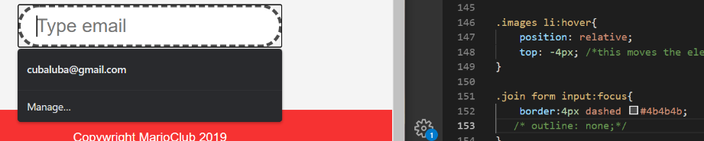

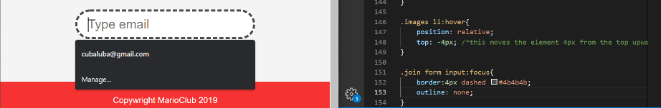Notice to the left how when selected (focused) the element at first has a default outline.

To hide this outline we simply have to create a css rule: outline: none;

Below we have a first-child pseudo class, and we use it to style the first child element inside its parent element. Note how we need to refer for what type of element we are defining the first child. In the example below we are looking to style the first <li> element of an <ul> within a <nav>. Since we are aiming to style a <li> element, we shall assign the pseudo class to that <li> element, like it was done below.

nav li:first-child{

    border: 3px solid #F6323}

# **PSEUDO ELEMENTS**

article p::first-line{

    font-weight: bold;

    font-size:1.2em;

}

Above we can notice a pseudo element introduced by (::) . Pseudo elements are used to more precisely select segments of our regular elements, or in other words, to precisely select parts of our <tag> elements, without having to create a separate <tag> in order to style them.

/*Below we are looking for a section with a class of join*/

/* when the selector finds <section class="join"> he enters it*/

/*then looks to select any <p> elements within it*/

section.join p:first-letter{

    font-size:1.5em;

}

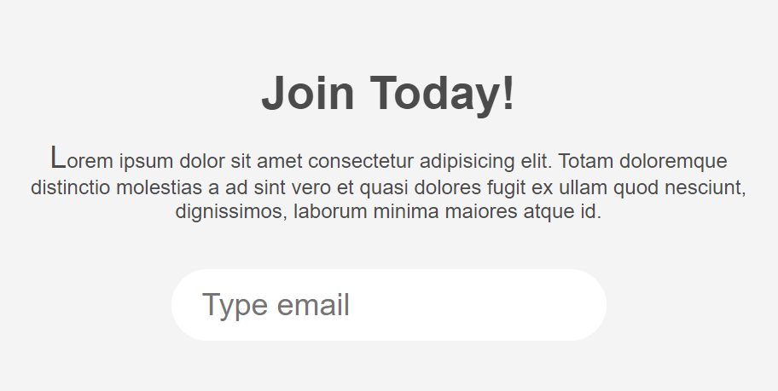

Here we see the effect of css selection, using the pseudo element "first-element"

section.join p::selection{

    background-color: #f63232;

    color: white;

}

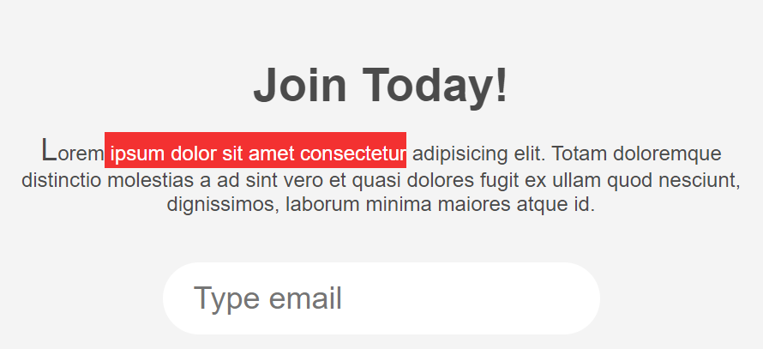

Pseudo element “::after” allows us to inject some content after the end of the declared element preceding the declaration of “::after”.

p::after{

    content: '...';/*this css property represents a string*/

}

The above rule splaces (…) at the end of every paragraph on the page

# **RESPONSIVE DESIGN**

Having the website ooking good on all devices, regardless of the size of the viewport

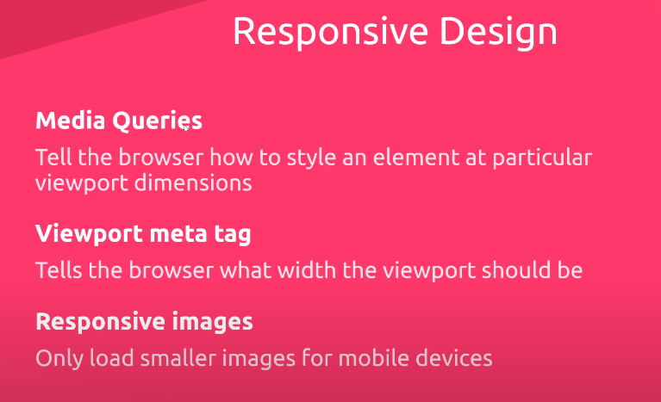

When you’re design a responsive website you need to have a defined approach in advance.

Usually in practice we see the mobile-first approach. Here we first prioritize the content as it should be on mobile devices, after which we gradually roll in more styles and content for larger screens.

So in essence we wish to program the essential content for the mobile devices first, then add up extra layers and styles for the larger screens as they grow in size. Think small 🡪Big. Doing it in the different direction is much more complicated from a planning perspective, as you would have to rethink the concept of your content as you cut it into smaller and smaller chunks in order to fit handheld devices. For this reason mobile-first approach is far more quality-of-life friendly.

# **VIEWPORT METATAG**

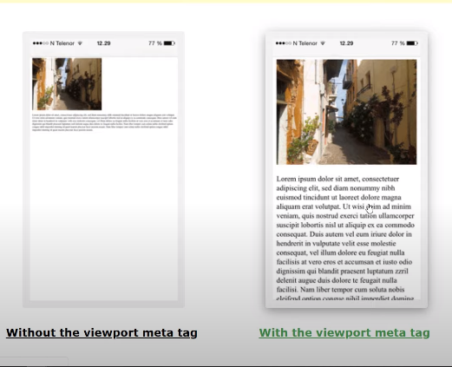

On the left is the website without a defined viewport meta-tag, on the right is with a defined viewport meta-tag

Usually the content is either scrunched up to fit the view-port it is displayed on, or it takes up as much space as is available to stretch out the content as it is defined in its html and css. What we want is to have the content displayed in a preditermined manner, one where it looks good and has a couple of in-advance defined sizes that are designed to fit most viewport in a way that is accessible and user friendly, so that it wouldn’t get scrunched up or stretched out (automatically) from display to display…

 <meta name="viewport" content="width=device-width, initial-scale = 1.0">

***Insert the above meta-tag by default if you want to create a responsive website***

The above sets the website to the width of the device, and the scale to 1.0*deviceSize. If it were initial-scale = 2.0, it would mean that the website would be zoomed in to display in two times the size of the viewport on the device, or simpler, the size would be: 2.0*deviceSize.

# **MEDIA QUERY**

/*The following styles apply for all screens 1400px ir below*/

@media screen and (max-width: 1400px){

}

/*What the above query means is: on screens(all devices with a screen*/

/* and that have a max-width of the viewport of 1400px, apply the following css rules  */

/*In essence, if the viewport is above 1400px, the styles in the media query will not apply*/

/*but if it is 1400px or less, the media query styles will apply*/

@media screen and (min-width: 800px){

}

/*The above styles apply for all screens 800px or above*/

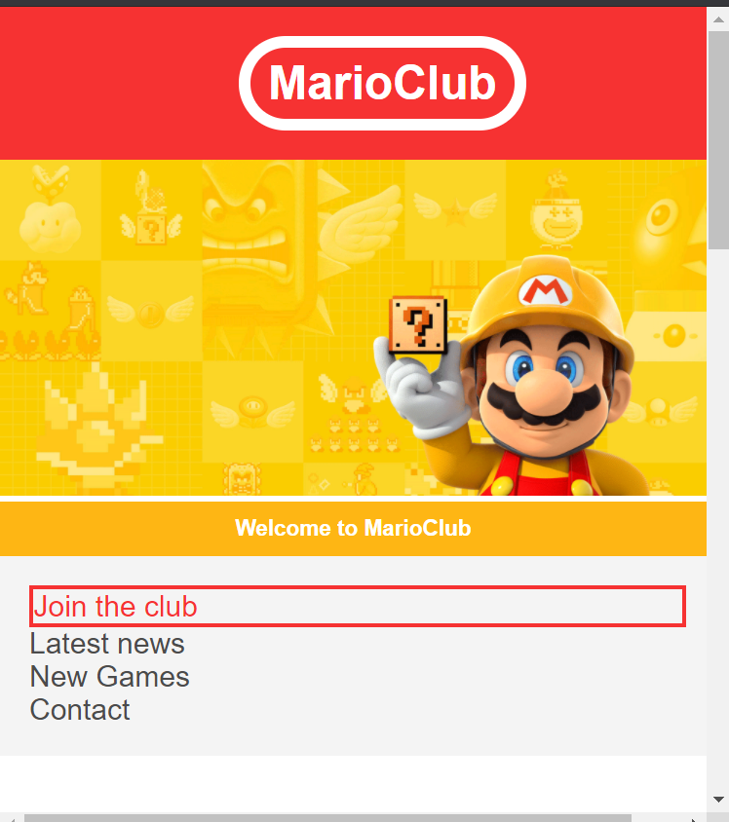EXERCISE(4) Create the mobile phone version of the website as displayed on the image. Note that the nav bar needs to stick to the top of the screen as the user scrolls down

/*Responsive Styles, media queries*/

/*The following styles apply for all screens 1400px ir below*/

@media screen and (max-width: 1400px){

    .banner .welcome h2{

        font-size: 40px;

        /*Note that we don't have to copy and paste all the rules above for our media query*/

        /*all the rules above still apply, the changes to the rules here simply override*/

        /*the default rules above the media query if the condition for the media query applies*/

    }

}

/*What the above query means is: on screens(all devices with a screen*/

/* and that have a max-width of the viewport of 1400px, apply the following css rules  */

/*In essence, if the viewport is above 1400px, the styles in the media query will not apply*/

/*but if it is 1400px or less, the media query styles will apply*/

@media screen and (max-width: 960px){

    .banner .welcome h2{

        font-size: 20px;

    }

}

@media screen and (max-width: 700px){

    .banner .welcome{

        position: relative;

        text-align:center;

        padding: 10px;

    }

    .banner .welcome br{

        display: none; /*this practicaly removes the targeted tag from the document*/

    }

    .banner .welcome h2{

        font-size: 15px;

    }

    .banner .welcome h2 span{

        font-size: inherit; /* we set the larger text to know be the size of the text in its parent element*/

        /*font-size: 1em; would have the same effect, as it would first use the font size of the parent element and multiply it by 1*/

    }

    nav li a{

        font-size: 20px;

    }

    .images li{

       width: 100%;

       margin: 20px;

       display: block;

       z-index:-1;

    }

}

@media screen and (max-width: 560px){

    nav{

        top: 0px; /*We are removing the sticky top 100xp buffer zone*/

    }

    nav li{

        font-size:20px;

        position: relative;

        display: block;/*now the nav elements will sit on top of each other*/

        width: 100%;

        margin: 12px, 0;

    }

    header{

        position: relative; /*we no longer want the header to stick to the screen at all times*/

    }

}

**CSS – GRID**

CSS grid was created to provide web-developers with a way to design block content on their pages without resorting to hacky fixes and solutions(think ducktape and stick) when using dummy content-blocks, margins, padding and positioning from the way the old float and position layout properties worked.

Instead of manipulating elements relative to the normal document flow, or in the case of floats, stacking multiple document-flow masks on top of one another, CSS-grid simply divides the webpage into an even grid, and within it, you may declare which element is placed into which space on the grid itself.

This way the grid ignores the normal-html layout and places the stated elements on the desired position, regardless of the order the element was writen in html. In short, the last placed html <element> can be placed at the top of the CSS grid above all the elements that preceded it, without a problem, and the same goes for placing the first element at the bottom, or middle, or anywhere on the grid, really…

Some things to note before we continue:

***The :nth-child(n) selector/pseudo-class:***

Specify a background color for every <p> element that is the second child of its parent:

p:nth-child(2) {  
  background: red;  
}

Below it specifies every odd <p> elemetn, so 1st,3rd,5th,7th, etc…

p:nth-child(odd) {  
  background: red;  
}

Below it specifies every even <p> element, namely: 2nd, 4th, 6th, etc…  
p:nth-child(even) {  
  background: blue;  
}

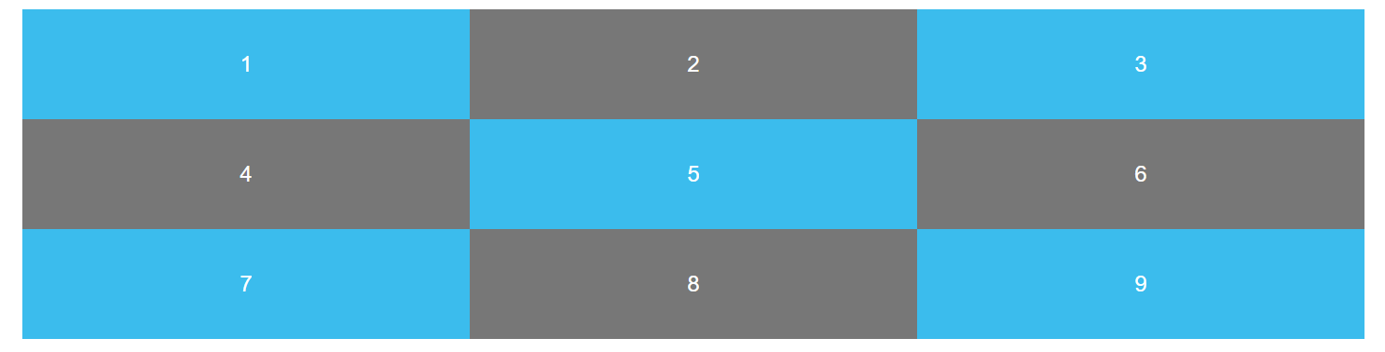

 #content{

                display:grid;

                grid-template-columns: 30% 20% 50%;

                grid-template-columns: 1fr 1fr 1fr;

                grid-template-columns: repeat(3,1fr);

max-width: 960px;

                margin:0 auto; /*centers on page*/

            }

Above we can see the three ways to write three grid rows for our div containers 1/9

The first way uses percentage, the second, uses fractions, while the third uses the repeat function which tells it how many times you wish to repeat (how many rows), and the size of the row. In other words:

***grid-template-columns: repeat(numberOfRows,SizeOfRow);***

## ***The default way css-grid rows and row height function:***

By default the row height is governed by the height/amount of content placed inside the row. CSS-Grid creates a new row automatically if there is no more horizontal space for another column.



What we can see is from the code above we’ve removed padding, so now the row height is defined by the content within it (*the height of the numbers placed inside, in this case)*

Though as it should be noted, we’ve only explicitly stated that 9columns should be created, yet in the picture above, we can clearly see that there are three columns and tree rows.

This happened automatically since only 3columns of this size can fit on to the horizontal plane of the page, so CSS-Grid created a new row for the next three columns, and having filled up the horizontal plane again, created the last row for the columns 7,8,9.

## ***Grid-auto-rows property***

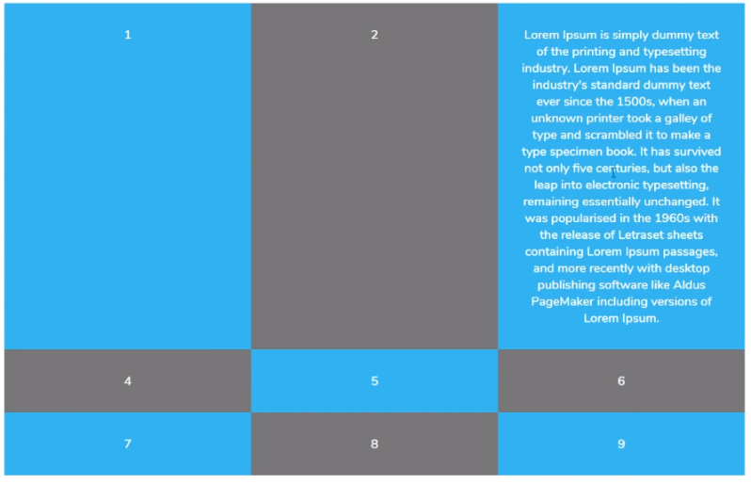On the left we have an example of the height of the row being dynamicaly adjusted to fit the content placed inside. In this case the <div>3</div> had some lorem-ipsum placed inside, and CSS-grid automatically stretched the height of the ***entire Row***, in order to fit the content.

This automatically adjusting property can be overriden by using the property “***grid-auto-rows: 200px***” which sets the height to every single row inside the grid to 200px

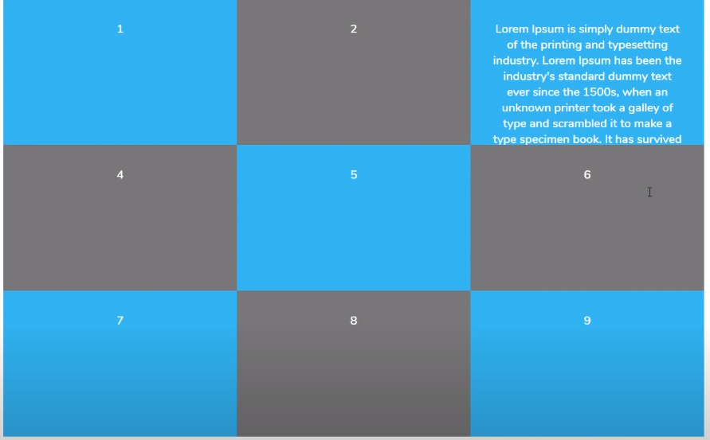To the right we see the result of using “grid-auto-rows: 200px;” property. A thing to note is that this property completely disregards the content inside the row if it is above the defined row height, cutting it (in this case) at the 200px.

To fix the problem of cutting cell content, we have a way to assign a height to all rows within a grid and to allow for the height of any particular row to stretch in order to fit the content, and this would be the following.

***“grid-auto-rows: minmax(min.size, max.size);”***

***“grid-auto-rows: minmax(100px, auto);”***

This property as stated above sets the minimum row height of 100px, with the maximum row height stretching automatically as high as necessary, in order to fit the content of the cell (the cell with the largest content-height in a given row)***.***

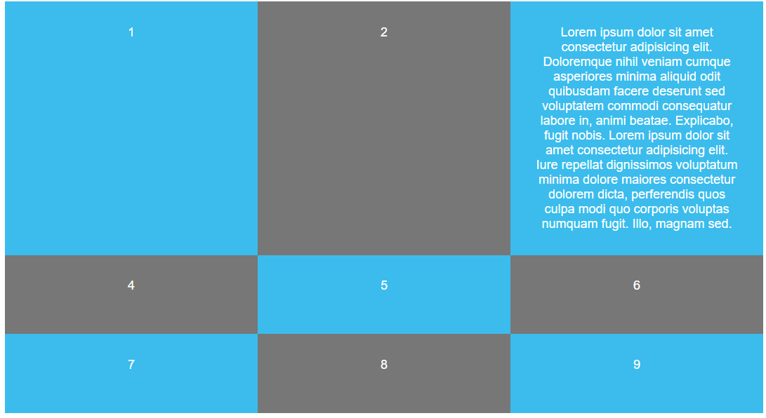So now we can see in the image to the left how all rows are following the defined 100px height, with the caveat that the first row has its height stretched in order to fit the content of the cell in the third column, as defined by our (100px,auto) rule.

## ***Explicitly creating rows in CSS-grid:***

grid-template-rows: 200px 300px 400px; /*px defines the height of our rows and the number of values defines the desired number of rows (in this case 3values==3rows)*/

We might achieve a simmilar result using the “***repeat(n,height);”*** function

grid-template-rows: repeat(3,200px);

The problem with the set height of 200px in this case is that it will automatically cut any cell content that exceeds the height of 200px.

In order to still be able to stretch the height of a row so it fits the maximum content height of it’s cells is by using the “***minmax(min,max);***” function as seen below:

grid-template-rows: repeat(3,minmax(200px,auto));

So now the row stretches automatically if its content is above 200px, and is otherwise set to default to a 200px height.

## ***Setting the gap/spacing between rows and columns***

Note that if we were to set a margin to our <div> elements within our <div id=”content”> parent container, we could set our rows and columns apart. But the problem arises when we note that we would have the margins applied in every direction, not just between the columns and rows.

To combat this problem, special properties are applied for creating space between rows and columns in CSS-Grid, and they are “***column-gap***” and “***row-gap***”

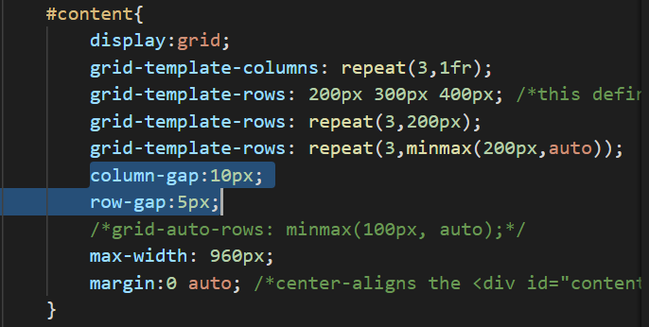The end result can be seen on the image below:

Note that the margins/spaces created only exsist between rows and columns and are placed nowhere else. Unlike the margin property if it were to be applied to the same effect. Note that ***column-gap*** and ***row-gap*** can be combined into a single property: **grid-gap: 10px;**

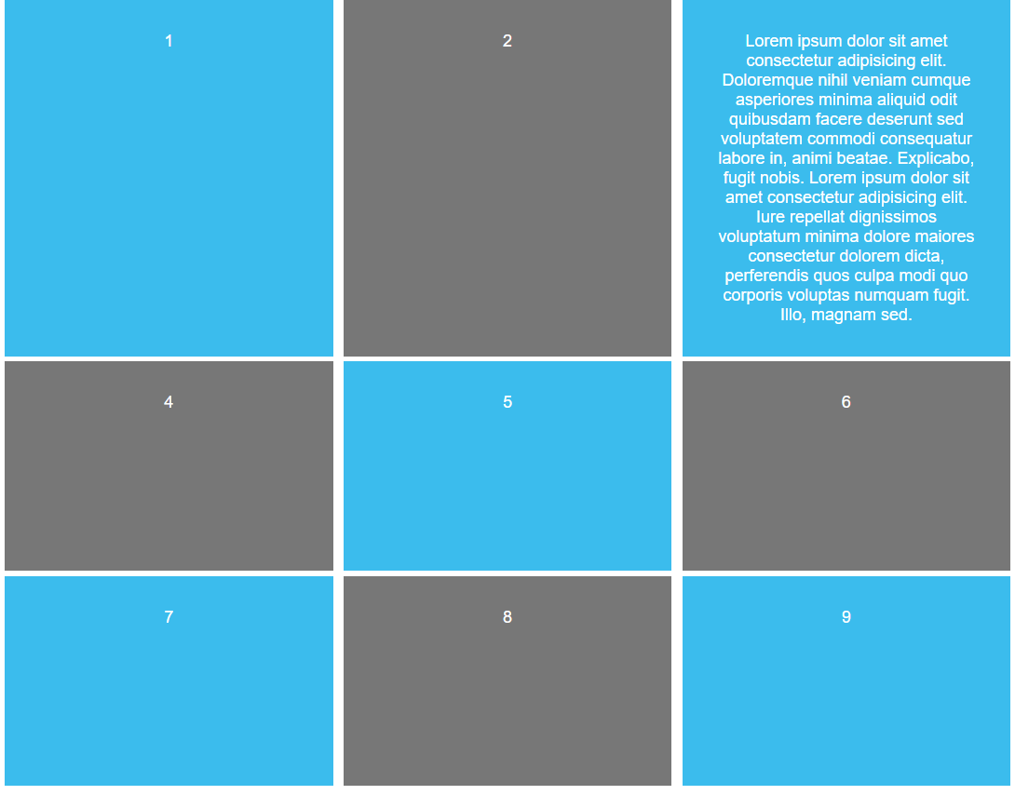

***Code for the properties and features mentioned above***

<!DOCTYPE html>

<html>

    <head>

     <style>

            body{

                color: #fff;

                font-family: 'Nunito Semibold', Arial, Helvetica, sans-serif;

                text-align:center;

            }

            #content{

                display:grid;

                grid-template-columns: repeat(3,1fr);

                grid-template-rows: 200px 300px 400px; /*this defines the height of our rows*/

                grid-template-rows: repeat(3,200px);

                grid-template-rows: repeat(3,minmax(200px,auto));

                /*column-gap:10px;*/

                /*row-gap:10px;*/

                grid-gap:10px;/*sets both the row and column gap to 10px*/

                /*grid-auto-rows: minmax(100px, auto);*/

                max-width: 960px;

                margin:0 auto; /*center-aligns the <div id="content" page*/

            }

            #content div{

                background: #3bbced;

                padding:30px;

            }

            #content div:nth-child(even){

                background: #777;

            }

     </style>

    </head>

    <body>

        <div id="content">

            <div>1</div>

            <div>2</div>

            <div>3</div>

            <div>4</div>

            <div>5</div>

            <div>6</div>

            <div>7</div>

            <div>8</div>

            <div>9</div>

        </div>

    </body>

</html>

## ***POSITIONING ELEMENTS ALONG THE CSS-GRID***

**THE DEFAULT POSITION:**

By default the css grid positions elements in order from the top to the left, along the grid. So the first element in a 3*3 grid that we are using would be in position(1,1) (row,column). The second element would be in position (1,2), third (1,3), fourth(2,1),…,ninth (3,3)

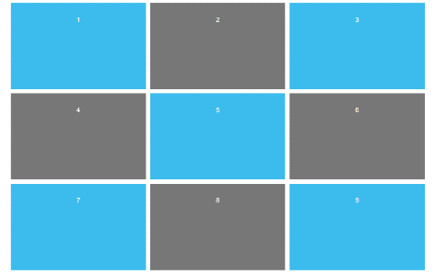<body>

        <div id="content">

            <div>1</div>

            <div>2</div>

            <div>3</div>

            <div>4</div>

            <div>5</div>

            <div>6</div>

            <div>7</div>

            <div>8</div>

            <div>9</div>

        </div>

    </body>

For positioning elements along a specific path inside a CSS-Grid, we use a concept called **“grid-lines”**

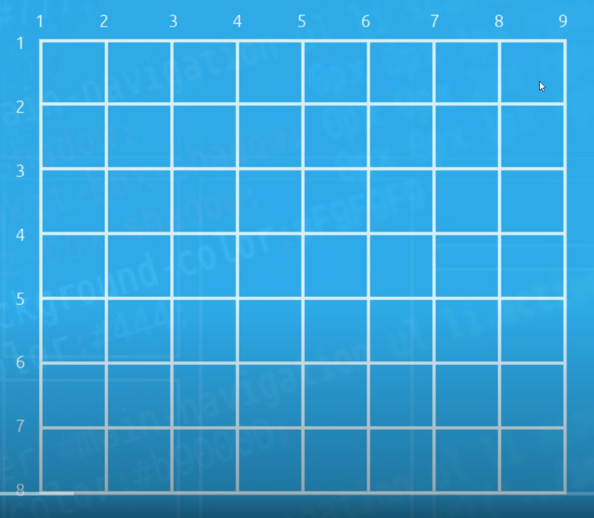As can be seen here, grid lines are the literal lines that span the grid. They span along the edges of columns as well as rows, so we differentiate column-lines and row-lines.

So for a grid that has 8-columns, there will be 9 “column-lines”, or in other words for a grid of (n) columns, there will always be (n+1) column lines.

And the same goes for “row-lines”, for an (n) amount of rows in a grid, there will always be (n+1) “row-lines”.

The +1 line is always the very last line on the vertical/horizontal edge of the grid.

## **grid-column, grid-row properties**

To the right we can se an element position defined within a CSS grid, using row-line, column-line properties.

To declare this positioning we would tell the browser to select the position that starts horizontaly at *column-line (3)* and ends at *column-line (6)*, while it starts vertically at *row-line(2)* and ends in *row-line(5)*

We do this using the ***grid-column*** and ***grid-row*** properties, of the following synthax, ***grid-row: startLine/endLine grid-column:startLine/endLine***

Exercise(1) Create a layout from the picture below using <div> containers and CSS grid.

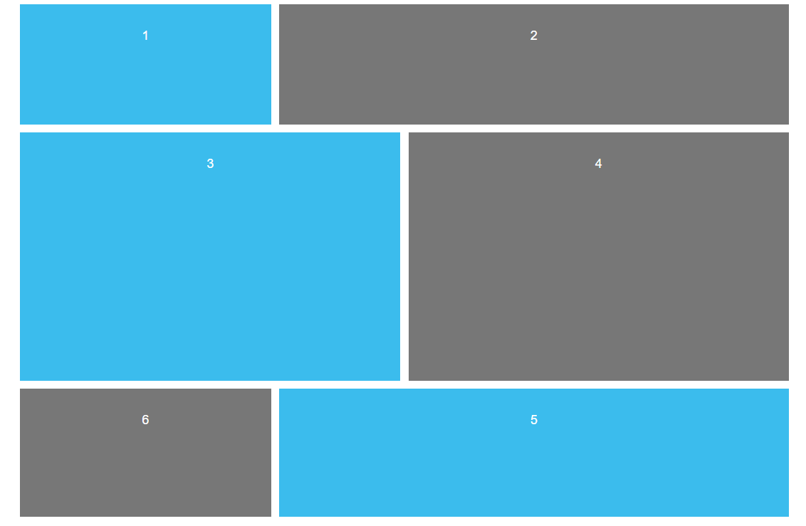**#content{**

**display:grid;**

**grid-template-columns: repeat(6,1fr);**

**grid-template-rows: repeat(4, minmax(150px,auto));**

**grid-gap:10px;**

**max-width: 960px;**

**margin:0 auto;**

**}**

**#content div{**

**background: #3bbced;**

**padding:30px;**

**}**

**#content div:nth-child(even){**

**background: #777;**

**}**

**.one{**

**/*grid-column-start: 1;**

**grid-column-end: 3;*/**

**grid-column: 1 / 3; /*grid-column: start / end*/**

**}**

**.two{**

**grid-column: 3 / 7;**

**}**

**.three{**

**grid-column: 1 / 4;**

**grid-row: 2 / 4;**

**}**

**.four{**

**grid-column: 4 / 7;**

**grid-row: 2 / 4;**

**}**

**.five{**

**grid-column: 3 / 7;**

**grid-row: 4 / 6;**

**}**

**.six{**

**grid-column: 1 / 3;**

**grid-row: 4 / 6;**

**}**

**</style>**

**</head>**

**<body>**

**<div id="content">**

**<div class="one">1</div>**

**<div class="two">2</div>**

**<div class="three">3</div>**

**<div class="four">4</div>**

**<div class="five">5</div>**

**<div class="six">6</div>**

## **NESTED GRIDS**

When we wish to nest grids within a grid element we can simply declare the grid element to display as a grid itself. So if we have had a <div class=”MainGrid”> <div class=”nested”><div class=”element”>… We declare the element within the main grid, here given the class “nested” as a grid of its own. .nested{ display: grid;}. Now that the nested element has a grid layout, we may simply insert into its html brackets any block level elements we wish to display along the grid we’ve just created. As can be seen from the example of the code and grid output below:

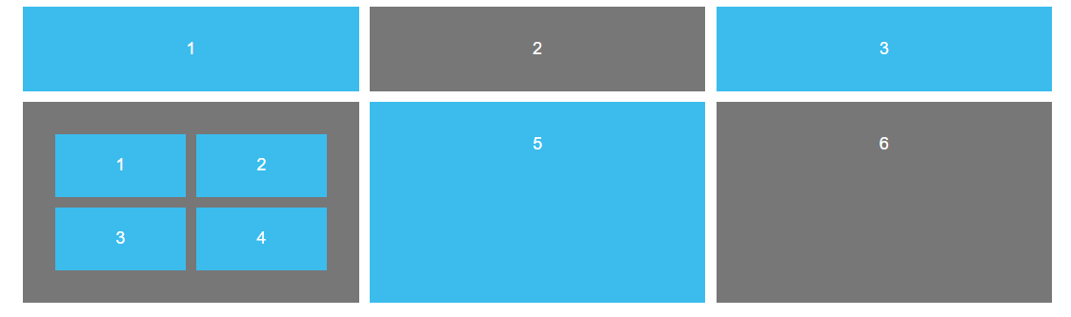

.nestedGrid{

                display:grid;

                grid-template-columns: repeat(2,1fr);

                grid-gap:10px;

            }

            .nestedGrid p{

                margin:0;

                background: #3bbced;

                padding:20px;

            }

     </style>

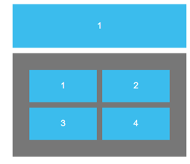    </head>

    <body>

        <div id="content">

            <div>1</div>

            <div>2</div>

            <div>3</div>

            <div class="nestedGrid">

                <p>1</p>

                <p>2</p>

                <p>3</p>

                <p>4</p>

            </div>

            <div>5</div>

            <div>6</div>

## **The span keyword**

This is a keyword we can use when defining the values of grid-line, grid-column property. For certain situations where we wish to stretch an element over a “span” of columns, relative to its original placement. So we cannot use the span property to completely reposition an element by defining its starting and ending line/row coordinates on the grid, but we can use it to easily stretch an element over a span of columns or rows,relative to its starting column/row-line.

Let’s look at how we would use the *grid-column* property, as well as its *span* property counterpart, for spreading the <p>1</p> element over the entire horizontal row, on the example above

***.first{grid-column: 1/3;}***

***.first{grid-column: span 2;}***

This takes the default start-position and tells it to span [*stretch over*] (x) columns from there. Note that it is two grid-columns, not two grid lines, as two grid lines make up only a single column. The takaway is the *span* property uses columns, while the *grid-column* property uses grid lines, when defining where the element should stretch to.

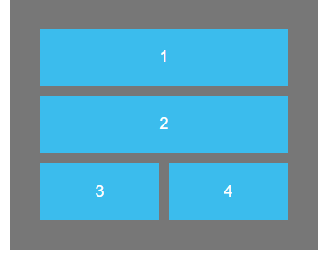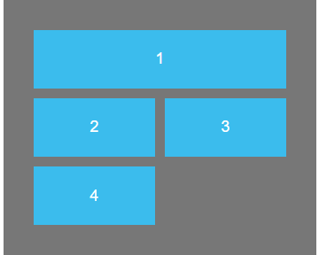  .firstNestedElement{

9Using the default column-line value

10Using the span keyword

   grid-column:span 2;

    }

   .secondNestedElement{

     grid-column: 1 / 3;}

## **JUSTYFYING AND ALIGNING ITEMS**

By default the nested elements within a grid take up the full space of a grid square. We can override this setting and define exactly how much space we want our block level elements to fill inside a grid-cell, as well as where on the grid-cell we want those elements to be placed(align-items: up/down, justify-items: left/right) As stated beforehand for this we will be using ***align-items: ;*** and ***justify-items: ;*** properties.

Note how we can use these properties on the grid element itself *(the wrapper element*), where the css property rule would apply to all elements inside the grid. Though alternatively we may use thsese align and justify properties on the individual-grid-elements (*the nested block elevel elements within the wrapper declared to display as grid),* so that only the declared rules only apply to specific cells within the grid.

Below, our wrapper <div id=”content”> is used as a selector to align all items within its wrapper grid.

    #content{

                display:grid;

                grid-template-columns: repeat(3,1fr);

                grid-auto-rows: minmax(150px,auto);

                grid-gap:10px;

                max-width: 960px;

                margin:0 auto;

                /*the following aligns all elements within the wrapper*/

                align-items: start;

                align-items: end;

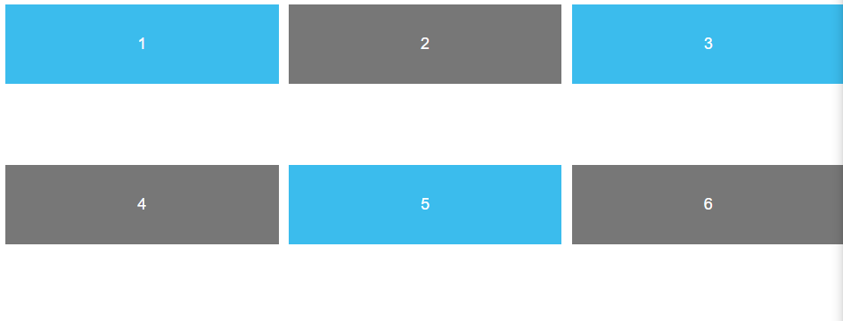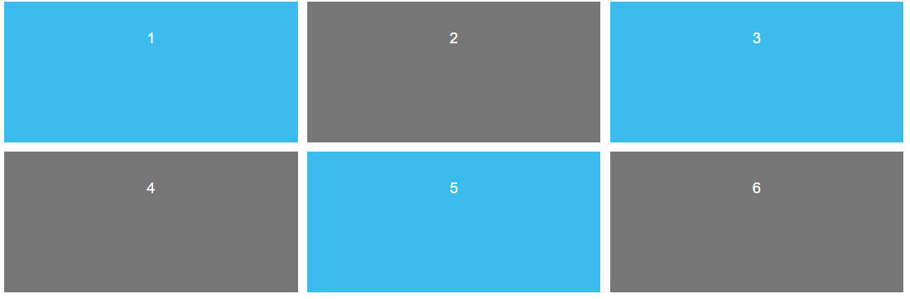                align-items: stretch; /*default value */

align-items: start;

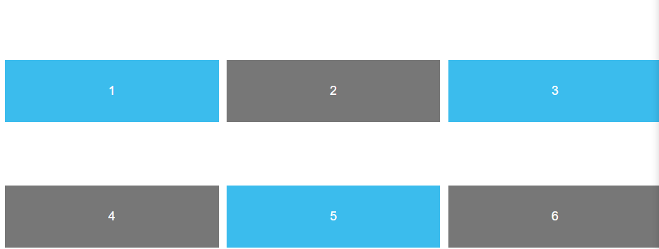

align-items: stretch; -> This is the default value

align-items: end: --> this places them at the bottom of the cell

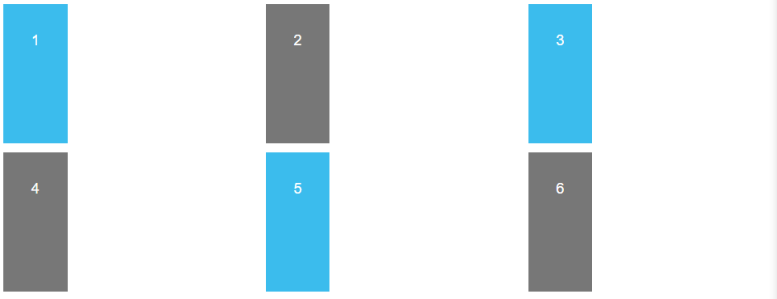 Here we can se how justyfy-elements declared within the wrapper-selector brackets aligns the content of all nested nested elements on the horizontal axis.

14Justify-elements: start,center,end;

15Here we can see the effect of justyfy-elements: end; align-elements: start;

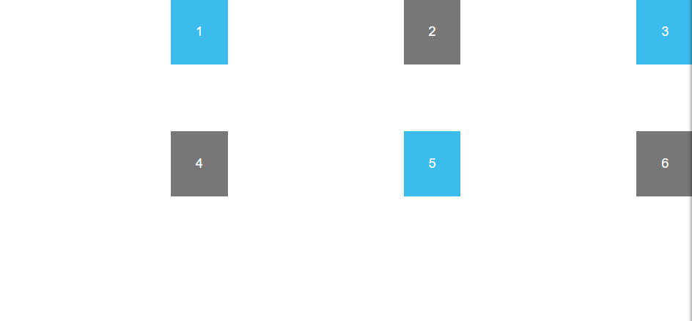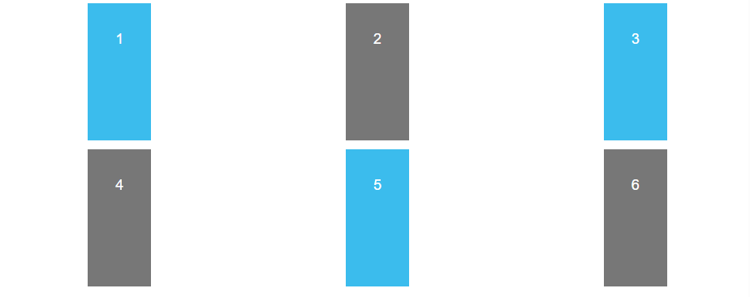

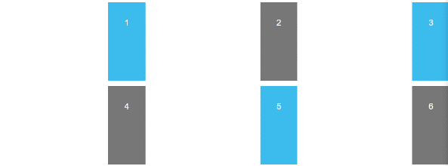

#content{

                display:grid;

                grid-template-columns: repeat(3,1fr);

                grid-auto-rows: minmax(150px,auto);

                grid-gap:10px;

                max-width: 960px;

                margin:0 auto;

                /*the following aligns all elements within the wrapper*/

                justify-items: end;

                align-items: start;

            }

To reiterate, if we were to have the rules apply only to a single cell, we would write the rules in the selector for the nested element within the grid-wrapper element.

## **CREATING A 12 COLUMN GRID WITH A TOGGLE-able GRID OVERLAY**

***EXERCISE***: create a 12Column website layout using css-grid, and add to it a toggle-able (via checkBox-input) overlay that displays the lines of the grid used in creating said layout, as shown in the pictures below:

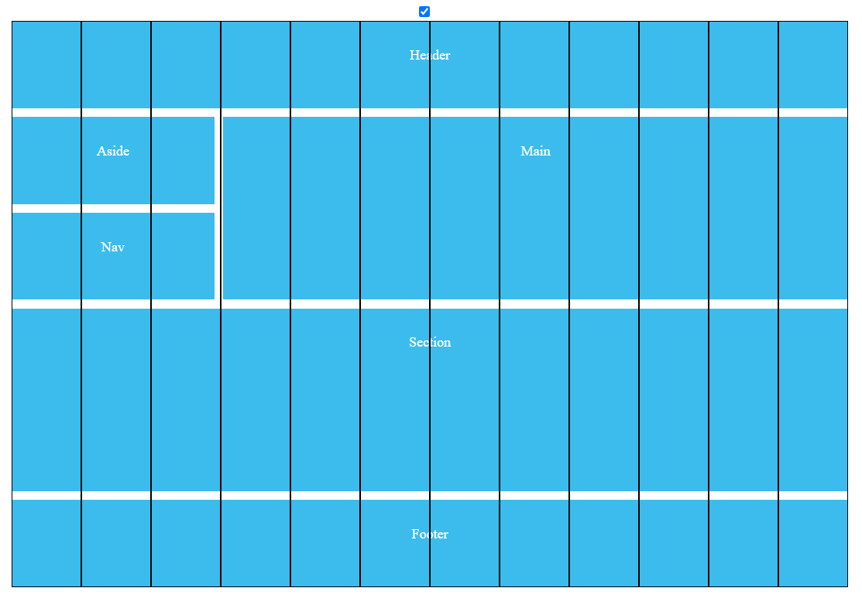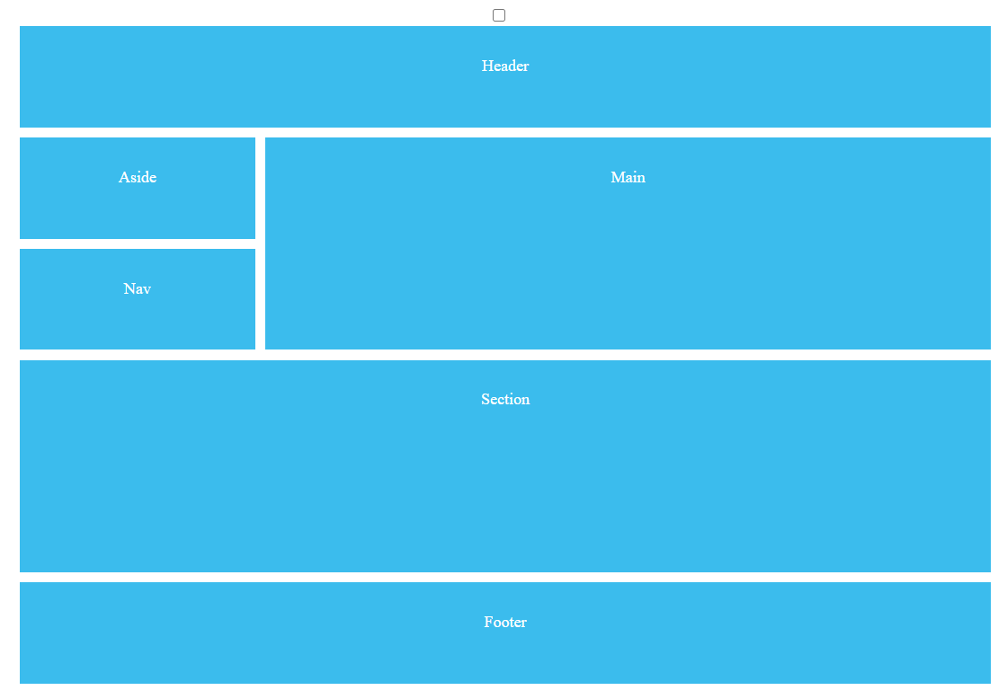

### ***HTML solution***

<!DOCTYPE html>

<html>

    <head>

 </head>

    <body>

        <input type="checkbox">/= <!--checkbox that toggles the grid-overlay -->

        <div id="content">  <!--#content is our main grid-->

            <div id="grid">  <!--#content is our grid-trace-overlay -->

                 <!--dummy content used to properly fill out and display the grid overlay-->

                <p></p><p></p><p></p><p></p><p></p><p></p><p></p><p></p><p></p><p></p><p></p><p></p>

            </div>

             <!--main content for our 12grid layout-->

           <header>Header</header>

           <main>Main</main>

           <section>Section</section>

           <aside>Aside</aside>

           <nav>Nav</nav>

           <footer>Footer</footer>

        </div>

    </body>

</html>

### ***CSS-Solution***

         body{

             color:#fff;

             font-family: 'Nunito Semibold';

             text-align:center;

         }

         #content{

             /*

              we set this to relative, so that the grid overlay may be positioned absolutely,

              relative to the content-div

              */

             position:relative;

             display:grid;

             grid-template-columns: repeat(12,1fr);

             grid-auto-rows: minmax(100px,auto);

             grid-gap:10px;

             max-width:960px; /*max width of "content" container*/

             /*default property reset */

             margin: 0 auto; /*center-aligns the "content" div*/

         }

         #content >*{       /*[>*] every child element, every direct descendant, any element of lesser hierarchy: Parent>child*/

             background:#3bbced;

             padding:30px;

             position:relative;

         }

         header{

             grid-column:1/13;

         }

         main{

             grid-column:4/13;

             grid-row: 2/4;

         }

         aside{

             grid-column: 1/4;

             grid-row:2/3;

         }

         section{

             grid-column:1/13;

             grid-row: 4/6;

         }

         nav{

             grid-column: 1/4;

         }

         footer{

             grid-column: 1/13;

         }

/*here we are creating an identical toggleable 12row grid overlay*/

         #grid{

             display:grid;

             position:absolute; /*positioned absolute relative to the parent element, we do this so it can display on top of the parent*/

             top:0;

             left:0;

             grid-template-columns: repeat(12,1fr);/*has the same number of rows, our parent div has */

             grid-auto-rows:minmax(100%, auto);/*100% of the height of the parent element*/

             width: 100%; /*100% of the width of the parent element*/

             height:100%; /*100% the height of the parent element*/

             background: transparent; /*so that we can see our main content behind it*/

             /*default property reset*/

             margin: 0 auto;

             padding:0;/*remove the padding from our container element*/

            /*on/off toggle to display/hide the grid*/

            display: none; /*the grid is hidden by default*/

         }

         input:checked + #content #grid{

             display:grid;

         }

         #grid p{

            border: 1px black solid;

            /*default property reset*/

            margin: 0;

            z-index:1;

         }

### Note the use of the ***SIBLING SELECTOR***

         input:checked + #content #grid{

             display:grid;

         }

Here we have joined a pseudo-class [ denoting a (checked-state) of an “input”-element] with a siblng selector (joining the checkbox to the selector target usign the (+) symbol.

What it says is, in the event of “ input:checked ” join “+ “ the element targeted by the compound selector “#content #grid “ (i.e. the element #grid nested inside an element #content) and set its display-property to “display:grid;”

# **CSS FLEXBOX**

**How flexbox works**

-Firstly we need to create a container, an element with a display type of : **FLEX**. This would mean that every decendant element within the container becomes a **FLEX-item.** Then we control the behavior of those **FLEX-items** using various css properties that apply to the items themselves or the flexbox container.

### **Default behavior for flex items**

They stack left to right on the top left corner of their parent element

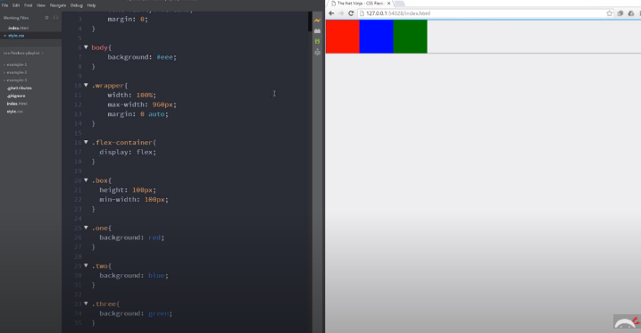

## **Flex-grow property**

As we can see on the left, there is some space left in the parent container. If we were to want to fill out that space with our elements, we would set a **flex-grow: 100;( growthRate)** either for the the parent container, in which case all the elements would fill up the empty space evenly (have the same width) or set the flex-grow property on the individual flex elements, in which case depending on the growth rate, they would take up different proportions of their parent element, as can be seen below. With the first element having the growth-rate of 1, second of 2 and third of 3.

**A useful way of imagining growth rates is as if they were a column number.**

Note that bellow we can use and get the same proportions for a 12 column grid using the growth rate numbers of 3(for red) 4(for blue) 5(for green) so in effect, red would cover 3 columns, blue4 and green5 using flex-grow property to achieve the same effect as collspan(3,4 and 5 respectively.) With the main difference between flex-grow and colspan being that flex-grow is a proportion rate relative to the other flex-elements within the same flex-container, while colspan literally takes up the columns where they are defined and is not a relative

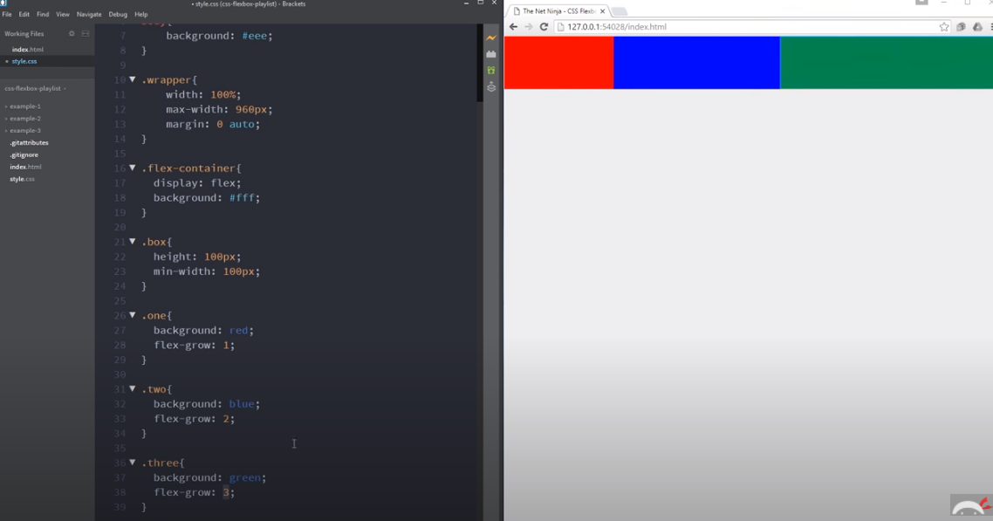

**ADDITIONAL FLEX-GROW NOTES:** Note that when we define a flex-grow property, the grow-rates are relative to the display size of the webpage, this means that the flex-elements will (flex grow) to fill up the space with their relative (growh-rate) proportion as we expand the webpage. Now the property max-width, min-width will define how much our flex-elements will grow/shrink. Meaning that they will shrink down to the element’s min-width property, while the flex-grow will be applied for as long as the element does not reach the max-width property.

### **Flex-shrink**

As we have defined above, the rate at which our flex-elements grow, with the **flex-shrink** property we will be defining the rate at which our flex-elements shrink.

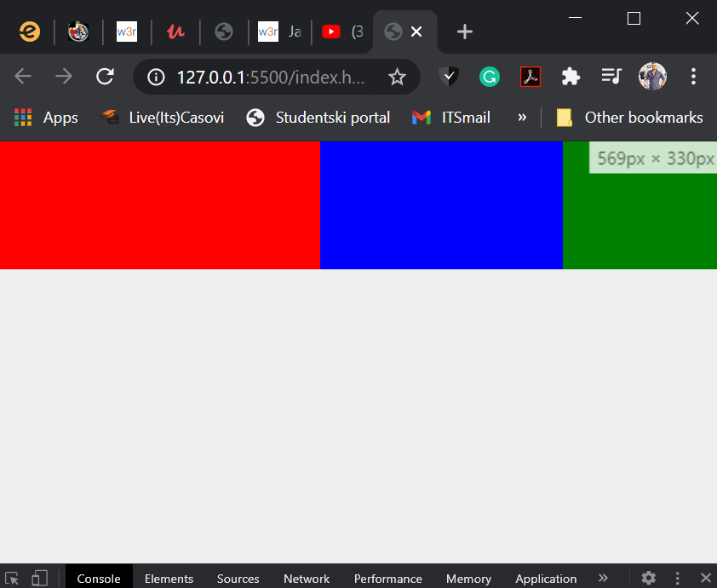**Default-flex-shrink behavior:** By default, flex

.one {

  background: red;

  flex-shrink: 1;

}

.two {

  background: blue;

  flex-shrink: 2;

}

.three {

  background: green;

  flex-shrink: 3;

}

The lost shrink rate property value will shrink the least as the browser gets smaller, while the values with a larger shrink value will shrink faster. So we would see the following result

As can be seen the **.one** box shrunk the least, seeing how it has a **flex-shrink: 1, and the others shunk proportionately.** Just do note that if we don’t use the flex-grow property on any of our flex-elements, they will not necesserily fill out the empty space that exists within their parent container, if they take up less space than the container itself. That filling out of parent container space, only happens when we apply a value to the flex-grow property.

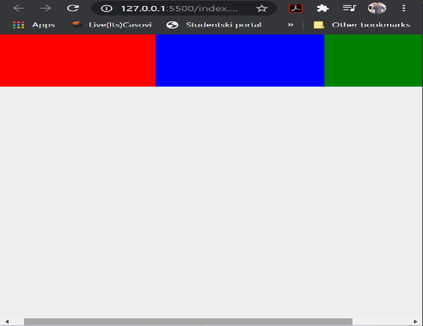**Additional note:** The flex-shrink values are just like the grow property values, relative to the growth/shrink rate of the other flex-elements inside the flex container.

## **Flex Wrap Property**

.box {

  height: 100px;

  min-width: 200px;

flex-grow: 1;

}

Notice how in this case, when we shrink the browser so much that the elements reach their min-width range of 200px, the flex property stops shrinking them because the min-width would not allow the elements to shrink bellow 200px in width, the result of this is us geting content gettng hid/cut off, outside of the browser, whereby we would need to scroll to the left or to the right in order to see the full size of all the three boxes (in this case, the green box is cut of by the edge of the browser). The minimum width being as it is, we don’t want our elements to get smaller, but we do want our elements to display within the users viewable browser space, so we would want those elements that don’t fit inside the screen wrap **to the next line down.** To do this would need to use the Flex wrap property.

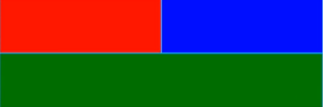 .flex-container {

  display: flex;

  background: white;

**flex-wrap: wrap;**

}

.box {

height: 100px;

  min-width: 200px;

**flex-grow: 1;**

}

Above we can see that the green element is now displayed below, so the parrent element effectivelly wrapped the green box being cutt-off, cut outside the viewable browser window, to a new line displaying now below the red and blue boxes. Now, since all our elements have a flex-grow property of 1, this means that when they take up a new line, they will at the same time take up all the available space on the new line of the parent container. As we see when the webpage is shrunk even further so that the blue-box gets wrapped to the next line.

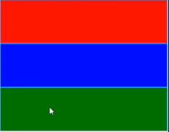This gives us a pretty awesome way to create dinamic **responsive** elements, without the need to use **media-queries**.

Default behavior is **flex-wrap: nowrap;**

if we want our cut-off element to display on a new line at the top of the flex-container (containing the colored boxes in our examples) we would use **flex-wrap:reverse-wrap;**

## **Flex Basis**

min-width: 200px; 🡨🡪 flex-basis: 200px;

We should remember that **min-width** actually defines the current width of an object, but at the same does not allow it to shrink/display with less than 200px.

In the case of **flex-basis** we can interchange **min-width and flex-basis** and they would bth behave the same. In short: ***both of these properties define the starting and minimum width of an element.***

**The subtle difference between flex-basis and min-width:**

The **flex-basis** automatically shrinks down the elements to fit the browser window, if the browser window becomes too small to fit the element. Now, if we don’t want our elements to ever become smaller then 200px, but still want them to display on screen, we would use flex-wrap so that the cut-off element moves to a new line, yet, it too has its limits, as the user can shrink down the browser even further so that no wrapped elements(new line or no) display in their full width. Here, instead of having parts of our elements remain offscreen, we may apply the flex-basis property, which will shrink the elements down, to always be displayed on screen. **Below is the short-hand notation for our flex properties.**

.box {

  height: 100px;

  flex: 1 0 200px; /*flex-grow(1) flex-shrink(1) flex-basis(200px)*/

}

Alternatively flex: 1; would set /*flex-grow(1) flex-shrink(1) flex-basis(0)bydefault

## **Flex styles**

/*Flex styles */

/*We want to use flex styles for the larger screens*/

/*

These  media query styles will overwrite the style of

the nav menu, for browsers larger than 768px.

*/

@media screen and (min-width: 768px) {

}

nav ul {

  display: flex;

  justify-content: flex-start;

}

nav li {

  /*no styles*/

}

justify-content: flex-start; /*note that flex-start is default*/



justify-content: flex-start;

justify-content: flex-end;

justify-content: space-around;

justify-content: space-between;

## **Flexercise (1) Create a flexbox-menu**

Create a flexbox menu that will completely fit the top of the browser screen but not exceed the width of 960px). When the user hovers over the nav bar items, the background changes to a lighht gray(the home menu had a cursor hover over it for the screenshot) The flexbox nav bar should display if the screen is larger than 768px

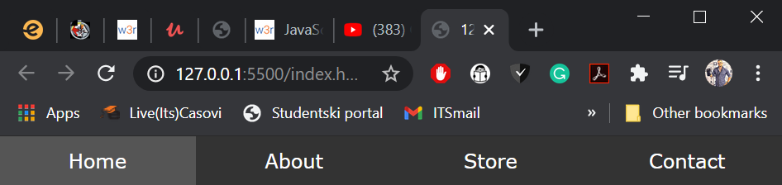

For screens smaller than 768px, a phone style nav bar should display, like below

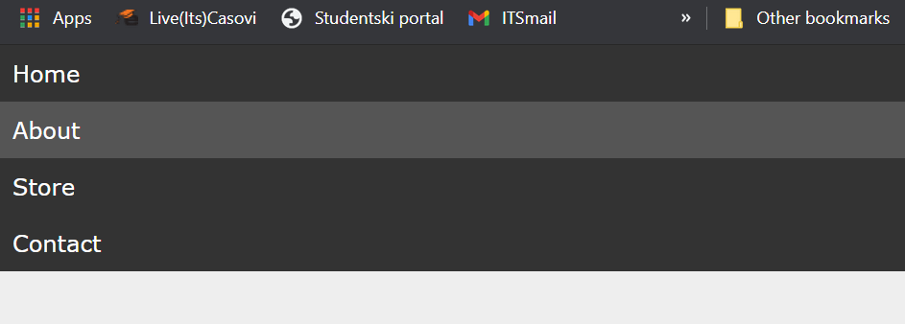

**Solution:**

<!DOCTYPE html>

<html lan="en">

  <head>

    <meta charset="UTF-8" />

    <meta

      name="viewport "

      content="width = device-width; initial-scale=

    1.0"

    />

    <link rel="stylesheet" href="styles.css" />

  </head>

  <body>

    <div class="wrapper">

      <nav>

        <ul>

          <li><a href="">Home</a></li>

          <li><a href="">About</a></li>

          <li><a href="">Store</a></li>

          <li><a href="">Contact</a></li>

        </ul>

      </nav>

    </div>

  </body>

</html>

* {

  font-family: verdana;

  margin: 0;

}

body {

  background: #eee;

}

.wrapper {

  width: 100%; /*lets the element take up full width*/

  max-width: 960px; /*but not if it is over 960px*/

  margin: 0 auto; /*centers the wrapper on screen*/

}

/*Phone menu base styles*/

/*We want to use these styles for small phone screen*/

nav {

  background: #333;

}

nav ul {

  list-style-type: none;

  padding: 0;

}

nav a {

  text-decoration: none;

  color: #fff;

  display: block;

  padding: 10px;

}

nav a:hover {

  background-color: #555;

}

/*Flex styles */

/*We want to use flex styles for the larger screens*/

/*

These  media query styles will overwrite the style of

the nav menu, for browsers larger than 768px.

*/

@media screen and (min-width: 768px) {

}

/*every <ul> inside the nav will be a flex-container*/

nav ul {

  display: flex; /*this tells the element to become a flex-container*/

}

nav li {

  flex: 1 1 0;

}

nav a {

  text-align: center;}

## **FLEXERCISE(1.2)**

Modify the html of the previous exercise to have a submenu for Facebook and Twitter below the navbar you just created, as demonstrated in the picture below:

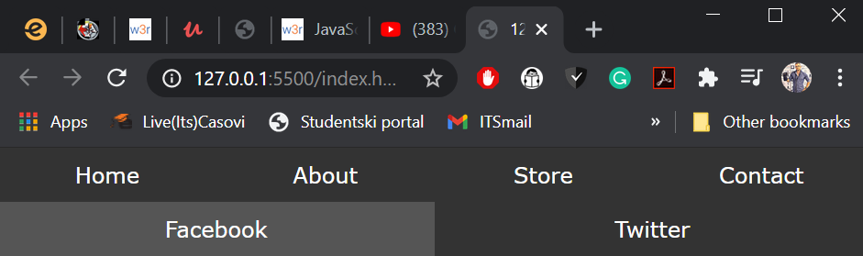

**SOLUTION:**

  <div class="wrapper">

      <nav>

        <ul>

          <li><a href="">Home</a></li>

          <li><a href="">About</a></li>

          <li><a href="">Store</a></li>

          <li><a href="">Contact</a></li>

 <!-- <li><a href="" class="fb">Facebook</a></li>

          <li><a href="" class="tw">Twitter</a></li>-->

        </ul>

        <ul class="social">

          <li><a href="" class="fb">Facebook</a></li>

          <li><a href="" class="tw">Twitter</a></li>

        </ul>

      </nav>

    </div>

Note that the flex-grow: 1, set on the <li> items applies to all flex-items inside the .wrapper class. That means that by creating a separate ul, the li elements divide between them half the space for Facebook and half the space for Twitter, but if we were to insert our new <li> elements in the original <ul> tag, ie (place it all in one <ul> instead of creating two, then the growth rate of (1) would apply to the Facebook and Twitter <li>s relative to all six elements, and facebook and twitter nav items would take up a sixth of the screen space and all in a single nav-bar line as can be seen below:

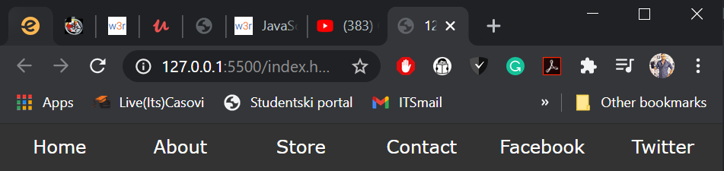

## **Flow and Axis**

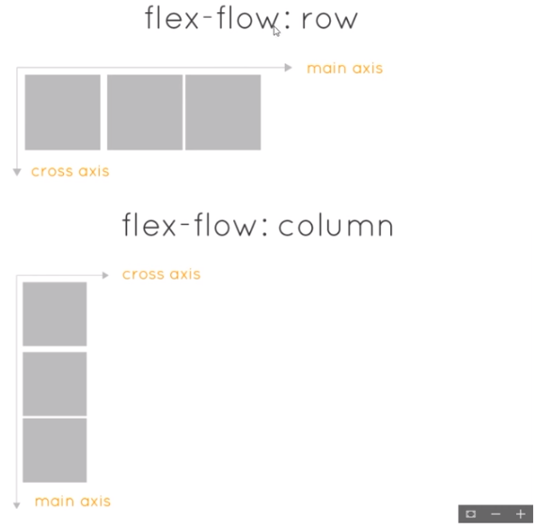The elements always follow the **main-axis**, this means that in the case of **flex-flow: row** they stack from left to right, while in the case of **flex-flow: column** the elements stack from top to bottom, again, on the line of the main axis in both cases, respectively. With this in mind, consider how flex-properties generally work relative to the main-axis or cross-axis, and expect the effect to be inverted if you use the same flex-property, for example **justify-content: flex-end** for **flex-flow:row** or for **flex-flow: column** Namely justify-content centers or aligns to the beginning, center or end the flex-elements, along the main axis, that means that in a **(row)** flow, justify would align left,center, right, while in the (**column)** flow it would align top, center, bottom as seen below:

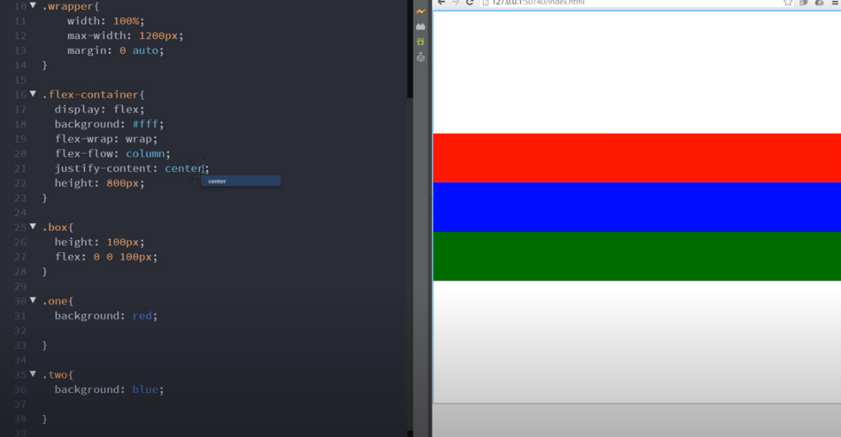

**MODERN JAVASCRIPT**

Our basic html set-up:

<!DOCTYPE html>

<html lang="en">

    <head>

        <meta name="viewport" content="width=device-width initial-scale=1.0">

        <meta http-equiv="X-UA-Compatible" content="ie=edge">

        <title>Document</title>

    </head>

    <body>

        <h1>Test</h1>

    </body>

</html>

Note how localhost is the adress 127.0.0.1

http://127.0.0.1:5500/index.html = http://localhost:5500/index.html

**Initializing and declaring variables and constants**

/*declaring and initializing variables */

/* "let" is Modern the keyword used to declare a variable */

var score = 75; //var is the old keword used to declare variables

let age = 25;

let year = 2019

age = 30;

console.log(age, year);

/*Creating a constant a variable that cannot be overwritten */

const P = 3.14;

console.log(P);

/*Constraint in naming conventions of variables

 the names cannot have the following:

 empty-space, start with a number, have anything other than

 underscore as far as symbols are concerned

*/

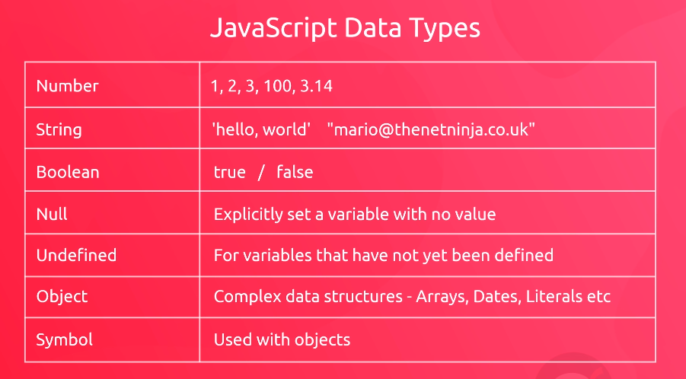

## ///////////////////STRINGS IN MODERN JAVASCRIPT////////

//directly printing text in our log

console.log("Hello, World");

//declaring and initializing a variable then printing it

//with our .log(); function

let email = "adam_milovanovic@yahoo.com ";

console.log(email);

//string concatination

let firstName = "Brandon";

let lastName = "Standerson";

let fullName= firstName + ' ' + lastName;

console.log(fullName);

//getting characters

console.log(fullName[0]);

 // fullName[n ]gets the n+1th element from the string

//note how JavaScript counts indexes from [0] -> 1st element

//String->properties

console.log(fullName.length)

// String->methods

//Methods are in fact functions, but functions that belong to a specific Object type

console.log(fullName.toUpperCase()); //this just prints everything in uppercase

let result = fullName.toUpperCase();

console.log(result, fullName);

//parametarized methods

let index = email.indexOf('@');//this method acesses the variable-string: "email" and returns the index of the "@" char.

//the returned method value is then assigned to the //newly declared "index" variable

                    //The value passed to a method is an "ARGUMENT"

                    //The value the method is set to expect is a "PARAMETER"

   console.log(index);

## //////////////declaring and initializing variables ////////////////

// "let" is Modern the keyword used to declare a variable

var score = 75; //var is the old keword used to declare variables

let age = 25;

let year = 2019

age = 30;

console.log(age, year);

//Creating a constant a variable that cannot be overwritten

const P = 3.14;

console.log(P);

///Constraint in naming conventions of variables///

 //the names cannot have the following:

 //empty-space, start with a number, have anything other than

 //underscore as far as symbols are concerned

## ////////COMMON STRING METHODS ////////

let email = "adam_milovanovic@yahoo.com";

//lastIndexOf();

let result = email.lastIndexOf('m');

//returns the last occurance [index] of a substring [entered as an argument] within the string variable

//slice();

 result = email.slice(0, 4);

 //Returns a section of the string from indexStart to indexEnd, including the characters at the start and end.

 //substr

 result = email.substr(0,10);

 //Works the same way as .slice(); with the exception that the second argument does not

 // state the final index, but the number of characters from the starting index, we wish to return

 result = email.replace('m','w');

 //in the example above, it replaces the first instance of a character 'm' with 'w'

////////NUMBERS and number operations ////////

let radius = 10;

const pi = 3.14;

//available math operators +, -, *, /, (**) to the power of, (%)remainder

//formula for calculating the area of a circle(obim)

//3.14 *r^2

result = pi*radius**2;

console.log(result);

## ///////////order of operation - BIDMAS //////////

/*

B brackets: (){}[]

I indicies: **

D divisions: (/)

M multiplications: *

A addition: +

S subtraction: -

*/

result = 5*(10-3)**2;

// B:  first it calculates B: (10-3) = 7

// I: then it calculates I: 7**2 = 49

// D: then it calculates D: there is no division.

// M: then it calculates M: pi*49

// A: there is no addition

// S: there is no subtraction

console.log(result);

// Returns the result:  245

///////INCREMENT-DECREMENT OPERATORS

let likes = 10;

likes = likes +1;

likes ++; //increment

likes --; //decrement

//////shorthand notation for simple calculations

likes += 10; //adds 10 to the current value

likes -=10;

likes *=2;

likes /=2;

//// NaN --> Not a number, usually an error where a number is expected but not returned

////CONCATINATION of strings with number-type variables

result = 'the blog has' + likes + ' likes';

console.log(result);

//notice how there is no need for a conversion with a toString();

//method in JavaScript

## ///////TEMPLATE STRINGS////

const title = "Best reads of 2019"

const author = 'Mario';

const likes = 30;

//Jamming it all into a single string, the concatenation way

let result = "The blog called " + title + " by " + author + " has " + likes + " likes ";

//template string way

let result = ` the blog called ${title} by ${author} has ${likes} likes`;

//Note that instead of single/double quotes, template strings use "Back Ticks"(``);

//CREATING HTML TEMPLATES

let tml =

`

<h2>${title}</h2>

<p>${author}</p>

<span>This blog has ${likes} likes</span>

`;

console.log(html);

//In the html-template above, we've basically created some

//thml synthax, inside of which we injected the current

//values of variables from our script.

//this means that wherever we insert this html, the values

//of the variables referenced inside it, will update dynamically

//alongside the original variables within the <script>

## /////////////ARRAYS IN MODERN JAVASCRIPT////////

let ninjas = ['shaun', 'ryu', 'chun-li'];

console.log(ninjas); //prints all the elements

console.log(ninjas[0]);//returns 'shaun'

//Overwriting the values within an array

ninjas[1] = 'ken';

console.log(ninjas);//returns 'shaun', 'ken', 'chun-li'

let ages = [20, 25,30, 35];

//Note that arrays can dynamically become heterogenic collections

//of various datatypes, though it is prefereable  by convention if arrays

//are used to store elements of the same datatype

let random = ['shaun', 'crystal', 30, true]; //this is fine ^^

console.log(random); //and it prints the values of these three different datatypes

console.log(ninjas.length);

//it will output 3, not as an index, but as a NUMBER OF elements inside an array

let result = ninjas.join(', ');

//this method connects all elements of an array, in a single string,

//with a (, ) between the array elements

result = ninjas.indexOf('chun-li');

//this one returns the array index of an element containing the value of ('chun-li)

result = ninjas.concat(['ken', 'crystal']);

//this concatinates two arrays. In the argument we can directly

//input a new array, or we can insert an array-object variable

///// DESTRUCTIVE METHODS

//Methods that change the original value of a variable/object/array

 result = ninjas.push('ken');

//Like on a stack, "push/pop", push here inserts a new element

//with the value of ('ken') inside the array "ninjas"

// then returns the updated value of the number of elements currently

//contained within the array, in short, it inserts an element and returns array.length.

result = ninjas.pop();

//Again, just like in "stack-collection"

//this method deletes the first element from an array

// and returns/outputs its value.

// in this case, output = 'ken',

// since we last called .push('ken'); placing it in [0]index

console.log(result);

//Move the .log(); method to check the various result values

//of the examples written above

# a/////////////ARRAYS IN MODERN JAVASCRIPT////////

let ninjas = ['shaun', 'ryu', 'chun-li'];

console.log(ninjas); //prints all the elements

console.log(ninjas[0]);//returns 'shaun'

//Overwriting the values within an array

ninjas[1] = 'ken';

console.log(ninjas);//returns 'shaun', 'ken', 'chun-li'

let ages = [20, 25,30, 35];

//Note that arrays can dynamically become heterogenic collections

//of various datatypes, though it is prefereable  by convention if arrays

//are used to store elements of the same datatype

let random = ['shaun', 'crystal', 30, true]; //this is fine ^^

console.log(random); //and it prints the values of these three different datatypes

console.log(ninjas.length);

//it will output 3, not as an index, but as a NUMBER OF elements inside an array

let result = ninjas.join(', ');

//this method connects all elements of an array, in a single string,

//with a (, ) between the array elements

result = ninjas.indexOf('chun-li');

//this one returns the array index of an element containing the value of ('chun-li)

result = ninjas.concat(['ken', 'crystal']);

//this concatinates two arrays. In the argument we can directly

//input a new array, or we can insert an array-object variable

## ///// DESTRUCTIVE METHODS

//Methods that change the original value of a variable/object/array

 result = ninjas.push('ken');

//Like on a stack, "push/pop", push here inserts a new element

//with the value of ('ken') inside the array "ninjas"

// then returns the updated value of the number of elements currently

//contained within the array, in short, it inserts an element and returns array.length.

result = ninjas.pop();

//Again, just like in "stack-collection"

//this method deletes the first element from an array

// and returns/outputs its value.

// in this case, output = 'ken',

// since we last called .push('ken'); placing it in [0]index

console.log(result);

//Move the .log(); method to check the various result values

//of the examples written above

## //////BOOLEAN VALUES/////

//Methods that return boolean

let name ='shaun';

let email = 'luigi@thenetninja.co.uk';

let names =['mario', 'lugigi', 'toad'];

let result = email.includes('@');

//returns true if the '@' character is nicluded inside the

// variable [email]

result = names.includes('luigi');

//it looks for an element with the value of 'luigi'

//within the array, and if it finds it, it returns true.

## //////COMPARISON OPERATORS////////

let age = 25;

console.log(age==25); //equals operator, output: true

console.log(age ==30); //output: false

console.log(age!=30); //output: true

console.log(age > 20); //output: true

console.log(age < 20); //false

console.log(age <= 25); //true

console.log(age >= 25 ); //true

## ///COMPARING STRINGS///

console.log(name == 'shaun');//true, uppercase letters are not equal to lowercase

console.log(name == 'Shaun');//false,

console.log(name > 'crystal');//true, only the first letters are compared:  later letters are > than earlier letters in the alphabet. B>A, C>B

console.log(name > 'Shaun');//true LowerCase is > Uppercase

console.log(name > 'Crystal'); //true, as C it is later in the alphabet than S

// and that overrides the fact that (s) is small and (C) is a capital letter

console.log(result);

true

## ///// LOSE COMPARISON////////

//(different datatypes can still be equal)

let age = 25;

console.log(age==25); //equals operator, output: true

console.log(age ==30); //output: false

console.log(age!=30); //output: true

console.log(age > 20); //output: true

console.log(age < 20); //false

console.log(age <= 25); //true

console.log(age >= 25 ); //true

## /////STRICT COMPARISON////

//(Different datatypes cannot be equal)//

console.log(age===25); //true

console.log(age === '25'); //false

console.log(age !== 25);

console.log(age !== '25');

//strict comparison compares datatypes as well

//while lose comparison makse datatype conversions behind the scenes

## ////// EXPLICIT TYPE CONVERSION ///////

let score = '100';

score = Number(score); //simple type conversion

console.log(score + 1);

//checking the type of data of a certain variable

console.log(typeof score);

//'typeof' keyword returns the datatype of the targeted variable

//in this case the keyword returns 'Number' for variable 'score'

let result = String(50);

result = Boolean(100); //returns true

//Some values are considered true/ others false

//So we have something usually refered to as Truthy and Falsey values

// Negative values (-100) and positive (100) are Truthy

//While (0) is false, and return true/false respectively

result = Boolean('0'); //Strings of any length are truthy (true)

result = Boolean('');//Empty string is a falsey (false)

console.log(result, typeof result);

# ////FLOW CONTROLS (LOOPS AND CONDITIONALS)////

Refered to as such because they help us to control exactly which parts of the code the program should run next, based on the outputs of conditional statements both within the loops (exit-conditionals) and outside loop(if/else-else if, conditionals)

## ////(FOR LOOP)>>>>

for(let i = 0; i<5; i++){

    console.log('current iteration of (i) is: ', i);

}

console.log('the loop has finished iterating its code');

// first we set (i) to 0

// second we check if (i) is < 5

//third we execute the code block within the loop

//fourth we execute i++;

//fifth we check if current(i) is < 5 if it is we loop again

// _||_

//n-th we check if current(i) is <5, it is not

//n+1th we exit the loop

//if we create an array

const names = ['shaun', 'mario', 'luigi'];

for(let i = 0; i<names.length; i++){

    console.log('current name:', names[i]);

}

//creating a little html template outputing our names

for(let i = 0; i< names.length; i++){

    let html= `<div>${names[i]}</div>;`

    console.log(html);

}

## ////WHILE LOOP>>>>

//basic synthax

while(i < 5){

    consle.log('in loop: ', i);

    i++

}

//iterating names from an array using a while() loop

const names =['shaun', 'mario', 'luigi'];

let i = 0;

let i = 0;

while(i< names.length){

    console.log(names[i])

    i++

}

## ////DO-WHILE LOOP>>>>

let i = 5;

do{

    console.log('val of i is: ', i);    //this code is executed regardless of the condition

    i++

}while(i<5); //when the while statement is at the end of a code block

            //we do have to add a semi-colon (;)

## ////if statements >>>>

const age = 25;

if(age > 20){

    console.log('you are over 20 years old');

}

const ninjas = ['shaun', 'ryu', 'chun-li', 'yoshi'];

if(ninjas.length > 4){

    console.log("that's a lot of ninjas!");

}

//we could use if-statements for validating passwords

const password = 'p@assword';

if(password.length >= 8){

    console.log('acceptable password length has been enetered');

}

## 

## //// THE ELSE CLAUSE >>>>

if(password.length >= 8){

    console.log('acceptable password length has been enetered');

}else{

    console.log('password is not long enough');

}

## ////THE ELSE IF CLAUSE >>>>

if(password.length >= 12){

    console.log('that password is mighty strong');

}else if(password.length >= 8){

    console.log('That password is long enough!');

}else {

    console.log('That password is too short!');

}

## //// LOGICAL OPERATORS OR || and AND &&

const password = 'p@ssword1234';

if(password.length >= 12 && password.includes('@')){

    console.log('that password is mighty strong');

}

else if(password.length >=8 || password.includes('@') && password.length >= 5)

{

    console.log('that password is strong enough');

}

else{

    console.log('that password is not strong enough');

}

## //// LOGICAL NOT (!) OPERATOR

let user = false;

## ////USING CONDITIONAL STATEMENTS SO THEY RUN ON BOOLEAN FALSE VALUES

//by default the if-statement runs only if the condition

//within its conditional statement returns true.

//in the case below, we see that the value of 'user' is false

//so the only way if allows its program snippet to run would be

//to switch the input value of false, to true, using the logical (!) not-operator

if(!user){

    console.log('you must be logged in to continue')

}

console.log(!true);

// console.log(!true;)=> turns the true value to false

// console.log(!false;) => turns the false value to true

## //// BREAK AND CONTINUE KEYWORDS >>>>

const scores = [50, 25, 0, 30, 100, 20, 10];

for(let i = 0; i<scores.length; i++){

    if(scores[i] === 0){

        continue;

    }               //the loop will restart if the score is 0,

                    //and so 0 will never be logged on screen

                    console.log('your score: ', scores[i]);

    if(scores[i] === 100){

      console.log('congrats, you got the top score!');

       break;

    }

}

    //even thought the for(conditional) iterates the entire

    //length of the array, with this if statement

    // we guarrantee that the entire array will never be

    //logged on screen, because the loop will always break

    // on scores[4] === 100, element value (fifth iteration)

//note that CONTINUE statement jumps out of the current iteration

//and goes back to the loop(conditional) in order to start a new

//iteration

// THE OUTPUT WILL BE: 50, 25, 30, 100 - Congrats, you got the top score!

////SWITCH STATEMENTS >>>>

//VERY IMPORTANT, switches check for strict equality ===

//So it checks if the dataType is equal, as well as the actual value

const grade = 'C';

switch(grade){

    case 'A':

        console.log('you got an A!');

        break;

    case 'B':

        console.log('you got a B!');

        break;

    case 'C':

        console.log('you got a C!');

        break;

    case 'E':

        console.log('you got a D');

        break;

    default:

        console.log('Not a valid grade');

//Runs only if there are no other valid cases

}

# **FUNCTIONS AND METHODS**

## ////FUNCTIONS>>>>

### //function declaration

function greet(){

    console.log('hello there');

}

//calling the function 3 times

greet();

greet();

greet();

//any time we get a variable and we set it equal to something

// (we assign some value to it with[=]operator)

//##it is called "an expression" and ends with a semi-colon (;)##

//##-> means important

### //##function-expression

// it stores the function output in a variable

//in other words, we store a function inside a variable

//also the only time we see a semi-colon at the end of {};

const speak = function(){

    console.log("good day");

};

//how we invoke(call) a function-expression

//same as regular functions!

speak();

speak();

speak();

## //##THE DIFFERENCE BETWEEN "function-declaration"

## // AND "function-expression"

//These two ways of creating functions may vary in the

//way they are created, but both are called in the same

//way.

//Where they differ is in something called Javascript-Hoisting

////FUNCTION HOISTING

//Whenever we declare a function, anywhere in our

//script file, javascript compiler automatically

//treats the function declaration as if it is hoisted

// at the top of the script.

// In other words, you can call the function anywhere

// in the javascript file, whether it is above or

//below the "function-declaration ".

//#Note that You cannot do this with "function-expression"

//Bellow, notice that we can call the function declaration

// above the declaration-statement, while we cannod to the same

//with the 'function-expression' (console returns error)

greet();

greet();    //correct

greet();

speak();

speak();    //returns error

speak();

Most of the time in JAVASCRIPT we will see function expressions, which represent functions stored inside of variables. They are invoked the same way as function declarations, but as it has been mentioned before, only function-declarations have JAVASCRIPT function-hoisting applied to them. Here I simply wish to emhasize the difference in synthax between the two. Basically function expression is written simply as assigning a value to the variable, in which the assigned value is the function-declaration, that in this case has the “function()” keyword, while it lacks the function-name, since it will be envoked through the variable it’s being assigned to.

function greet(){

    console.log('Hello there');

}

//function expression

const speak = function(){

    console.log('good day!');

}

## ////ARGUMENTS & PARAMETERS

// parameters, the types of data you set to receive

const speak = function(*name* = 'luigi', *time* = 'night'){

    console.log(`Good ${time} ${name}`);

};

//arguments, the data you pass on when you call the function

speak('shawn', 'day'); //output: "good day shawn"

speak(); //output: undifined => since there are no arguments, and our function

         //does not contain default-parameter values, we get this error.

// creating default arguments

const speak = function(*name* = 'luigi', *time* = 'night'){

    console.log(`good ${time} ${name}`);

};

//if we don't entery any arguments, the function will use

// the set default value for it's parameters

speak(); //"output: good night luigi"

//if we do opt to pass on arguments

// the arguments we enter will overwrite

// the set default-parameter values

speak('mario', 'night'); //output: "good night mario"

## **Function Expression-Definition.**

A function expression is in fact a a nameless function(anonymous) within a code.(its definition is a function expression) In other words a function that represents a dynamic value that has yet to be stored somewhere is in itself a function expression*. Let functionContent =* ***function(){…};*** the bold part is a function expression. Here we are storing the value of an unnamed function (**anonymous)** function within a variable “functionContent” this function is a “function-expression” whose value is stored within a variable.

## ///##RETURNING VALUES

const calcArea = function(*radius*){

    return 3.14 * radius**2; //area is calculated, then the result is returned

}

const area = calcArea(5); //this will return a value of the area

                 //and the returned value is assigned to

//the variable(constant) area

console.log(area);

## ////arrow function >>

//function expression via arrow-function

const calcArea = (*radius*) =>{

    return 3.14*radius**2;

};

//when we only have exactly ONE-parameter

//we dont need the parantheses ()

const calcArea = *radius* =>{

    return 3.14* radius**2;

};

// in all other cases

//where there are 0 parameters or more than one)

// we have to use the parentheses

const getFive = () => {

    return 5;

};

const returnSum = (*number1*, *number2*) =>{

    return number1+number2;

};

//Note that if we just want to return a value in one line

// of code, we don't even have to write down the {} curly braces

// or the return - keyword

// we simply write down the value our function returns

const getOne = () => 1; //it will return 1

const getHello = () => "hello" // returns hello

const returnArea = *radius* => 3.14 * radius**2; //returns calculated area

//note in the above example, we have just one input parameter so no parentheses

// we also want to return a result written in a single line of code

//so we don't need {}, or the return-keyword

## ///##RETURNING VALUES

const calcArea = function(*radius*){

    return 3.14 * radius**2; //area is calculated, then the result is returned

}

const area = calcArea(5); //this will return a value of the area

                          //and the returned value is assigned to the variable(constant) area

console.log(area);

## ////arrow function >>

//function expression via arrow-function

const calcArea = (*radius*) =>{

    return 3.14*radius**2;

};

//when we only have exactly ONE-parameter

//we dont need the parantheses ()

const calcArea = *radius* =>{

    return 3.14* radius**2;

};

// in all other cases

//where there are 0 parameters or more than one)

// we have to use the parentheses

const getFive = () => {

    return 5;

};

const returnSum = (*number1*, *number2*) =>{

    return number1+number2;

};

//Note that if we just want to return a value in one line

// of code, we don't even have to write down the {} curly braces

// or the return - keyword

// we simply write down the value our function returns

const getOne = () => 1; //it will return 1

const getHello = () => "hello" // returns hello

const returnArea = *radius* => 3.14 * radius**2; //returns calculated area

//note in the above example, we have just one input parameter so no parentheses

// we also want to return a result written in a single line of code

//so we don't need {}, or the return-keyword

//EXERCISE. TURN THE FOLLOWING REGULAR FUNCTIONS

//INTO ARROW FUNCTIONS

//ex1:

//regular function expression

const greet = function(){

    return 'hello, world'

};

//solution1.

//arrow function expression

const greet = () => 'hello, world';

//ex.2

//regular function expression

const bill = function(*products*, *tax*){

    let total = 0;

    for (let i = 0; i<products.length; i++){

        total +=products[i] + products[i]*tax;

    }

    return total;

}

//checking what the total is supposed to be in our arrow function

//note how we can directly call the "bill" function

//inside the .log(); function

console.log(bill([10,15,30], 02));

//solution2.

//arrow function expression

const bill = (*products*, *tax*) => {

    let total = 0;

    for (let i=0; i< products.length; i++){

        total +=products[i] + products[i]*tax;

    }

    return total;}

//note how the above more complex arrow function is only different from it’s

// regular form, in that it does not contain the keyword function

// and has instead the => arrow symbol after the parameters

//This shows how more complex functions, generally don't

//tremendously benefit from the shorter synthax of arrow-functions

//seing how the arrow synthax most successfuly shortens

//already simple functions, making writing simpler functions faster

//and more streamlined, while longer ad more complex functions can remain the same

# **METHODS AND .dot-Notation**

// dot (.) notation, for calling methods over particular

//variables.

// Remember that methods are functions tied to particular objects, datatypes

//so methods can be called/envoked via their appropriate object/type

//using .Notation... think string.ToString();

const name = 'shaun';

const greet = () => 'hello'; //here we are binding a function within the variable-definition

                            //This is a function expression

                            //end in this case the function is envoked in the definition of the

                            //function-expression

let resultOne = greet(); //here we are invoking a function

                         //and storing its value inside the variable

## **//METHODS**

let resultTwo = nam.toUpperCase();

console.log(resultTwo); //output: SHAUN

//Methods are functions asociated with a datatype or object

//and they can be invoked through their asociated object/type

//using dot-notation.

//The difference between methods and functions are

//1.How we call them

//2.Where they are defined

# **//CALLBACK FUNCTIONS >>**

//The proces of passing a functions as an argument

//to another function. This means that apart from being able

//to pass direct values or variables as function arguments

//you can also pass the value of a function as an argument

//by  invoking said function inside the argument itself

//for this function, the parameter will accept

// a value, a variable, a function, a method.

function calcSquare (*number*){

    return number**2;

}

let result = 0;

result = calcSquare(5); //output 25

result = calcSquare(getFive());

result = calcSquare(five.number); //this one may not actually compile

                        //as it is just a theoretical method invoked over an object

//The instance where the function is invoked inside another function

//is what we call a callback function

**In the example like** :Array,forEach(callbackFunction(element){}); we are only allowed to define the callbackFunction, but it is the .forEach(); method that actually envokes it. That is why when we directly place a named function call within a parameter that expects us to define a callback function, we instead of defining the callback function for the method, simply envoke and execute the function we created out of context of the callback function as it is used in the method.

Alternatively, placing an elsewhere defined named-function as an argument(just the function name, without the envokation-brackets();) would let the method take the instructions from the address of the named functions, and use those instructions to define the body of its own callback function when it triggers it.   
Array,forEach(namedFunction); // If we just enter the function name, without () 🡪which would allow the method to take the body of the named function and use it to define the execution of the default forEach callback function. Erroneously placing the function namey with the envokation brackets(), would simply trigger that function argument as that line of code is read by the compiler. And not when the method calls upon its callback-function-argument.

## **////Nesting an entire function-declaration inside a function-call argument>>**

const myFunc = (*callbackFunc*) =>{

    //do something

    let value = 50;

    callbackFunc(value);

};

//This is an example where we've inserted an entire function

//declaration within an envokation(call) of the function expression

//we defined above

myFunc(function(*value*){

    //do something

    console.log(value);

});

# **////.forEach() method in JAVASCRIPT >>**

//in JAVASCRIPT for each is an array.method();

//and does not exist as a regular flow control loop like in C#

//though in C# we also had a method .forEach that could be envoked

// on collection type elements.

//The default JAVASCRIPT .forEach() method synthax

array.forEach(*element* => {

});

//More foreach examples:

let people = ['mario', 'luigi', 'ryu', 'shaun', 'chun-li'];

//notice how forEach has inside it a callback function

//that defines exactly what we wish to do in our forech iterations

//this function can accept parameters, depending on what

//we wish to have done.

people.forEach(function(){

    console.log('something');

});

//this will log 'person' five times

////**TWO ARGUMENTS OF THE FOREACH CALLBACK FUNCTION**>>

//first named argument represents the ELEMENT-VALUE of the array

//the second named argument represents the ELEMENT-INDEX

//Here is an example of the callback function accepting a single named argument

// 'person', 'item' or whatever we wish to call it.

//What this means is that each forEach iteration, where we fire

//the callback function .forEach(function())

// if we set a parameter inside the callback function like so

// .forEach(function(person))

//we get that individual array element, from the current iteration of the

//foreach loop, to work with and manipulate in our code.

// in this case we use the element within our console.log() method

// and log it onto the console.

people.forEach(function(*person*){

    console.log(person);

});

//output: mario, luigi, ryu, shaun, chun-li

//Entering the second named argument (element index)

people.forEach(function(*person*, *index*){

    console.log(index, person);

});

//output: 0 mario, 1 luigi, 2 ryu, 3 shaun, 4 chun-li

## **////C# and JAVASCRIPT forEach compared**

//lets take a look at the c# analogue to the JAVASCRIPT .forEach()

// foreach(string person in people)

//      console.WriteLine(person.ToString());

//people.forEach(function(person){

//   console.log(person);

//});

## **////CREATING forEach(callbackFunction()) OUTISDE FOREACH>>**

const logPerson = (*person*, *index*) =>{

    console.log(`${index} - hello ${person}`);

};

people.forEach(logPerson());

//Here we see the logPerson() function being passed

//on and executed as a callBack function within the

//.forEach() method.

# **CREATING A METHOD THAT UPDATES AN HTML DOCUMENT**

## **//INJECTING HTML template, which generates <li> elements**

## **//for our array values**

//initially we create a constant, with a reference

//to an html document. Here we used a class selector for

//our anchor, <ul class="people"> which we target by calling

// the method .querySelector(id/class) over the "document" static class

const ul = document.querySelector('.people');

//this is the array we will use to create li elements.

const people = ['mario', 'luigi', 'ryu', 'shaun', 'chun-li'];

//this is the variable where we will be storing our html template

let hmtl=``;

//here we generate our "html" string with our html-template

//which appends our "html" variable with a li element that

//has in it embeded the element value from the array people

//which is derived from the callback function argument

people.forEach(function(*person*){

    //create html template for each person

    hmtl += `<li style="color: purple">${person}</li>`;

});

//this lets us display our generated code in our console

console.log(html);

//here we call the method ".innerHTML" over our "constant ul"

//and assign to it the value of our "html" content from the aptly

//named html variable

// The (.innerHTML places the value assigned to it,

//inside the html element reference assigned to the ul-constant.

ul.innerHTML = html;

//JUST THE CODE FROM ABOVE, without the comments

const ul = document.querySelector('.people');

const people = ['mario', 'luigi', 'ryu', 'shaun', 'chun-li'];

let hmtl=``;

people.forEach(function(*person*){

    //create html template for each person

    hmtl += `<li style="color: purple">${person}</li>`;

});

console.log(html);

ul.innerHTML = html;

# ***//#OBJECT LITERALS***

## ***//Creating an object>>***

let user ={

    //creating object properties

    name: 'crystal',

    age: 30,

    email: 'crystal@thenetninja.co.uk',

    location: 'berlin',

    blogs: ['wyh mac & cheese rules', '10things to on springbreak']

};

//We can se that object properties are created by using

// [key: value] pairs, connected via (,) commas

console.log(user);

//Here the output be the entire code to the object

## **//ACCESSING PROPERTY VALUES>>**

//using dot.Notation to see select a property value from an object

console.log(user.name); //output will be the value of the property "name"

//Overwriting property values

user.age = 35;

//this overwrites the property inside of the object "user"

//accessing the property values using square-bracket notation>>

//inside the square brackets you have to have the correct

//keyName = [datatypestring] -> 'propertyName'

console.log(user['name']);

user['name'] = 'chun-li';

## //CREATING METHODS for OBJECTS>>

let user ={

    //properties

    name: 'crystal',

    age:30,

    email: 'crystal@theninja.co.uk',

    location: 'berlin',

    blogs: ['why mac & cheese rules', '10 things to make'],

    //methods

    login: function(){

        console.log('the user logged in');

    },

    logout: function(){

        console.log('the user logged out');

    },

    logBlogs: function(){

        console.log('This user has written the following blogs: ');

        this.blogs.forEach(*blog* =>{

            console.log(blog);

        })

        //above we used an arrow-function notation

    },

    logBlogs2: function(){

        console.log("foreach standard function")

        this.blogs.forEach(function(*blog*){

            console.log(blog);

        })

    //above we used the standard function notation

    }

};

## //calling(evoking) an object method>

user.login();

//objectName.MethodName();

user.logout();

user.logBlogs();

## //THE "this." KEYWORD (CONTEXT-OBJECT)>>

//using the-"this." keyword (context-object)

    //refers the object-name within the domain of it's first parent element

    // so this.blogs -> refers to the "user"-object and with the .dotNotation selects

    //its "blogs" parameter.

    //So inside the object-method, "this" leyword fundamentaly represents

    //a static instance of object "user"

    // Its area of effect

    // is fundamentaly defined by the parent element it is currently within

## //THE GLOBAL CONTEXT

    //So calling "this." outside a function or object would

    //reference a global-context object, which in case of JAVASCRIPT

    //is the "window"-object [the global context object in javascript]

## //THE REASON FOR USING REGULAR FUNCTIONS

## //WHEN DEFINING OBJECT-METHODS

    let user ={

        //properties

        name: 'crystal',

        age:30,

        email: 'crystal@theninja.co.uk',

        location: 'berlin',

        blogs: ['why mac & cheese rules', '10 things to make'],

        //methods

        login: function(){

            console.log('the user logged in');

        },

        //note how the main functions bellow cannot be arrow-functions

        //since the this.keyword when used in arrow functions

        //actually envokes the this.context-object from the location

        //the method was called. So if called outisde of any functions or

        //objects, the method would in itself invoke this. that references

        //the GLOBAL JAVASCRIPT WINDOW OBJECT

        //So in order to use this. in a method, we need to use

        //a regular function

        logout: function(){

            console.log('the user logged out');

        },

        logBlogs: function(){

            console.log('This user has written the following blogs: ');

            this.blogs.forEach(*blog* =>{

                console.log(blog);

            })

            //above we used an arrow-function notation

        },

        logBlogs2: function(){

            console.log("foreach standard function")

            this.blogs.forEach(function(*blog*){

                console.log(blog);

            })

        //above we used the standard function notation

        }

    };

## //SHORTHAND NOTATION FOR REGULAR FUNCTIONS

    //There exists a shorter way of writing regular-functions

    //when we are defining methods for our objects

    //fundamentaly, notice that we can simply delete

    //the two opening dots (:) and the "function" keyword

    //so that the function in a sense looks as if

    //it was generated in c# (-the security and datatype definitions)

    //this will be the default way we define our methods from now on...

    let user ={

        //properties

        name: 'crystal',

        age:30,

        email: 'crystal@theninja.co.uk',

        location: 'berlin',

        blogs: ['why mac & cheese rules', '10 things to make'],

        //methods

        login(){

            console.log('the user logged in');

        },

        logout(){

            console.log('the user logged out');

        },

        logBlogs(){

            console.log('This user has written the following blogs: ');

            this.blogs.forEach(*blog* =>{

                console.log(blog);

            })

            //above we used an arrow-function notation

        },

        logBlogs2(){

            console.log("foreach standard function")

            this.blogs.forEach(function(*blog*){

                console.log(blog);

            })

        //above we used the standard function notatio

        }

    };

## **//Using arrays of objects**

//Bellow are array of objects of the general object-datatype

const blogExamples = [

    {title: 'why mac & cheese rules', likes: 30},

    //this is the equivalent of writing:

// new object(){string title = 'why mac & cheese rules', int likes: 30 }

    {title: 'ten things to make with marmite', likes: 50}

    //this is another object type as before

];

console.log(blogExamples);

let user ={

        //properties

        name: 'crystal',

        age:30,

        email: 'crystal@theninja.co.uk',

        location: 'berlin',

        blogs: [

            {title: 'why mac & cheese rules', likes: 30},

            {title: 'ten things to make with marmite', likes: 50}

        ],

        //methods

        login(){

            console.log('the user logged in');

        },

        logout(){

            console.log('the user logged out');

        },

        logBlogs(){

            console.log('This user has written the following blogs: ');

            this.blogs.forEach(*blog* =>{

                console.log(blog.title, blog.likes);

            })

        }

    };

## **//Math objects**

console.log(Math);

console.log(Math.PI);

console.log(Math.E);

const area = 7.7;

console.log(Math.round(area));

//rounds the number to the closest integer

//7.6 -> 8

//7.1 -> 7

console.log(Math.floor(area));

//rounds the number to the previous full number, ex: 6.9 -> 6

// 7.2 -> 7...

console.log(Math.ceil(area));

//rounds it to the next full number up, ex: 6.1 -> 7

//7.9 -> 8

console.log(Math.trunc(area));

//this removes the decimal and leaves the integer

// 7.9 => 7  7.1 => 7

//function-expression

const random  = Math.random();

console.log(random);  //here we envoked the function expression as an argument

//by default it is always a random decimal between 0 and 1

console.log(Math.round(random));

//in this case it picks at random either 1 or 0, as it always

//as the Math.round() function always rounds the decimal random argument

console.log(Math.round(random*100));

// this gives off a random number between 0 and 100

# **PRIMITIVE AND REFERENCE TYPES**

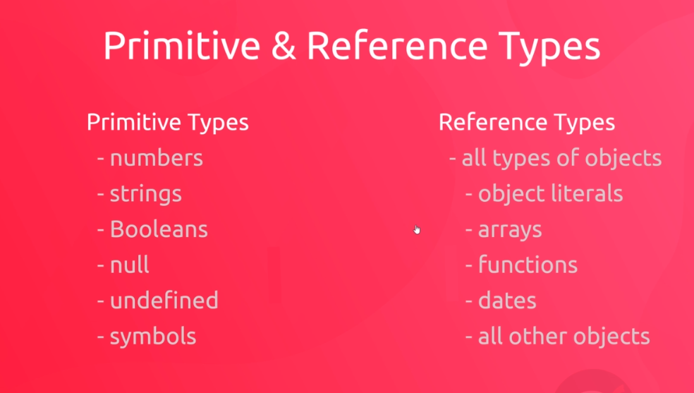

Primitive types are stored on the stack memory, which is smaller (less memory space) yet faster and easier to reach. While reference types, ie: the objects being referenced, are stored on the heap, which is larger(more memory space) but slower to access.

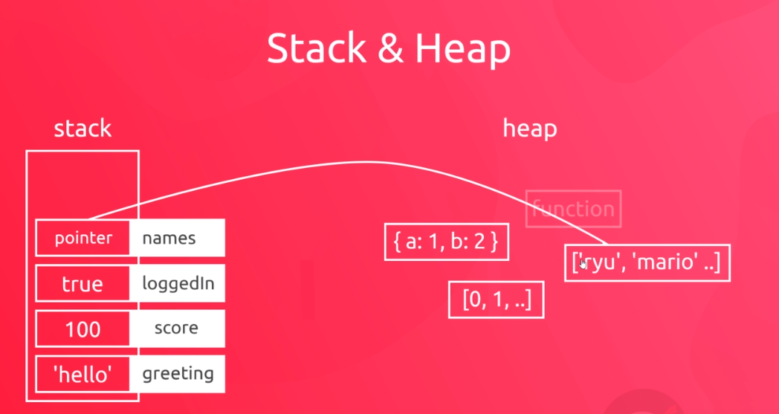

**Storing reference-types:** When we create objects, arrays and functions, the compiler creates the data for the objects themselves on the heap, but it alswo creates the name(the pointer) for said object and functions(as a pointer) inside the stack memory. So objects are created in the heap memory, while the object-names (pointers) are stored on the stack, as the line shows in the image above.

**Storing primitive-types:** Primitive types have their data, and variable names stored directly on the stack, and as such they are deallocated and re-initialized each time we close and reopen our application, that is, they are created and stored on the temporary memory. The same is the case for the pointers, while the objects themselves are stored in the permanent memory.

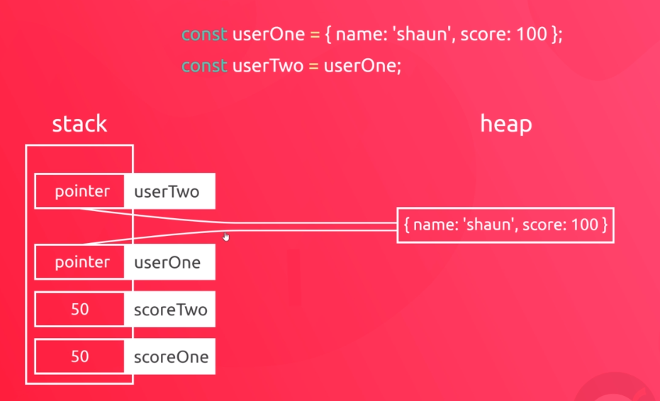

**Assigning primitive types to each other:** If we make copies of primitive values, ie when assigning score1 = score2; the value of score1 is copied to score2, so while their respective value-data is the same, two copies of the value 50 are stored on the stack, each corresponding to their own named variable.

**Assigning object types to each other:** On the other hand, when making copies of reference types (pointers), what happens on the stack is the pointer-data is copied, so “userOne, User2” have the same pointer data, directing to a single-object on the HEAP. So in this case, there are no duplicate objects created. Whenn assigning one objectName to another, you are copying the pointer coordinates, not the object itself.

# **INTERACTING WITH THE BROWSER – Document.Object.Model(DOM)**

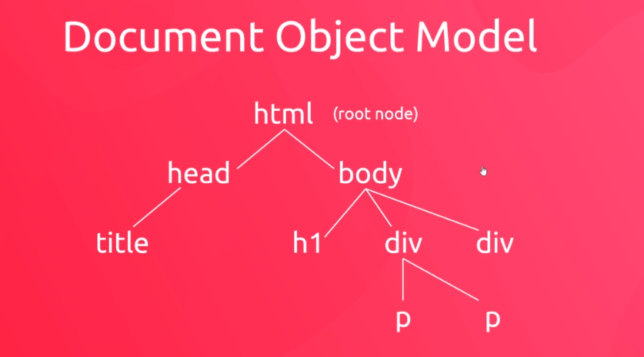

**Querying the DOM:** The action of reaching into the Document Object Model in order to get a reference(handle) for the element we wish to target and modify/change using JavaScript

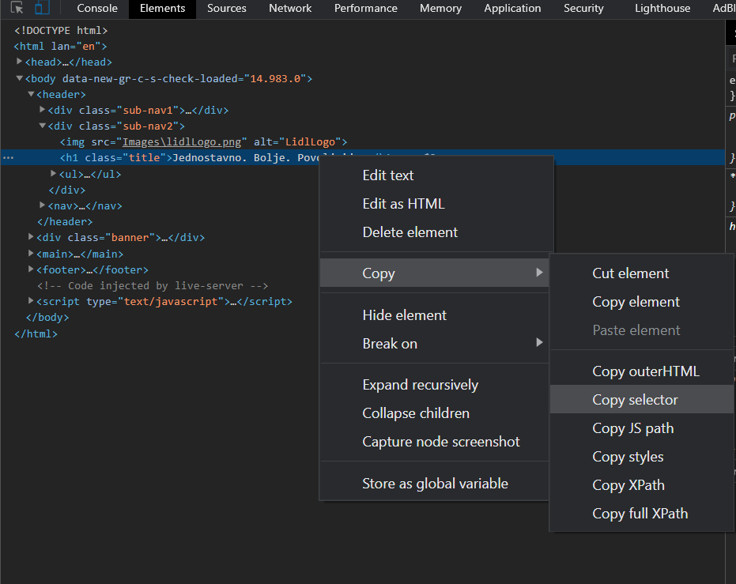

Finding the selector for handling the appropriate element from your HTML can be done either by inserting the appropriate css-selector argument to a documentQuery method, but if you are not sure how to select a specific element, seeing as generally JAVASCRIPT handles **the first** element that corresponds to the stated css-selector argument in the handle-method.

**CSS-Selector reminder:** if you wish to select a very specific element type that bellongs to a certain class (which encompasses more than one element types) you can state the following: **elementName.ClassName{}** -> This selects only the elements of the “elementName” type that have the “ClassName” class defined in their <elementName class=”ClassName”> brackets.

## **////MAIN WAYS TO QUERY THE "DOM"**

//Bellow we have methods used to Query the DOM

//or to handle/select the elements from our html document

## **//QUERY SELECTOR**

//The method below returns only the first <p> element it finds

const paragraph = document.querySelector('p')

//Here the method querySelector('css-selector');

//accepts a css selector to grab a reference to an html element

//what it does is, enter the document->html->first<p>element

//and it stops with the first element it finds that corresponds to the

//css selector, and returns it's handle(reference)

//storing it inside the variable/constant, in this case

## **//QUERY SELECTOR ALL**

//if we wish to handle all of the elements

//that correspond to the query selector

//we simply use the following method:

paragraph = document.querySelectorAll('p');

//It returns a "nodeList[]"collection of references for all p-tags

//Note that the handles are returned as a collection, a nodeList[]

//// nodeList[]  collection>>

//what can we do with the returned nodeList?

//access its individual elements

console.log(paragraph[0]);

//iterate through its elements

paragraph.forEach(function(*paragraph*){

    console.log(paragraph)

});

const errors = document.querySelectorAll('error');

## **////ALTERNATIVE WAYS TO QUERY THE "DOM"**

### **//GET AN ELEMENT BY "ID"**

const title = document.getElementById('page-title');

console.log(title);

//This method only ever grabs a single element(Id's are unique, anyways)

//here we don't need to use the #(hash) sign like we would

//if we used a css-selector, as the # is already implied

//seeing as the method expects an element-ID, so we simply

//forward the id-name, as is.

### **//GET ELEMENTS BY THEIR CLASS NAME**

const errors = document.getElementsByClassName('error');

console.log(errors);

//This returns an "HTMLCollection" for the corresponding

//class. As before, we directly forward the class-name as-is.

// no need to define the (.)Dot, before the class name

### **//HTMLCollection[ ]**

        //It should be noted that we cannot use forEach

        //for an HTML collection, though we can access its elements

        //using a square-bracket notation[], ex: console.Log(errors[0]);

### **//GET ELEMENTS BY THEIR TAG NAME**

const paras = document.getElementsByTagName('p');

console.log(paras);

console.log(paras[1]);

//Note that this method returns an HTMLCollection

// with handles for all elements with the statet tag name

// The downside to this method compared to the QueryAll

// is in the fact that we cannot iterate through our elements

//using the forEach method on HTMLCollection[] returned by

//the above method, while we can iterate using forEach

//on the NodeList[] returned by the queryAll() method

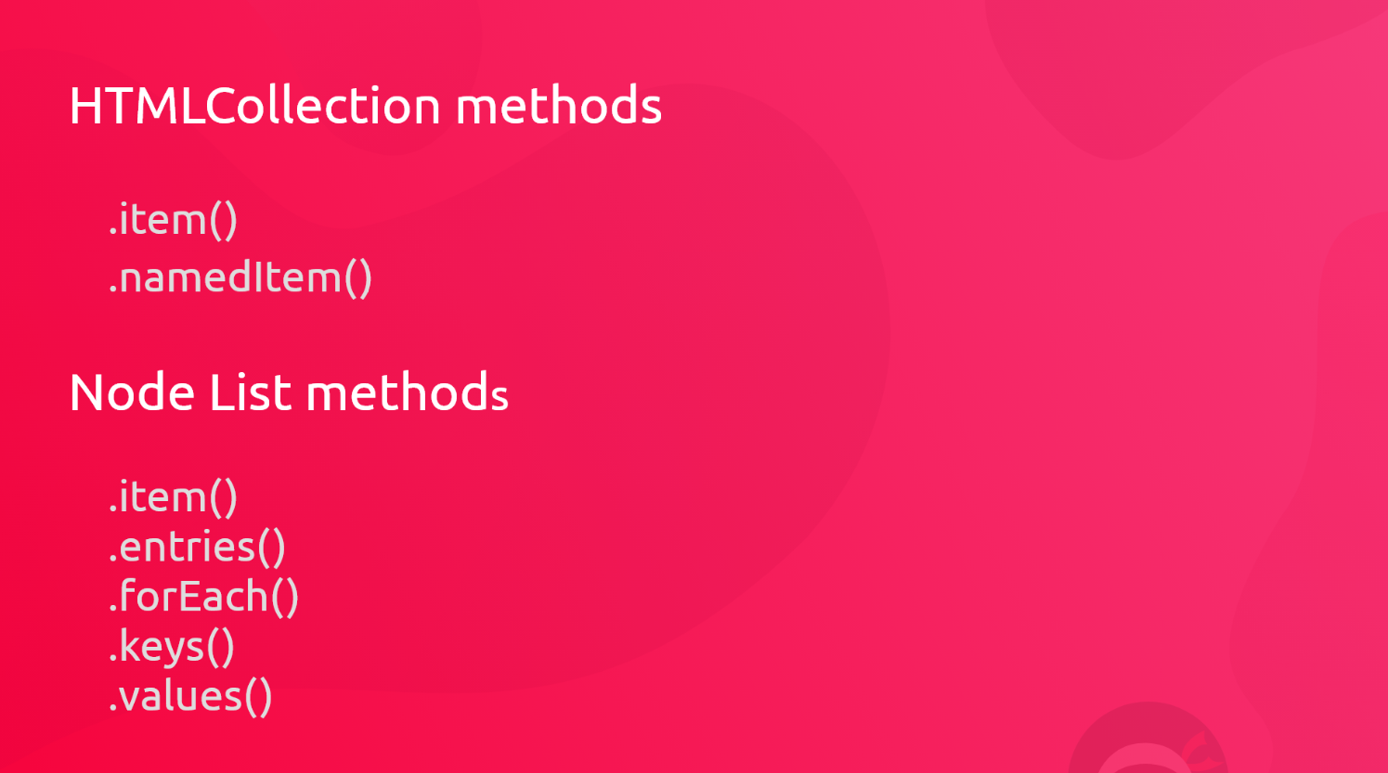

## **INNER_TEXT and INNER_HTML properties**

const paragraph = Document.querySelector('p');

### **//.innerText   ->property  >>>**

//it contains the text within an element

console.log(paragraph.innerText);

//UPDATING(OVERWRITING) THE INNER TEXT OF AN ELEMENT

paragraph.innerText = 'Ninjas are awesome';

//APPENDING THE INNER TEXT OF AN ELEMENT

paragraph.innerText += 'Ninjas are awesome';

//CHANGING THE TEXT OF SEVERAL ELEMENTS AT ONCE>>

//The method bellow logs-out the .innerText within our

//<p> elements

const paragraphs = Document.querySelectorAll('p');

parahraphs.forEach(function(*paragraph*){

    console.log(para.innerText);

})

//The method below updates the values/Append or overwrite

//of the elements returned by our .querySelectorAll()

paragrahps.forEach(function(*paragraph*){

    paragraph.innerText += ' new text';

})

### **//.innerHTML   ->property  >>>**

//note how below we have to use

//the css-class (.) dot to show it is a class we are selecting

const content = document.querySelector('.content');

//OVERWRITING INNER HTML

console.log(content.innerHTML);

//this will log-the html content of our element, ie. <the content inside the brackets>

content.innerHTML = '<h2>This is a new H2</h2>'

//this overrwrites all child-html elements within

// the element referenced by the querySelector

//APPENDING INNER HTML

content.innerHTML += '<h3>This is an h3 bellow the new h2</h3>'

//Now this adds a new html element to the existing elements

//inside the first element with the .content class.

### **//GENERATING HTML TEMPLATES FOR OUR ARRAY ELEMENTS>>**

//for each person in this array, we wish to generate

// a little html template that creates a place for them

//inside the html document

//our array of elements

const people = ['mario', 'luigi', 'yoshi'];

//our handle(reference) on the "conent" class html element

content = document.querySelector('.content');

//Now we are adding an html template inside the

//innerHTML of our "content" class element

people.forEach(function(*person*){

    content.innerHTML+= `<p>${person}</p>`;

})

## **////GETTING AND SETTING HTML_ATTRIBUTES**

const link = document.querySelector('a');

console.log(link.getAttribute('href'));

//above we use the .getAttribute() method to read its value

link.setAttribute('href', 'https://www.thenetninja.com');

//to set/change an html attribute we use the setAtribute()

//method which accepts 2 argumens

//.setAtribute(attributeName, desiredAttributeValue);

link.innerText = 'TheNet Ninja Website';

const mssg = document.querySelector('p');

document.log(mssg.getAttribute('class'));//outputs the attribute class

mssg.setAttribute('class', 'success');

## **//Defining (initializing) an attribute for an html-element**

mssg.setAttribute('style', 'color:green');

//It does not matter above that the attribute does not

//currently exist inside the tag. Whenever we setAttributes

//if they are not present within a tag

//JavaScript will automatically create it for you and assign

//the desired value. Otherwise, the existing attribute's

//value gets updated as expected.

## **///CHANGING THE CSS-STYLE PROPERTIES**

const title= document.querySelector('h1');

//With the .setAttribute() method, we have a problem with

//setting those attributes that may have more than one

//value for an element. For example inline "style="attribute

//often has more than one css rule within it.

// Now if we wish to change anything to the style attribute

//using the .setAttribute() method would mean that

// all of the set "style= value1 value2... value(n)"

//would get overwritten by the single value set by the method

//title.setAttribute('style', 'margin: 50px');

//This problem is circumvented by being more specific with

//the (in this case) "style" attribute-property we are setting

// note bellow how our title(handle) has a style html-property

//which itself has all css-style-properties to choose from

console.log(title.style);

## **//example of style property's -cssProperties**

console.log(title.style.color);

console.log(title.style.background-image);

title.style.margin='50px';

title.style.color='crimson';

title.style.fontSize = '60px';

//Note how "font-size: " property would in JAVASCRIPT

//translate to a mathematical: subtract 'size' from 'font'

//so when these properties appear in JAVASCRIPT synthax

//they have to be written in "camelCase" instead of "camel-Case"

## **//DELETING STYLES**

title.style.margin= ''; //we set it to an empty string

                        //thus removing the property

## **ADDING AND REMOVING CLASSES**

const content = document.querySelector('p');

//handle(reference) property that returns a list

//of all the classes an element has

console.log(content.classList);

## **//ADDING A CLASS**

content.classList.add('error')

//if a class attribute is not defined JS will add both

//the class-attribute and class-value

## **//REMOVING A CLASS**

content.classList.remove('error');

**//EXERCISE(1)** Create a handle that references the following

//<p> elements, a find a way to assign each element

//that contains an error/success a class of error/success

//respectively.

/*

<p>Lorem error ipsum</p>

<p>lorem success ipsum</p>

<p>lorem ipsum lorem</p>

<p>lorem ipsum success</p>

<p>error lorem ipsum</p>

<p>lorem ipsum lorem</p>

<p>lorem ipsum error</p>

<p>success lorem ipsum</p>

*/

//The classes are going to enforce the following css rules on said <p> tags

.error{

    padding: 10px;

    color: crimson;

    border: 1px dotted crimson;

}

.success{

    padding:10px;

    color: limegreen;

    border: 1px dotted limegreen;

}

const paragraphs = document.querySelectorAll('p');

//this returns a node list, and we can use a .forEach(/)

//on this node list

//Solution1. using innerText property

//Note that innerText can only "get" the visible text

//within an element

paragraphs.forEach(function(*paragraph*){

    if(paragraph.innerText.includes('success')){

        paragraph.classList.add('success');

    }

    else if(paragraph.innerText.includes('error')){

        paragraph.classList.add('error')

    }else{

        paragraph.classList=''; //sets the list to an empty string

    }

})

//Solution2. using TextContent property

//This returns all the text content, regardless if it is

//hidden or not.

paragraphs.forEach(function(*paragraph*){

    if(paragraph.textContent.includes('success')){

        paragraph.classList.add('success');

    }

    else if(paragraph.textContent.includes('error')){

        paragraph.classList.add('error')

    }else{

        paragraph.classList=''; //sets the list to an empty string

    }

})

## **//.toggle() METHOD**

const title= document.querySelector('.title');

title.classList.toggle('test');

title.classList.toggle('test');

//calling the above method is iterating each time

//through true/false, so how it works:

//if(toggle===true){ title.classList.add('test); toggle= !toggle;}

//    else{title.classList.remove('test'); toggle =!toggle;)}

//each time we call the toggle-method it adds/removes the stated class

## **NODE RELATIONSHIPS**

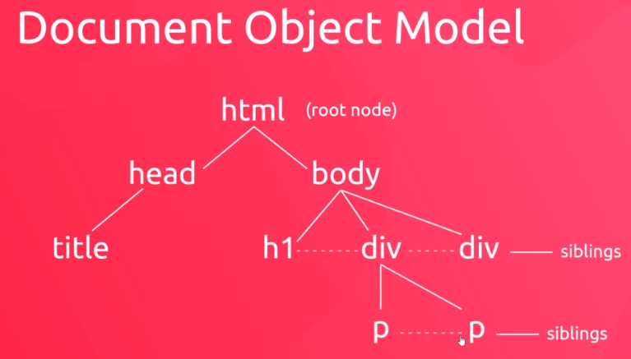

16 Above: The sibling node relationship

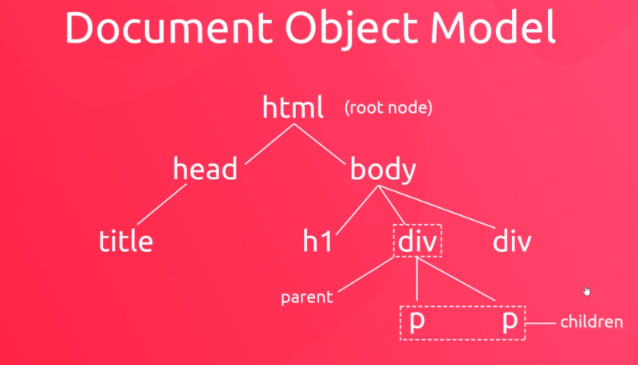

17Above: the parent/child node relationship

## **//Parent Children and Sibling relationships**

const article = document.querySelector('article');

//FINDING THE CHILDREN ELEMENTS>>

console.log(article.children);

//the .log above will log out all the children elements from

// the first <article> tag within the html document

//regardless of the type of tag they are.

//NOTE: article.children -> property returns an HTMLcollection

//HtmlCollection cannot be iterated using .forEach()

//so we need to find a way to iterate through this collection

## **//CONVERTING HTML_COLLECTION INTO AN ARRAY**

//THE Array.from(example: htmlCollection);

//Here we will use the Array class method

//that turns the input argument collection into an array output

// by creating a new copy of the collection as an array type

//and returning it.

//This means that this method is not destructive, and as such

//our original collection data is untouched, with the

//output-array representing its copy, in an array-datatype

console.log(Array.from(article.children));

### **//CLASS LIST**

//since the method below returns an Array

//we can directly use a .forEach(); method on the

//Array.from(input) -> method call

Array.from(article.children).forEach(function(*child*){

    child.classList.add('article-element');

    //this will give each element from the array "children"

    //the class "article-element". Remember how these are all

    //the elements inside the parent "article"

});

## **//FINDING THE PARENT ELEMENT>>**

const title=document.querySelector('h2');

console.log(title.parentElement);

//returns its parent element handle(reference)

## **//CHAINING parentElement METHODS, PSEUDO RECURSIVELY>>**

console.log(title.parentElement.parentElement);

//returns the parent-element handle of the parent of the

//element referenced in the "const title"

//In other words, returns the parent(handle) of the parent

/**/FINDING THE SIBLING ELEMENTS**

//Sibling elements are the elements (their tag type is irelevant)

//that exist in the same node level.

console.log(title.nextElementSibling);

console.log(title.previousElementSibling);

//These properties return the next/previous element within a

//parent container <body><div><article>etc...

//of the handle that envokes the property,

// in this case "h2 tag reference stored in "title" const"

//and the order is from top down, above or left is previousElememnt

//while the element below or to the right is the next element.

## **//CHAINING PARENT AND SIBLING RELATIONSHIPS**

console.log(title.nextElementSibling,parentElement.children);

//this selects the next element, then it's parent element, then

//it gets all the child-elements from said parent and returns them

//as an HTMLCollection

## **STEPS TO ENABLE AND EXECUTE EVENT HANDLING IN JAVASCRIPT**

1. **Query the DOM** 
   1. To get the handle of the element we expect the event to happen at
2. **Add an EventListener**
   1. It actively listens to user events triggered at the specified element
3. **Write a Callback function** 
   1. that will fire when the event happens

## **EXERCISE(2) EXAMPLE OF HANDLING AN EVENT**

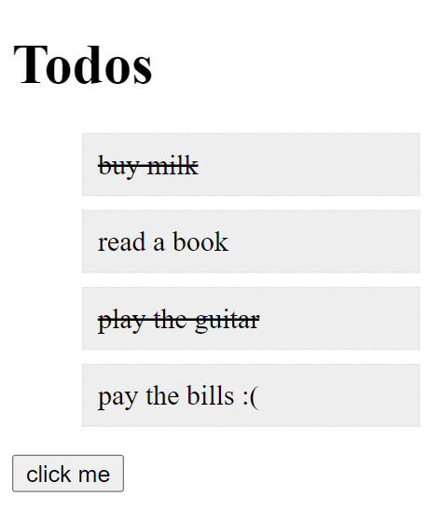

Create a Todo list similar to the one above, and write JS code that will strike-through the text within the <li> elements on the list when the user generates a click event on any one of them. If the clicked element is already striked-through, the click event handler should instead remove the strike-through line, in a sense making it toggleable. Note: In the image above the <li>read a book</li> has been clicked on, twice.

**//EXERCISE(2)SOLUTION:**

const button = document.querySelector('button');

//the first argument defines what event the method is listening for

//in this case it's "click" - event

//the second argument is a callback function that tells

//the method what to do in the case of the event triggering.

button.addEventListener('click', function(){

    console.log('you clicked me');

})

const items = document.querySelectorAll('li');

items.forEach(function(*item*){

    item.addEventListener('click', function(*event*){

        console.log(event.target);

    //The Event-listener callback function accepts an event object

    //generated from the EventListener method

    console.log(item);

    //we also have acces to the item itself

    //from the node list

    //below we have declared a toggle-able textDecoration rule

    //for the style property of each target element

    // in the cycle that triggered the event listener object

    //it crosses off the text of the element on-click

    //and uncrosses it when we click again

    if(item.style.textDecoration.includes('line-through')){

        event.target.style.textDecoration ='';

    }  else{

        event.target.style.textDecoration = 'line-through';

    }

    });

});

### **//THE EVENT OBJECT**

//Each time an event is triggered the event listener

//generates an event-object, In JScript this object has

// its own set of properties and methods, like any other object

### **//EVENT OBJECT TARGET PROPERTY**

//below we could see that we have selected the target property

// of an event-object we named "event", and this

//target property returns an entire html element and it's content

//of the element that had triggered the event-object, it returns the same value //it returns the same element that our “item” object returns: “item==event.target”

const items= document.querySelectorAll('li');

items.forEach(function(*item*){

    item.addEventListener('click', function(*event*){

        event.target.style.textDecoration='line-through';

    }) })

## **CREATING AND REMOVING ELEMENTS**

const button = document.querySelector('button');

const ul = document.querySelector('ul');

button.addEventListener('click', function(){

    ul.innerHTML +=`<li> New task </li>`;

### **//INSERTING AN ELEMENT WITHOUT WRITING  AN HTML TEMPLATE**

    // we create a new object, containing a <li> element

    const li = document.createElement('li');

    li.textContent = 'something new to do';

    ul.append(li);

    //this appends the li element putting it at the bottom

    ul.prepend(li);//this puts the li element at the top

})

### **//.remove() METHOD**

// .remove() method fully removes the referenced element

//when we click on it in the page from the page

//Note that removed elements via JavaScript retrn once

//the page has been refreshed. We are simply defining

//the way our website behaves, not destructively changing

//it's layout.

let items= document.querySelectorAll('li');

//note that here we are using a .forEach method so that we

//wouldn't have to manually create an EventListener for

//each <li> item in an <ul>.

//ForEach() here is just a shorthand way of writing an

//event listener for each <li> element.

items.forEach(function(*item*){

    item.addEventListener('click', function(*event*){

        event.target.remove();

        //this will remove the clicked element from the todo list

    })

})

## **EVENT BUBBLING**

The event starts at the event target (the clicked element) and javascript checks if there is an event listener set for the targeted element. If the element has an event listener, javascript executes the callback function within the eventListener. But the story does not end there, next Javascript checks if the parent element of the event,target contains an event listener, and if it does, it executes the callback function of the parent element’s eventListener, and so on and so forth it travels up through parent bubbles until there are no parents/bubbles left.

In other words, events function in the following manner:

The event listener callbackFunction of the eventTarget is checked then (if it exists) executed.The same is done for its parent and its parent’s parent, and so on and so forth until there are no parent elements left.

So in Javascript events basically bubble up from executing the target callback function of the child, to also executing the callback function of their parent as well

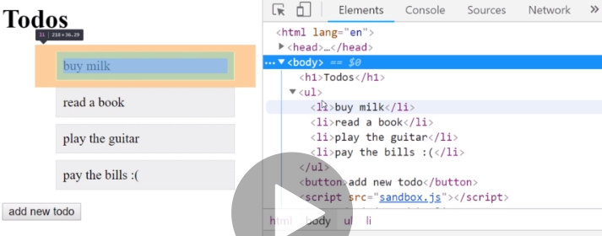

In the above example, were we to set a “click” event on an <li> tag, and also set a “click” event on its <ul> parent. If we click on a li tag, javascript would execute the event-callback function for the <li> tag, but it would also automatically execute the parent (<ul>) tag’s callback function for its own “click” event.

**EVENT BUBBLING UP VISUAL EXAMPLE:**

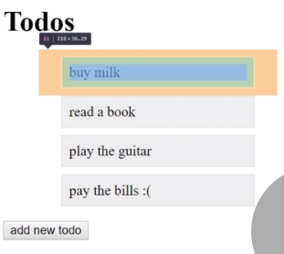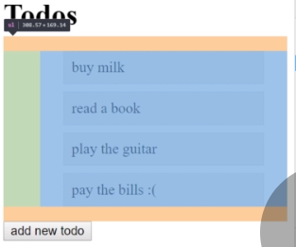

<li> event.Target element bubble

<ul> parent bubble

To stop the bubbling up effect of child event triggering it’s parent event, we can simply envoke the **event.stopPropagation();** method on the event-object when we don’t want the event trigger to bubble up to the parent element. To be more specific we use the .stopPropagation(); method on the eventTarget where we wish to end the cycle. In the example above, if we don’t want the event from <li> to bubble up to its parent <ul> element, we need to envoke liEvent.stopPropagation In the event handler for the <li> tag.

const ul = document.querySelector('ul');

const items = document.querySelectorAll('li');

items.forEach(function(*item*){

    item.addEventListener('click', function(*event*){

        event.target.remove();

        event.stopPropagation();

    });

});

## **ALTERNATIVE TO ATTACHING EVENT LISTENERS TO EVERY ELEMENT**

Since we have thus far needed to attach event listeners to any element we wish to trigger an event for, or handle the events that can trigger on them, we may notice that this works, but is also incredibly manual and time consuming approach, as well as constly (memory wise) to attach eventListeners to many elements on the page. Apart from the memory cost, any dinamically created (javaScript inserted) html element, will not automatically have eventListeners attached to them.

Because of the beforementioned disadvantages, let’s take a look at an alternative approach:

There is a reason **EventBubbling** exists. And the reason is in the fact that we may only attach one eventListener to a parent element. Trigger an event inside its child element, and we are guaranteed that the parent-element’s event will triger as well. This is good. But how will we know which child element triggered the event if the chidren elements don’t have **eventListeners** attached to them? Simply, we can learn where the event was triggered by accessing the **event.target** property of the parent event-handler.

This means that we only need to set-up **eventListeners** for the parent elements, and within them we can find the specific element that triggered the event by using the **event.target** property.

**Example alternative (better) approach below:**

const ul = document.querySelector('ul');

/*

const items = document.querySelectorAll('li');

items.forEach(function(item){

    item.addEventListener('click', function(event){

        event.target.remove();

        console.log('event in li');

        event.stopPropagation();

    });

});

*/

ul.addEventListener('click', function(*event*){

    //console.log('event in ul');

    console.log(event.target);

})

## **EXERCISE(3)**

Write a script code for the html markup below, that will remove a <li> element that triggered a ‘click’ event, by only using a single EventListener(); on the <li> parent element (<ul>).

   <ul>

            <li>buy milk</li>

            <li>read a book</li>

            <li>play the guitar</li>

            <li>pay the bills :( </li>

        </ul>

**Solution(3)**

const ul = document.querySelector('ul');

ul.addEventListener('click', function(*event*){

    if(event.target.tagName==='LI');//TAG_NAME IS IN CAPS!!!

        event.target.remove();

})

We found the element that triggered the ‘click’ element via event.target property. To make sure that the clicked element is a <li> tag, and not some random click on the <ul> element itself, we place an if-clause within the callback function of the event handler that checks if the event.target element’s .tagName property is **exactly** equal to ‘LI’ (the tagName property value is always in capital letters) and in the case that it is, we safely remove the clicked <li> tag using the .remove(); method on the event.target

## **MORE DOM EVENTS**

### **COPY EVENT**

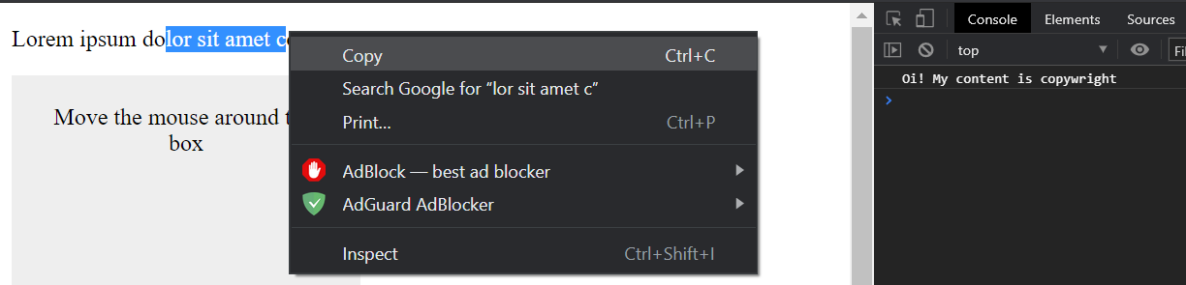

const copy = document.querySelector('.copy-me');

copy.addEventListener('copy', function(){

    console.log('Oi! My content is copywright');

})

### **MOUSE MOVE (Hover) EVENT**

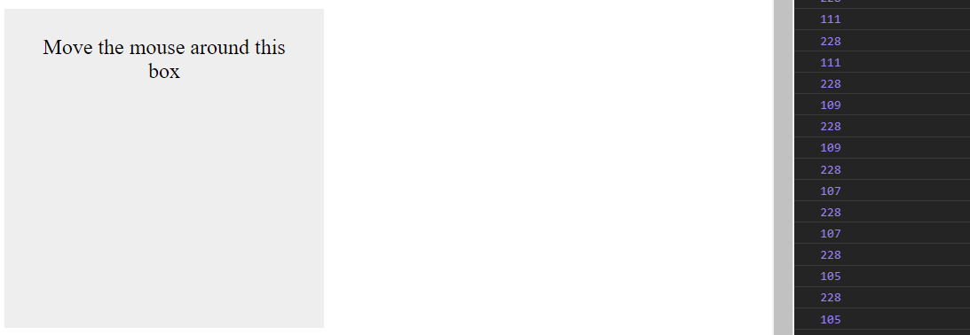

const box = document.querySelector('.box');

box.addEventListener('mousemove', function(*event*){

    console.log(event.offsetX);

    console.log(event.offsetY);

})

Logs the x and y coordinates. offsetX being the number of pixels away from the left edge of the box, while offsetY being the number of pixels away from the top edge.

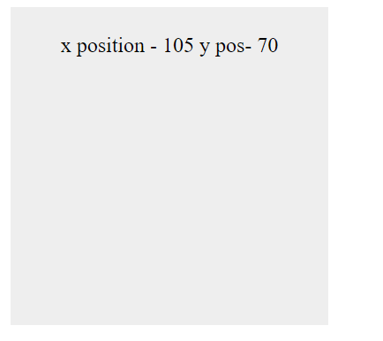Alternatively we can set the text content of the box class div to show the x and y positions to it as the mouse hovers (mousemove) over the box.

const box = document.querySelector('.box');

box.addEventListener('mousemove', function(*e*){

    box.textContent = `x position - ${e.offsetX}  y pos- ${e.offsetY}`;

})

### **WHEEL EVENT (SCROLL)**

This event is connected with the HTML document itself. This means that if we wish to monitor and handle the scroll action on the webpage we need to add an eventListener to the document-object.

document.addEventListener('wheel', function(*e*){

    console.log(e.pageX, e.pageY);

});

Note that the properties .**pageX** and .**pageY**  give us the position of the edges of our viewport x(the left edge) y(the top edge) relative to the left and top position of the webpage (document) itself.

## **EXERCISE(4)**

Create a website popup like in the images bellow. The popup should “pop” up when the user presses the red button and not display on the webpage otherwise( default is display: none. It should cover in a dark overlay the entirety of the webpage behind it, and close only if the user clicks on the x icon on the top right corner of the popup. Try to style it to match the example images below. Have fun!

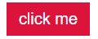

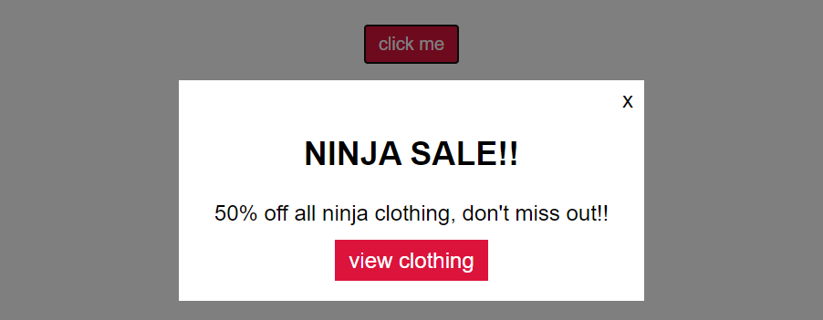

**Html solution(4):**

<!DOCTYPE html>

<html lang="en">

    <head>

        <link rel="stylesheet" href="styles.css">

        <meta name="viewport" content="width=device-width initial-scale=1.0">

        <meta http-equiv="X-UA-Compatible" content="ie=edge">

        <title>Document</title>

    </head>

    <body>

        <button>click me</button>

        <div class="popup-wrapper">

            <div class="popup">

                <div class="popup-close">x</div>

                <div class="popup-content">

                    <h2>NINJA SALE!!</h2>

                    <p>50% off all ninja clothing, don't miss out!!</p>

                    <a href="#">view clothing</a>

                </div>

            </div>

        </div>

     <script src="sandbox.js"></script>

    </body>

</html>

**JAVASCRIPT SOLUTION(4)**

const button = document.querySelector('button');

const popup = document.querySelector('.popup-wrapper');

const close = document.querySelector('.popup-close');

button.addEventListener('click', function(){

    popup.style.display='block';

});

close.addEventListener('click', function(){

    popup.style.display='none';

});

**CSS solution(4)**

button {

    display:block;

    margin: 20px auto;

    background: crimson;

    color: white;

    border: 0;

    padding: 6px 10px;

}

.popup-wrapper{

    background: rgba(0,0,0,0.5);

    /*rgbAlfa-channel (opacity ranges from 1-normal to 0-invisible)*/

    position: fixed;

    top:0;

    left:0;

    /*top, left at zero means it starts at the top left corner of the screen

     or the very begining, and with height and widht below, spans the entire page*/

    width:100%;

    height:100%;

    display:none; /*we don't want the popup to be visible by default*/

}

.popup{

    font-family: arial;

    text-align: center;

    width:100%;  /*for small screens it will take up 100%*/

    max-width: 300px; /*for larger screens it will stay at 300px */

    margin:10% auto; /*centers it on screen*/

    padding: 20px;

    background: white;

    position: relative; /*this is to position something as "absolute" inside it*/

}

.popup a{

    background: crimson;

    color: white;

    text-decoration: none;

    padding: 6px 10px;

}

.popup-close{

    position: absolute;

    top: 5px;

    right: 8px;

    cursor: pointer;

}

## **(QUERYING ONLT THE SCOPE OF AN ELEMENT) ENVOKING QUERY SELECTOR ON AN ELEMENT HANDLE**

### **ACCESSING CHILD ELEMENT TAGS BY ENVOKING .querySelector() on their parent element handle.**

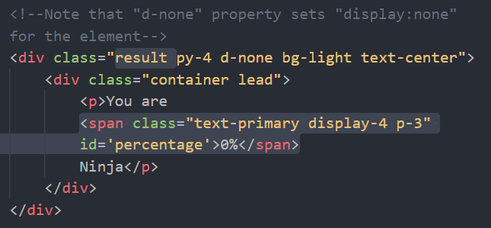

Say that we wish to access and change “0%” –textContent within the <span> element that is inside the <div class=”result…”> as in the picture above. We can get a handle for the parent element:

const result = document.querySelector('.result');

and navigte through his child elements using the child/sibling hierarchy properties as demostrated below: result.firstElementChild.firstElementChild.firstElementChild.textContent=”new";

Though a simpler way would be to envoke the querySelector(); on the parent element handle “const result” and input the argument ‘span’ so it would grab the reference for the first <span> element within the scope of the parent element <div class=”result …”>

const result = document.querySelector('.result');

result.querySelector('span').textContent=”new”;

# **THE WINDOW GLOBAL OBJECT**

Pretty much everything we create for front-end javascript will be stored in the allfather “Window” object class. Very similar to the “Object” class in C#

Like in C#, where everything is basically object.etc, in Javascript the window. Is inferred, being the global object and the fact that all other objects come out of it, we don’t have to write out window.windowProperty, as the (window.)Is , again, inferred. So just writing out the name of the “windowProperty” as is is good enough for you to get/set them.

console.log("hello"); IS THE SAME AS WRITING : window.console.log("hello");

document.querySelector('form'); 🡨 🡪   window.document.querySelector('form');

alert('hello!'); 🡨 🡪   window.alert('hello');

So, whenever we see in a JScript code an envocation of a function without an object attached to it, it is either a user created function Or a window.method(); where the window object is inferred. In other words, whenever we call a method without an object attached, it is a window.Method();

## **//SET INTEVAL METHOD**

This method accepts two arguments:

**window.setInterval(callbackFunction(), miliseconds);**

and in intervals of the set amount of miliseconds it executes whatever code is stored within the first argument/callbackFunction

setinterval(function(){

    console.log('hello');//logs hello every 1000milisecons (1second)

}, 1000 );

## **//CONTROLING THE NUMBER OF INTERVALS OF A SET-INTEVAL METHOD**

let i = 0;

const timer = setinterval(function(){

    console.log('hello');

    i++;

    if(i=== 5){

        clearInterval(timer);

    }

}, 1000 );

//description:

//We've initialized a counter to 0, and stored the method witihn

//a constant/variable.

//inside the callback function of the setInterval(); method

//we are logging 'hello' each 1000miliseconds(the second iinput argument)

// after loging 'hello' the counter is incremented by 1

// after the counter has been iterated we set up a conditional if(clause)

//the if clause checks if the counter has reached a value at which

//we wish our interval to stop working.

//if it has, we call a window method clearInterval();

//and as is first argument enter the constant/variable where

//we've stored the setInterval method.

//now the clearInterval(); method stops the interval from firing again

NINJA QUIZ APP CODE

const correctAnswers = ['B', 'B', 'B', 'B'];

const form = document.querySelector('.quiz-form');

const result = document.querySelector('.result');

form.addEventListener('submit', function(*e*){

    e.preventDefault();//stops 'submit' event from refreshing the page

    //LOAD ANSWERS

    let score = 0;//default score will be 0

    const userAnswers = [form.q1.value, form.q2.value, form.q3.value, form.q4.value];

    //CHECK ANSWERS

    //remember that we can get the value(answer) and its index

    userAnswers.forEach(function(*answer*, *index*){

        if(answer === correctAnswers[index]){

            score +=25;

        }

    });

    //SHOW RESULT ON PAGE

    scrollTo(0,0); //scrollTo(x-Axis, y-Axis);

    result.classList.remove('d-none');

    let output = 0;

    const timer = setInterval(function(){

        result.querySelector('span').textContent=`${output}%`;

       if(output ===score){

           clearInterval(timer);

       }else{

           output++;

       }

    },10);

});

//HOW THE "SHOW RESULT ON PAGE" WORKS

//scrollTo(); sends the user to the top of the page

//result.classList.remove('d-none); removes the class

//that hides the <div> container where our score is displayed

//'let output =0;' we initialize a variable that will

//output the score in the <span> textContent property, where we display

//the score.

//next we create a constant "timer" where we load a

//setInterval(); window method

//within the setInterval(callbackFunction());

//we take a reference for our <span> element

//and we do this by using the querySelector(); over our

//"result" <div class="result"> handle  and search for

//the first <span> element within the <div class ="result">

// result.querySelector('span')    and directly access

// the textContent property of the handle:

// result.querySelector('span').textContent = `${output}%';

//setting its value to the value of our 'output' variable.

//now our output variable is initially 0

//and we want it to increment to the final score our user

//got after he submited his quiz.

//the user's score is stored in the variable 'score'

//Now we want the output to display on the page and increment

//from 0% to (100% ex) the user's score, incrementing

//by one % until it reaches the score.

// We do this by incrementing the output++ as long as the

// output is lesser than the user's 'score'

//if(output ===score){

//    clearInterval(timer);

//}else{

//   output++;

//}

// if the output value is equal to the score

// the Interval will stop iterating and output will not

//iterate again.

**HTML**

<!DOCTYPE html>

<html lang="en">

    <!-- BOOTSTRAP CLASSES

        ////TOP SECTION////

        Bstrap classes py3(padding y-axis) bg-white(whiteBackground)

        ".container"(keeps our text in a central column)

        "text-primary"(primary text)

        ".display-3"(display text)

        ".my-3"(margin y-axis of 4[bootstrap strenght value])

        ".text-white-50"(white text color with opacity=50 so half the opacity)

        ////QUIZ SECTION////

    -->

<head>

    <!--BOOTSTRAP LIBRARY LINK -->

    <link rel="stylesheet" href="https://cdn.jsdelivr.net/npm/bootstrap@4.5.3/dist/css/bootstrap.min.css" integrity="sha384-TX8t27EcRE3e/ihU7zmQxVncDAy5uIKz4rEkgIXeMed4M0jlfIDPvg6uqKI2xXr2" crossorigin="anonymous">

    <!---------------------------->

    <meta charset="UTF-8">

    <meta name="viewport" content="width=device-width, initial-scale=1.0">

    <title>Document</title>

</head>

<body>

     <!-- Top Section -->

    <div class="intro py-3 bg-white text-center">

        <div class="container">

            <h2 class="text-primary display-3 my-4">Ninja Quiz</h2>

        </div>

    </div>

    <!--result section-->

    <!--Note that "d-none" property sets "display:none" for the element-->

    <div class="result py-4 d-none bg-light text-center">

        <div class="container lead">

            <p>You are

            <span class="text-primary display-4 p-3" id='percentage'>0%</span>

            Ninja</p>

        </div>

    </div>

   <!--Quiz section-->

   <div class="quiz py-4 bg-primary">

       <div class="container">

         <h2 class="my-5 text-white">On with the questions</h2>

        <form class="quiz-form text-light">

            <!--QUESTION 1-->

        <div class="my-5">

            <p class="lead font-weight-normal">1.How do you give a ninja directions?</p>

            <div class="form-check my-2 text-white-50">

                <!-- Labels here are tied to imputs via form-check/form-check-label BS classes-->

                <input type="radio" name="q1" value="A" checked>

                <label class="form-check-label">Show them a map</label>

            </div>

            <div class="form-check my-2 text-white-50">

                <input type="radio" name="q1" value="B">

                <label class="form-check-label">Don't worry, a ninja will find you</label>

            </div>

        </div>

            <!--QUESTION 2-->

        <div class="my-5">

            <p class="lead font-weight-normal">2.If a ninja has five 3 apples and gives one to mario & one to Yoshi, how many apples does a ninja have left?</p>

            <div class="form-check my-2 text-white-50">

                <input type="radio" name="q2" value="A" checked>

                <label class="form-check-label">One apple</label>

            </div>

            <div class="form-check my-2 text-white-50">

                <input type="radio" name="q2" value="B">

                <label class="form-check-label">3 apples and two corpses</label>

            </div>

        </div>

            <!--QUESTION 3-->

        <div class="my-5">

            <p class="lead font-weight-normal">3.How will you recognize a Ninja?</p>

            <div class="form-check my-2 text-white-50">

                <input type="radio" name="q3" value="A" checked>

                <label class="form-check-label">You'll recognize the outfit</label>

            </div>

            <div class="form-check my-2 text-white-50">

                <input type="radio" name="q3" value="B">

                <label class="form-check-label">The grim reaper will tell you</label>

            </div>

        </div>

              <!--QUESTION 4-->

            <div class="my-5">

              <p class="lead font-weight-normal">4.What is a ninja's favorite array method?</p>

              <div class="form-check my-2 text-white-50">

                  <input type="radio" name="q4" value="A" checked>

                  <label class="form-check-label">.forEach();</label>

              </div>

              <div class="form-check my-2 text-white-50">

                  <input type="radio" name="q4" value="B">

                  <label class="form-check-label">.slice();</label>

              </div>

            </div>

            <div class="text-center">

                <input type="submit" class="btn btn-light">

            </div>

        </form>

        </div>

   </div>

    <script src="app.js"></script>

</body>

</html>

**FORMS & EVENTS**

## **EVENTS INSIDE OF FORMS**

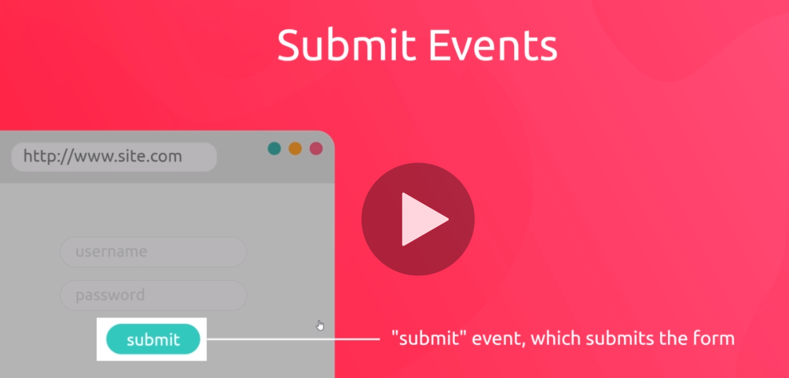

**HTML**  
<!DOCTYPE html>

<html lang="en">

    <head>

        <link rel="stylesheet" href="styles.css">

        <meta name="viewport" content="width=device-width initial-scale=1.0">

        <meta http-equiv="X-UA-Compatible" content="ie=edge">

        <title>Document</title>

    </head>

    <body>

        <!--

            When we are listening for a submit-event,

            we attach an eventListener to the form-itself

         -->

        <form class="signup-form">

            <input type="text" id="username" placeholder="username">

            <input type="submit" value="submit">

            <!--When the user clicks the submit input, it fires a submit-event-->

        </form>

     <script src="sandbox.js"></script>

    </body>

</html>

**JAVASCRIPT**

//if we attach a click event to the submit button

//the event would only trigger if the user clicks on the<button>

//but if we attach a submit event to the <form> itself

//the event will trigger if the user clicks the submit

//button, or if the user clicks the "enter" key, as both

//will trigger the submit event from the submit-input type

//Default action for the submit-button is "PAGE-REFRESH"

//so for it to do anyhing else, e need to handle the default

//action somehow.

//We do this by envoking the e.preventDefault(); method

const form = document.querySelector('.signup-form');

const username = document.querySelector('#username');

form.addEventListener('submit', function(*e*){

    e.preventDefault(); //prevents default page-refresh

    console.log(username.value);    //returns user-input string

});

## **//Getting child element handles using .DotNotation**

//There is a way to reference the <input #username>

//within the <form> without using a separate querySelector

//We simply select the form-handle + (.)dot + TargetelmentID+

//This .Notation attaches to element ID and element NAME properties

// <input name='username'/id='username'> for both of these

//properties the dot notation reference would be

// -->  parentElement.username

const form = document.querySelector('.signup-form');

form.addEventListener('submit', function(*e*){

    e.preventDefault();

    console.log(form.username.value); //logs out the string-value

});

**CSS**

body{

    background:#eee;

}

form{

    max-width:200px;

    margin:40px auto;

    background: white;

    padding:10px;

}

input{

    display:block;

    margin:10px auto; padding:4px;}

## **Regular expressions**

All regular expressions start with a right (forward slash) and end with a right forward slash +gm

**(/ regEx /gm)**

### **String validation**

If we wish to control an input to allow only inputs that contain the strings of characters: “ninja” in that exact order, anywhere in the input text for example, then we do the following:

**/ ninja /gm**

If we wish to allow (validate) only the word “ninja” and nothing else

**/^ninja$/gm**

(^) tells the validator where we wish our word(string) to start

($) tells the validator where we wish our(string) to end.

In the example above (^) is at the start of the expression and ($) at the end, Which means that we want the word to start at the beginning of the input field, an also end at the end of the input field. In other words, we only want the validation to accept that word and nothing else before or after it.

### **Character(char) validation**

To validate single characters we place our validation rule in sqare brackets [ ] and the rule inside them applies to a single character

**/^[a-z]$/gm**

In the example above the regEx states that the character should be the first and last input in the user-input control (nothing can come before **/^** or after **$/**gm it. The rule for the character it contains tells us the following **[a-z]** 🡪 allow any single [] alphabet character ranging from the letter a(including a) to z(including z).

Were we to place [a-d], the only valid inputs in the input field would be (a, b, c,d), for example in a questioneer or a test with multiple choice questions, where it wouldn’t make sense to enter numbers or other characters or letters (if there are only four available answers)

### **If we want to allow capital letters as well**

**/^[a – z A - Z]$/gm**

### **If we want to specify a length of a word using the set range of characters**

**/^[ a – z A –Z]{6, 10}$/gm** This would accept any single word, with capital letters, that is between 6-10 letters long.

### **If we want to allow numbers in the single input word**

**/^[ a – z A –Z 0 - 9]{6, 10}$/gm**

### **If we want to allow special characters**

.(dot) symbol in regular expressions means that any character is permitted/accepted

**/^.{6,10}$/gm**

The above states that the user may enter a single six to 10 letter word using any characters numbers or letters. So anything between 6 to 10characters will match and validate.

## **TESTING REGULAR EXPRESSION**

//We will endevour to create a regular expression that checks

//if the submitted word has at least six letters and makes sure it is

//all lowecase letters

### **//regEx .test(); method>>**

//this method is envoked on a constant/variable that contains

//our "regular-expression" in the example below

//our regular expression is stored in the "pattern" variable

//When we envoke the pattern.test(); method, the method accepts an

//input argument. It can be any string input, but more imporantly

//it is the input we wish to test. Since we are creating a username input

// we create a username-example constant that we wish to constrain

// using our regEx pattern. If the .test(); Regex method returns "true"

//we know that we've used the appropriate expression that will be able

//to check and accept our created username example.

//Alternatively we may create a username example we wish to reject

//as a username, in which case pattern.test(usernameExample); returning false

//is proof that our regEx expression works.

const testUsername= 'shaun';

//creating a regular expression (storing it in a constant)

const regExPattern = /^[a-z]{6,}$/;

//result will be boolean true/false

//depenant on the true/false return value of .test();

let result = regExPattern.test(testUsername);

if(result){

    console.log('regex test passed :)');

}else{

    console.log('regex test failed :( ');

}

## **//THE .search(regExPattern); RegEx METHOD**

//Alternatively we don't have to use the regExPattern

//and test the username on it

//We can use the username itself, and test the regEx pattern

//on the username, effectively reversing the process

//demonstrated before.

//For this purpose we are using the .search(); method

//which searches the string on which the method was envoked on

//for a value that corresponds to its regularExpression argument

//If it finds the value within its envokation variable

//it returns an integer. And the integer it returns represents

//the position on which it finds a match.

//If we don't get a match it returns (-1)

//if our regex expression specifies that our valid input

//must begin in the first position (/^) than the only

//return value we can expect from .search(); method

//will be (-1) -> no match, or (0) -> match at the first position

result = testUsername.search(regExPattern);

## **EXERCISE(5)**

Create an input form for a username, that accepts a username between 6-12 characters (LETTERS ONLY) both accepting both small and Capital letters, and the validation ‘submit’ event should display to the user whether his username is valid or not. Base your form on the example below:

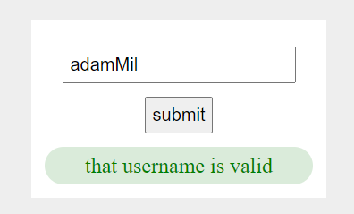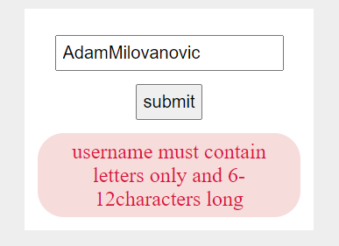

**SOLUTION(5)**

**HTML**

<!DOCTYPE html>

<html lang="en">

    <head>

        <link rel="stylesheet" href="styles.css">

        <meta name="viewport" content="width=device-width initial-scale=1.0">

        <meta http-equiv="X-UA-Compatible" content="ie=edge">

        <title>Document</title>

    </head>

    <body>

        <!--

            When we are listening for a submit-event,

            we attach an eventListener to the form-itself

         -->

        <form class="signup-form">

            <input type="text" id="username" placeholder="username">

            <input type="submit" value="submit">

            <!--When the user clicks the submit input, it fires a submit-event-->

        <div class="feedback"></div>

        </form>

     <script src="sandbox.js"></script>

    </body>

</html>

**CSS**

body{

    background:#eee;

}

form{

    max-width:200px;

    margin:40px auto;

    background: white;

    padding:10px;

}

input{

    display:block;

    margin:10px auto;

    padding:4px;

}

.feedback{

    bottom: 0;

    text-align: center;

    margin: 0 auto;

    color: gray;

    border-radius: 20px;

    padding:5px;

    background: rgba(70, 153, 70, 0.2);

    background: rgba(216, 82, 82, 0.2);

}

**JAVASCRIPT**

const form = document.querySelector('.signup-form');

const feedback = document.querySelector('.feedback');

form.addEventListener('submit', function(*e*){

    e.preventDefault();

    //validation

    const username = form.username.value;

    const regExPattern = /^[a-z A-Z]{6,12}$/;

    //Note that for this regExPattern, it accepts empty spaces

    //but counts them in the character count, so you may very well have 6-12 empty spaces.

    //.test(username) returns true if the test argument-value is valid

    //and false if it is not valid for the regEx pattern

   if(regExPattern.test(username)){

         feedback.style.background = 'rgba(70, 153, 70, 0.2)'

         feedback.style.color=' green';

         feedback.textContent = 'that username is valid';

   }

   else{

        feedback.style.background = 'rgba(216, 82, 82, 0.2)'

        feedback.style.color='crimson';

        feedback.textContent = 'username must contain letters only and 6-12characters long';

    }

});

# **NINJA QUIZ**

# **JAVASCRIPT EXERCISES**

EXERCISE(1) Write javascript that will change the color of the paragraph on the press of the button

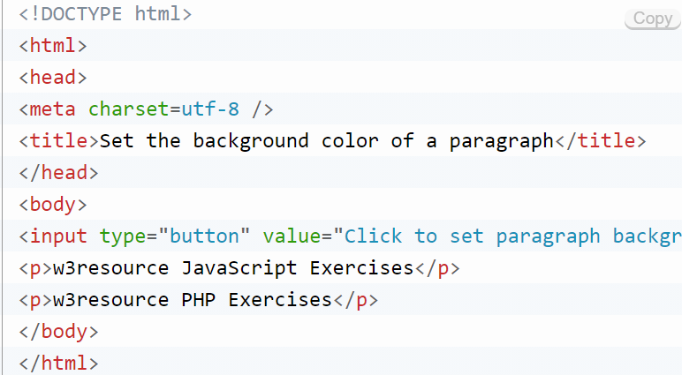

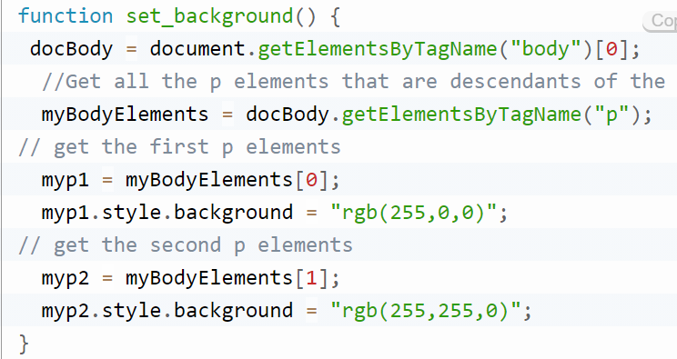

**1.**Here is a sample html file with a submit button. Now modify the style of the paragraph text through javascript code. [Go to the editor](https://www.w3resource.com/javascript-exercises/javascript-dom-exercises.php#EDITOR)  
Sample HTML file :

<!DOCTYPE html>

<html>  
<head>

<meta charset=utf-8 />

<title>JS DOM paragraph style</title>

</head>

<body>

<p id ='text'>JavaScript Exercises - w3resource</p>

<div>

<button id="jsstyle"

onclick="js_style()">Style</button>

</div>

</body>

</html>

Clicking on the button the font, font size, and color of the paragraph text will be changed.  
[Click me to see the solution](https://www.w3resource.com/javascript-exercises/javascript-dom-exercise-1.php)

**2.**Write a JavaScript function to get the values of First and Last name of the following form. [Go to the editor](https://www.w3resource.com/javascript-exercises/javascript-dom-exercises.php#EDITOR)  
Sample HTML file :

<!DOCTYPE html>

<html><head>

<meta charset=utf-8 />

<title>Return first and last name from a form - w3resource</title>

</head><body>

<form id="form1" onsubmit="getFormvalue()">

First name: <input type="text" name="fname" value="David"><br>

Last name: <input type="text" name="lname" value="Beckham"><br>

<input type="submit" value="Submit">

</form>

</body>

</html>

[Click me to see the solution](https://www.w3resource.com/javascript-exercises/javascript-dom-exercise-2.php)

**3.**Write a JavaScript program to set the background color of a paragraph. [Go to the editor](https://www.w3resource.com/javascript-exercises/javascript-dom-exercises.php#EDITOR)[Click me to see the solution](https://www.w3resource.com/javascript-exercises/javascript-dom-exercise-3.php)

**4.**Here is a sample html file with a submit button. Write a JavaScript function to get the value of the href, hreflang, rel, target, and type attributes of the specified link. [Go to the editor](https://www.w3resource.com/javascript-exercises/javascript-dom-exercises.php#EDITOR)

<!DOCTYPE html>

<html><head>

<meta charset=utf-8 />

</head>

<body>

<p><a id="w3r" type="text/html" hreflang="en-us" rel="nofollow" target="_self" href="https://www.w3resource.com/">w3resource</a></p>

<button onclick="getAttributes()">Click here to get attributes value</button>

</body></html>

[Click me to see the solution](https://www.w3resource.com/javascript-exercises/javascript-dom-exercise-4.php)

**5.**Write a JavaScript function to add rows to a table. [Go to the editor](https://www.w3resource.com/javascript-exercises/javascript-dom-exercises.php#EDITOR)  
Sample HTML file :

<!DOCTYPE html>

<html><head>  
<meta charset=utf-8 />

<title>Insert row in a table - w3resource</title>

</head><body>

<table id="sampleTable" border="1">

<tr><td>Row1 cell1</td>

<td>Row1 cell2</td></tr>

<tr><td>Row2 cell1</td>

<td>Row2 cell2</td></tr>

</table><br>

<input type="button" onclick="insert_Row()" value="Insert row">

</body></html>

[Click me to see the solution](https://www.w3resource.com/javascript-exercises/javascript-dom-exercise-5.php)

**6.**Write a JavaScript function that accept row, column, (to identify a particular cell) and a string to update the content of that cell. [Go to the editor](https://www.w3resource.com/javascript-exercises/javascript-dom-exercises.php#EDITOR)  
Sample HTML file :

<!DOCTYPE html>

<html><head>  
<meta charset=utf-8 />

<title>Change the content of a cell</title>

</head><body>

<table id="myTable" border="1">

<tr><td>Row1 cell1</td>

<td>Row1 cell2</td></tr>

<tr><td>Row2 cell1</td>

<td>Row2 cell2</td></tr>

<tr><td>Row3 cell1</td>

<td>Row3 cell2</td></tr>

</table><form>

<input type="button" onclick="changeContent(2,1, 'updated text content')” value="Change content">

</form></body></html>

[The solution](https://www.w3resource.com/javascript-exercises/javascript-dom-exercise-6.php):

const button = document.querySelector('button');

function changeContent(*row*, *column*, *content*)

{ let table = document.querySelector('table');

    let tableRows = table.querySelectorAll('tr');

    let tableData = Array.from(tableRows[row-1].children);

    tableData[column-1].textContent = content;

}

**7.**Write a JavaScript function that creates a table, accept row, column numbers from the user, and input row-column number as content (e.g. Row-0 Column-0) of a cell. [Go to the editor](https://www.w3resource.com/javascript-exercises/javascript-dom-exercises.php#EDITOR)  
Sample HTML file :

<!DOCTYPE html>

<html>

<head>

<meta charset=utf-8 />

<title>Change the content of a cell</title>

<style type="text/css">

body {margin: 30px;}

</style>

</head><body>

<table id="myTable" border="1">

</table><form>

<input type="button" onclick="createTable()" value="Create the table">

</form></body></html>

[The solution](https://www.w3resource.com/javascript-exercises/javascript-dom-exercise-7.php):

function createTable(){

    defineTable(4,6);

}

function defineTable(*rows*, *columns* ){

    //here we are grabbing a handle for the 'table' element

    //and declaring and initializing our row and column counters

    //that we will use  to count down the number of rows

    //and columns, as each row/column gets created.

    let table = document.getElementById('myTable');

    let rowCounter = 0;

    let columnCounter = 0;

    //Here we are creating as many <tr></tr> templates

    //as the user specifies in the 'rows' parameter

    rowCounter = rows;

    while(rowCounter > 0){

        table.innerHTML += `<tr></tr>`;

        rowCounter--;

    }

    //Here we are creating as many <td> tags as the user

    //specified in the 'columns' parameter, inside each

    //of our <tr> tags, that we iterate using forEach()method

    //no our 'tableRows' collection

    let tableRows = table.querySelectorAll('tr');

    rowCounter = 0;

    tableRows.forEach(function(*row*){

        columnCounter = columns;

        while(columnCounter > 0){

            row.innerHTML += `<td>row(${rowCounter+1}) column(${columns - (columnCounter-1)})</td>`;

            columnCounter--; //in every while iteration column counter gets smaller

        }

        rowCounter++;// for each row iteration, rowCounter grows

    });

}

**8.**Write a JavaScript program to remove items from a dropdown list. [Go to the editor](https://www.w3resource.com/javascript-exercises/javascript-dom-exercises.php#EDITOR)  
Sample HTML file :

<!DOCTYPE html>

<html><head>

<meta charset=utf-8 />

<title>Remove items from a dropdown list</title>

</head><body><form>

<select id="colorSelect">

<option>Red</option>

<option>Green</option>

<option>White</option>

<option>Black</option>

</select>

<input type="button" onclick="removecolor()" value="Select and Remove">  
</form></body></html>

[Click me to see the solution](https://www.w3resource.com/javascript-exercises/javascript-dom-exercise-8.php)

**9.**Write a JavaScript program to count and display the items of a dropdown list, in an alert window. [Go to the editor](https://www.w3resource.com/javascript-exercises/javascript-dom-exercises.php#EDITOR)  
Sample HTML file :

<!DOCTYPE html>

<html><head>

<meta charset=utf-8 />

<style type="text/css">

body {margin: 30px;}

</style>

<title>Count and display items of a dropdown list - w3resource</title>

</head><body><form>

Select your favorite Color :

<select id="mySelect">

<option>Red</option>

<option>Green</option>

<option>Blue</option>

<option>White</option>

</select>

<input type="button" onclick="getOptions()" value="Count and Output all items">

</form></body></html>

[Click me to see the solution](https://www.w3resource.com/javascript-exercises/javascript-dom-exercise-9.php)

**10.**Write a JavaScript program to calculate the volume of a sphere. [Go to the editor](https://www.w3resource.com/javascript-exercises/javascript-dom-exercises.php#EDITOR)  
Sample Output of the form :

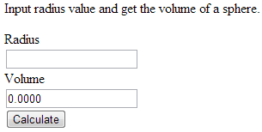

[Click me to see the solution](https://www.w3resource.com/javascript-exercises/javascript-dom-exercise-10.php)

**11.**Write a JavaScript program to display a random image (clicking on a button) from the following list. [Go to the editor](https://www.w3resource.com/javascript-exercises/javascript-dom-exercises.php#EDITOR)  
*Sample Image information* :

"http://farm4.staticflickr.com/3691/11268502654_f28f05966c_m.jpg", width: "240", height: "160"  
"http://farm1.staticflickr.com/33/45336904_1aef569b30_n.jpg", width: "320", height: "195"  
"http://farm6.staticflickr.com/5211/5384592886_80a512e2c9.jpg", width: "500", height: "343"

[Click me to see the solution](https://www.w3resource.com/javascript-exercises/javascript-dom-exercise-11.php)

**12.**Write a JavaScript program to highlight the bold words of the following paragraph, on mouse over a certain link. [Go to the editor](https://www.w3resource.com/javascript-exercises/javascript-dom-exercises.php#EDITOR)  
*Sample link and text*:  
[[On mouse over here bold words of the following paragraph will be highlighted](https://www.w3resource.com/javascript-exercises/javascript-dom-exercises.php)]  
**We** have just started **this** section for the users (**beginner** to intermediate) who **want** to work with **various** JavaScript **problems** and write scripts online to **test** their JavaScript **skill**.  
[Click me to see the solution](https://www.w3resource.com/javascript-exercises/javascript-dom-exercise-12.php)

**13.**Write a JavaScript program to get the width and height of the window (any time the window is resized). [Go to the editor](https://www.w3resource.com/javascript-exercises/javascript-dom-exercises.php#EDITOR)  
[Click me to see the solution](https://www.w3resource.com/javascript-exercises/javascript-dom-exercise-13.php)

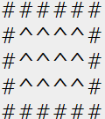

**14.**Write a JavaScript program to draw a (X*Y) rectangle on a webpage, as displayed to the right (5*6). You are allowed to insert any kind of html element and css styles you need in order to properly format your square elements so that they visibly display on the browser.

<!DOCTYPE html>

<html lan="en">

  <head>

    <meta charset="UTF-8" />

    <meta

      name="viewport "

      content="width = device-width; initial-scale=

    1.0"

    />

    <meta http-equiv="X-UA-Compatible" content="ie=edge" />

    <link rel="stylesheet" href="styles.css" />

  </head>

  <body>

       <script src="sandbox.js"></script>

  </body>

</html>

[The solution](https://www.w3resource.com/javascript-exercises/javascript-dom-exercise-13.php):

//dinamically create a div with the class of square inside  html <body>tag

document.querySelector('body').innerHTML += `<div class = "rectangle"></div>`;

//grab a handle to the newly created <div class="square">

let rectangle = document.querySelector('.square');

//create a function that takes the numer of rows/columns

//representing a X*Y rectangle

function drawRectangle(*rows*, *columns*) {

  //the first loop counter (i)represents every row-iteration(creates rows)

  for (let i = 0; i < rows; i++) {

    //it creates rows by adding a <p> block element to the rectangle

    rectangle.innerHTML += `<p class = "row${i}"></>`;

    //the second loop (j) represents an element(column)within a row

    //it has a role of actually filling up the <p>rows</p> as they are generated

    for (let j = 0; j < columns; j++) {

      //completely fills up with # the first and last row (i->row)

      if (i == 0 || i == rows - 1)

        document.querySelector(`.row${i}`).textContent += '#';

      else {

        //Checks to only add # at the start and end of every row in-between

        if (j === 0 || j === columns - 1) {

          document.querySelector(`.row${i}`).textContent += '#';

        } else {

          //we use ^ instead of empty space because ^ takes up the same

          //character-space on screen as #, while ' ' only takes up half as much

          document.querySelector(`.row${i}`).textContent += '^';

        }

      }

    }

  }

}

//Calling the function to draw a 5*6 rectangle

drawRectangle(5, 6);

# **THE COMPLETE JAVASCRIPT COURSEFROM ZERO TO EXPERT!**

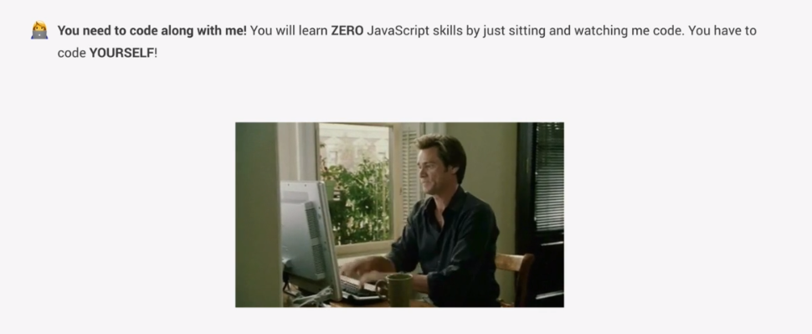

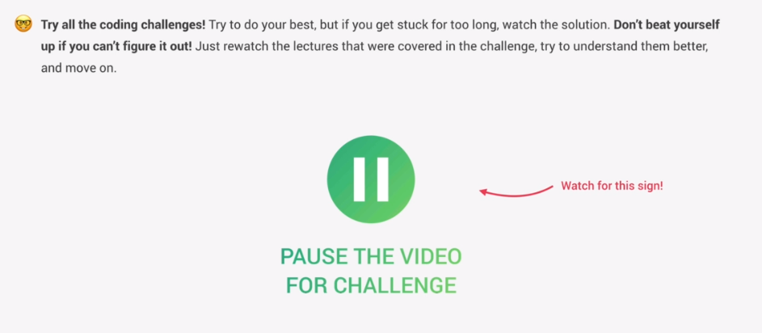

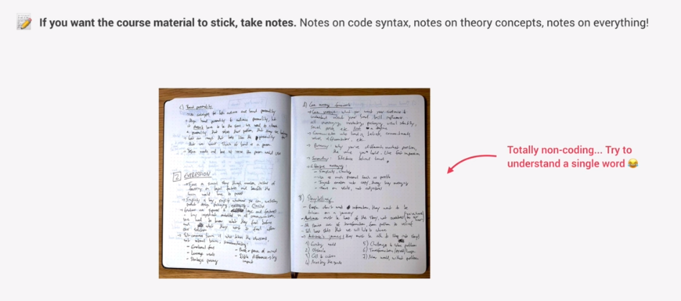

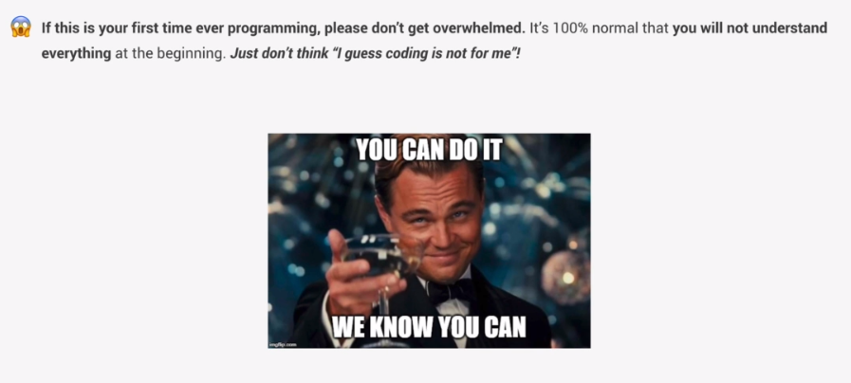

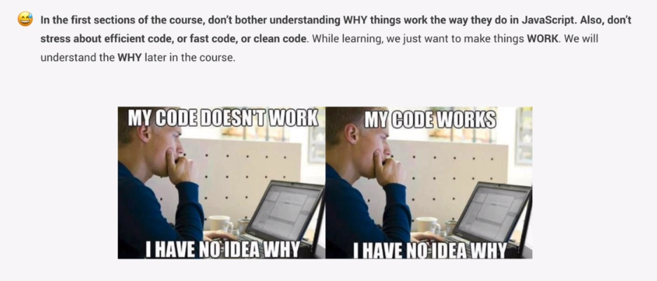

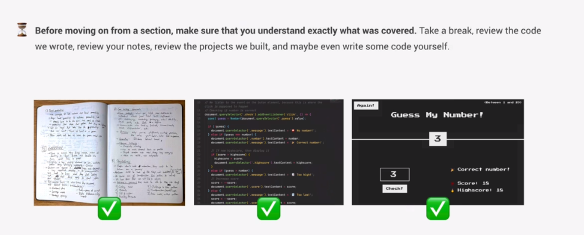

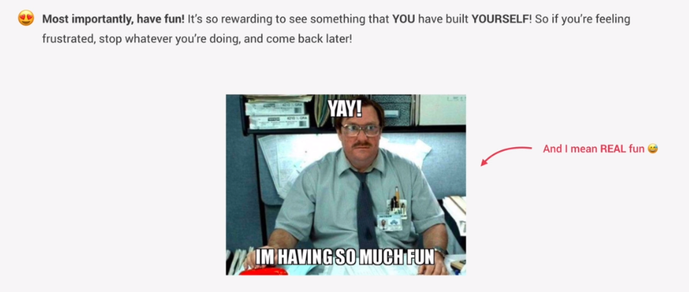

# Developer skills & Editor Setup

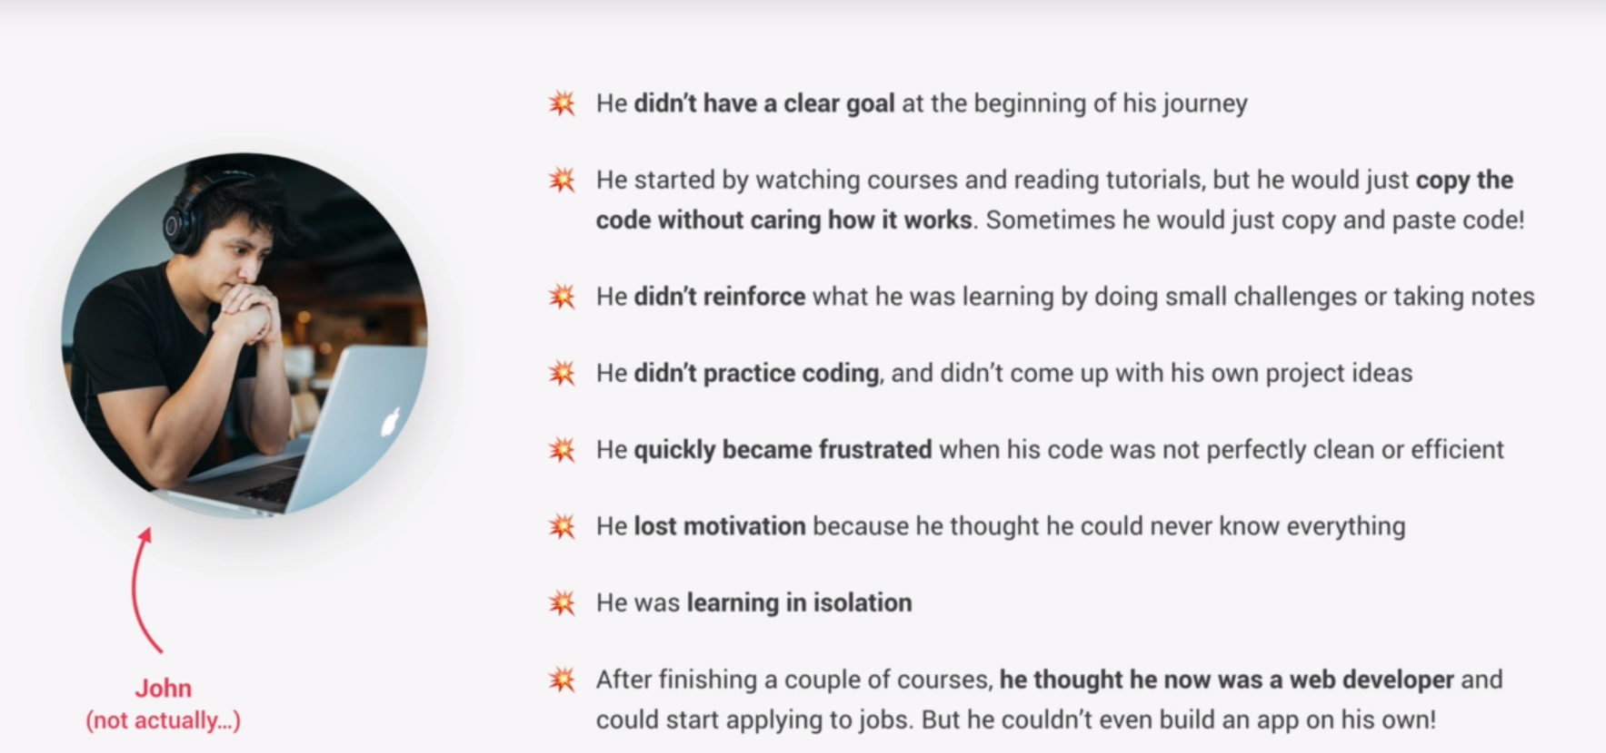

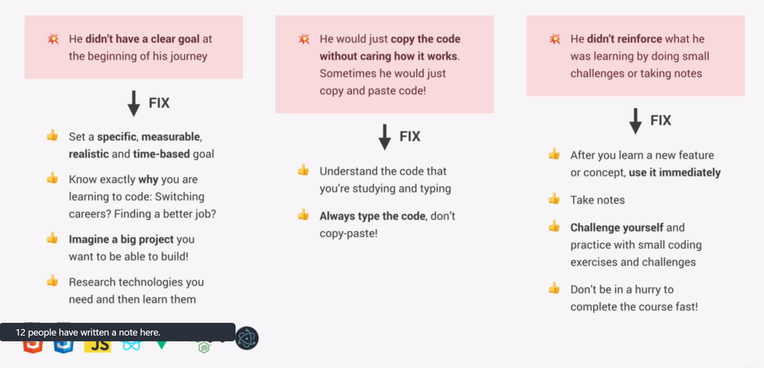

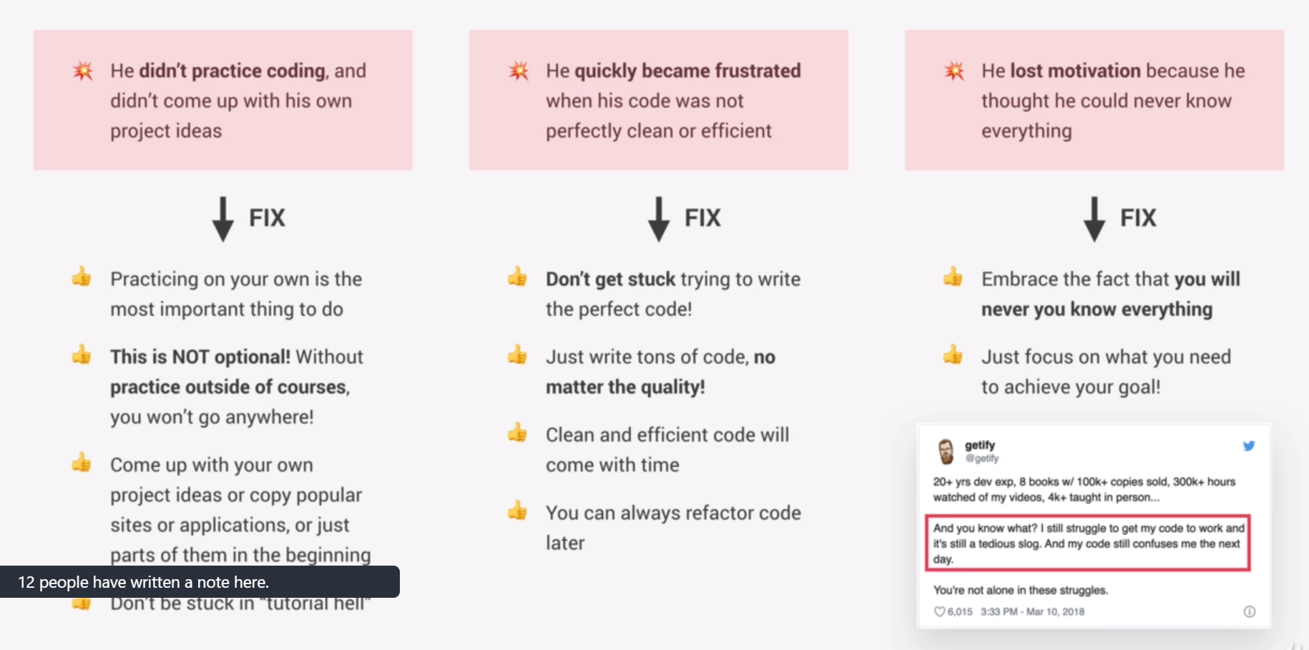

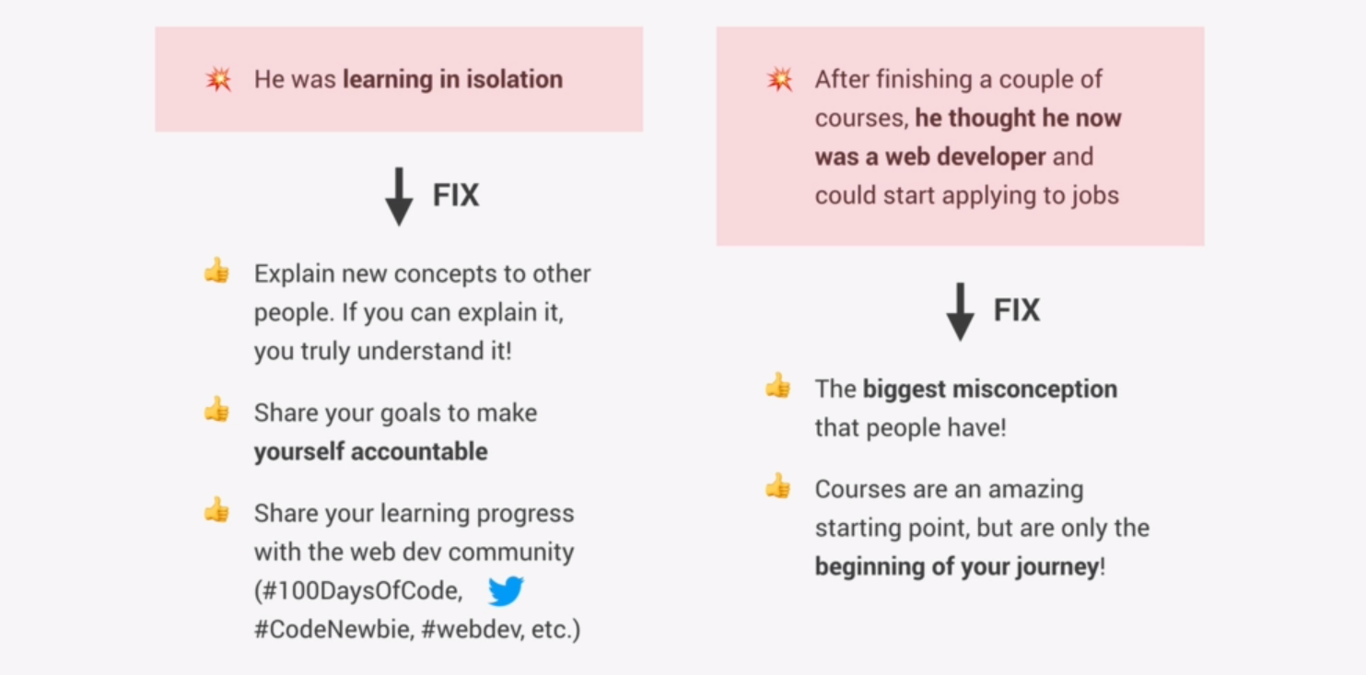

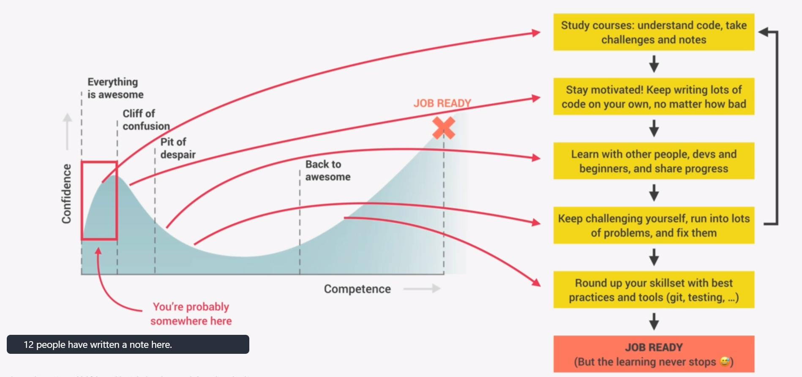

# **Var vs Let vs Const**

//We don't use (Var) at all anymore

//(const) is a constant and as such it is

//read-only for the entirety of it's domain

// whereas you can only change it's value where it is declared

// and that will update all of the references to the (const)

//(let) functions as a regular variable

# **HOW TO SOLVE PROBLEMS!**

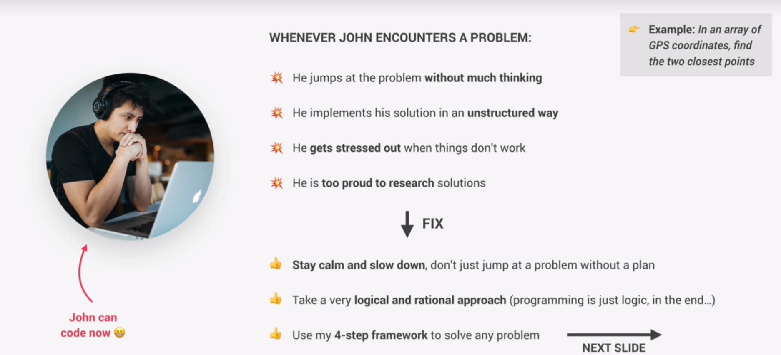

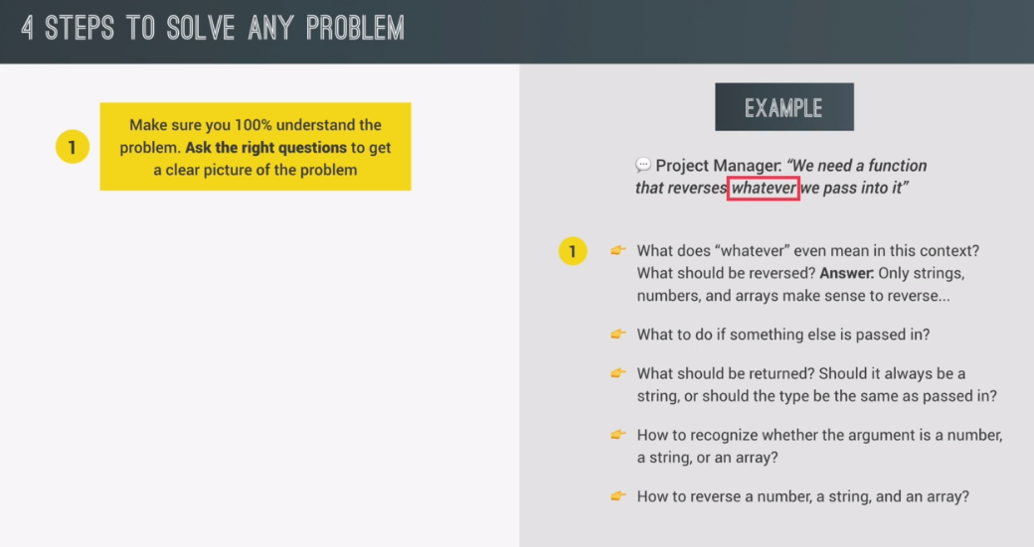

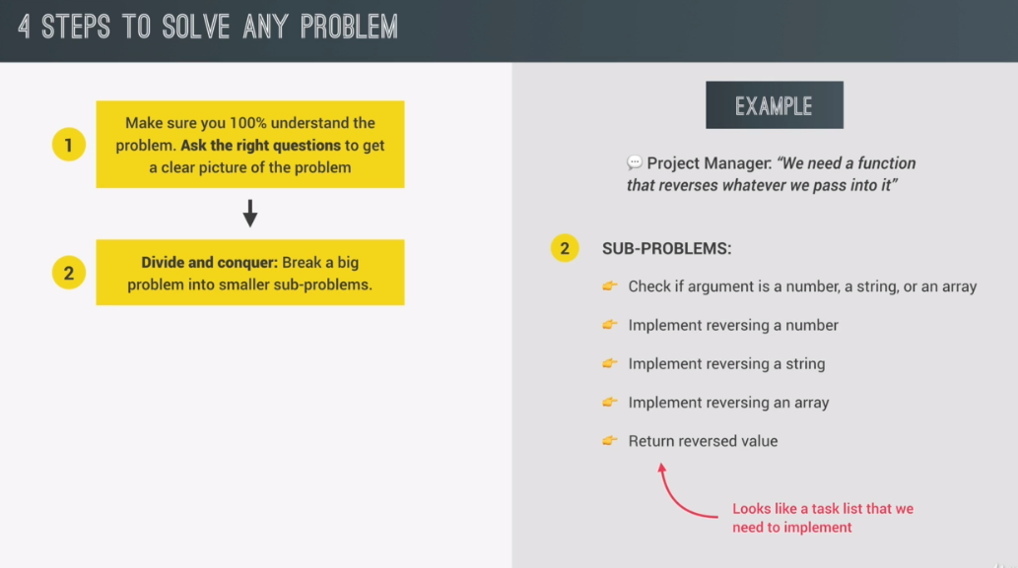

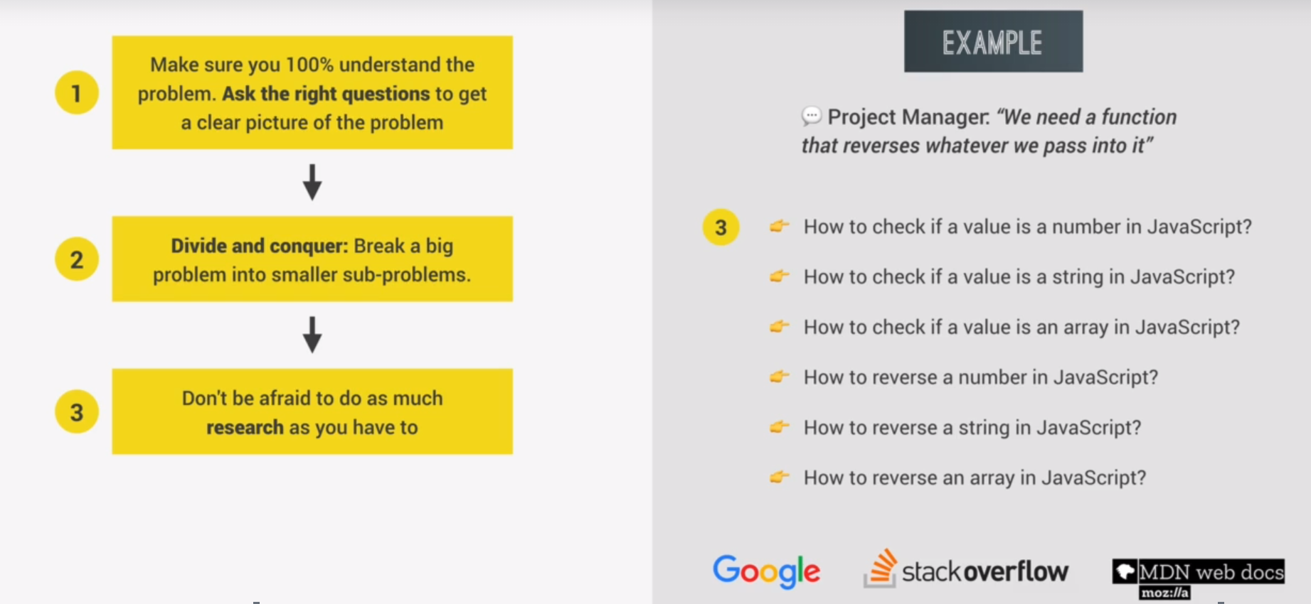

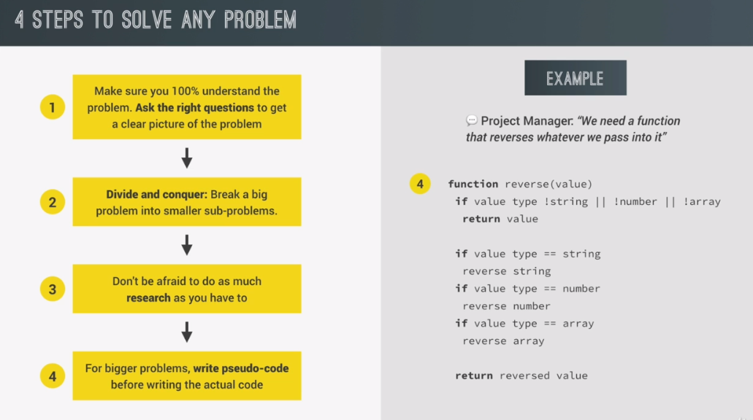

# Solving a problem using the above 4-step method

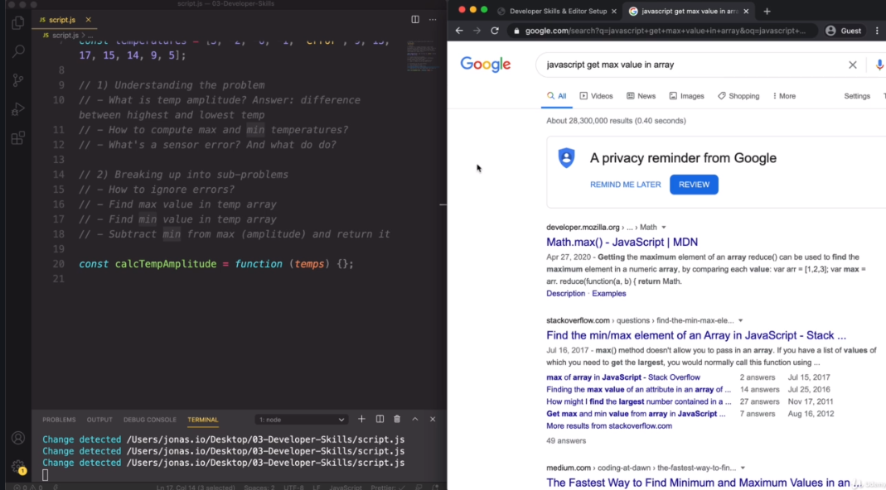

Above we have an example of writing down questions and breaking it into chunks of tasks that need to be completed. On the left side, we can se the way we should ask questions about problems.Simply write down the programming language/program you are having a problem within, in this case “javascript” and next to it pen the problem as precisely and concisely as possible.

When you find a solution it is best practice not to copy the code exactly from stackOverflow, but to try and understand the solution concept, and build around the idea your own code for the program you are working on.

## **//PROBLEM 1:**

// We work for a company building a smart home

//thermometer. Out most recent task is this: "

//"deliver an array of temepratures of one day,

//calculate the temperature amplitude.

//Keep in mind that sometimes there might be a sensor error.

const temperatures = [3, -2, -6, -1, 'error', 9, 13, 17, 15, 14, 9, 5];

//1.)understanding the problem

//(write out questions and answers)

// --What is temp amplitude? Answer: difference between highest and lowest temp

//--How to calculate the max and min temperatures?

//--What does a sensor error look like?And what to do?

//2.)breaking up the problem into sub problems

//(Write out tasks/mini problems)

//--How to ignore sensor erros?

//--Find max value in temp array.

//--Subtract min from max and return it (the amplitude).

//3.)Do your research on MDN, Google and StackOverflow

//4.) Write pseudo code to better understand the coding steps

//Samostalni rad.

const calcTempAmplitude = function (*temps*) {

  //Finding the maximum temperature

  let maximum = temps[0];

  let minimum = temps[0];

  temps.forEach(function (*temperature*) {

    //Skips the code operation if the value is not a number

    if (typeof temperature == 'number') {

      //checks if we have a new max or min value

      if (temperature > maximum) {

        maximum = temperature;

      } else if (temperature < minimum) {

        minimum = temperature;

      }

    }

  });

  //Returns a calculated amplitude

  return maximum - minimum;

};

const amplitude = calcTempAmplitude([2, 'error', 7, 5]);

console.log(amplitude);

## **//PROBLEM 2:**

//Function should now receive 2 arrays of temperatures

//###Course Solution:

//1(Understanding the problem)

//--Do we need to implement the previous function twice?

//Answer: No, we could just merge the two arrays

//and then proceed with the same functionality as before

//2(Divide and conquer)

//--merge two arrays

//--calculate the min and max of the resulting array

//--calculate and return the amplitude with that min/max

let calcTempAmplitude2 = function (*temps1*, *temps2*) {

  //merging the two arrays

  let temperatures = temps1.concat(temps2);

  //initializing the min/max values

  let maximum = temperatures[0];

  let minimum = temperatures[0];

  //compares and stores elements for min/max values

  temperatures.forEach(function (*temperature*) {

    //Skips the code operation if the value is not a number

    if (typeof temperature == 'number') {

      //checks if we have a new max or min value

      if (temperature > maximum) {

        maximum = temperature;

      } else if (temperature < minimum) {

        minimum = temperature;

      }

    }

  });

  return maximum - minimum;

};

console.log(calcTempAmplitude2([1, 2, 3], [4, 'error', 6]));

//output is (5) so our code is good! ^_____^

## **DEBBUGING (FIXING ERRORS)**

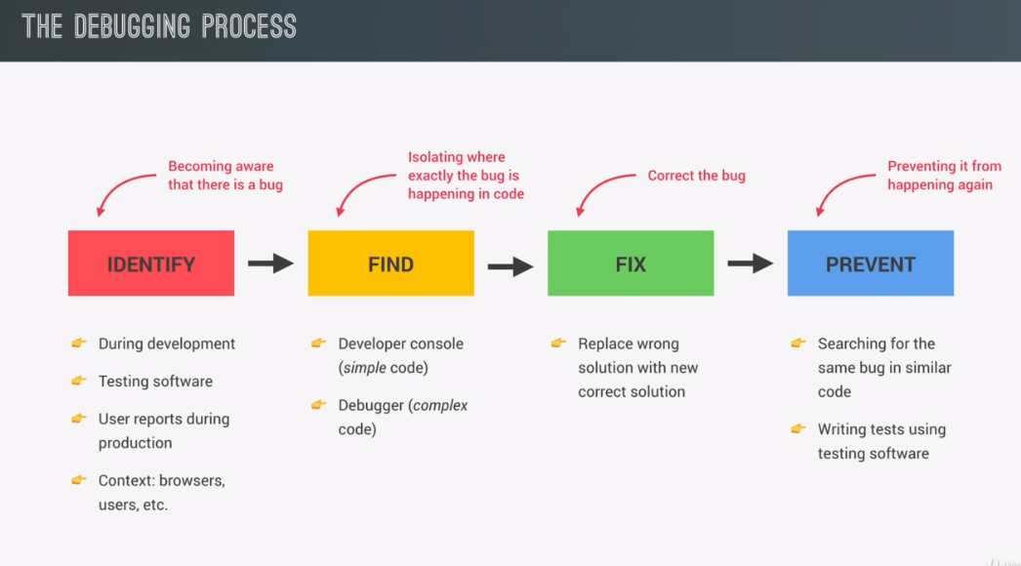

**Creating an object:**

const measurement = {

    type: 'temp',

    unit: 'cels',

    value: prompt('degrees celsisus: '),

  };

Note how the prompt method always returns a “string”.

### **String Concationation with in the (string+number) context**

-String concatination is excected in JAVASCRIPT with the + operator. A very importnant thing to notice here is how if Javascript notices a + operator next to a string, ie if one of the two elements being added is a string, it will automatically turn the non-string element into a string.

String + number = string + number.ToString()

### **Explicit conversion of values**

value: Number(prompt('degrees celsisus: ')),

const measureKelvin = function () {

  const measurement = {

    type: 'temp',

    unit: 'cels',

    //C)FIX BUG

    //Original: value: prompt('degrees celsisus: '),

    value: Number(prompt('degrees celsisus: ')),

  };

  //B) FIND BUG

  console.log(measurement);

  const kelvin = measurement.value + 273;

  return kelvin;

};

//A) IDENTIFY BUG

console.log(measureKelvin());//Output is 10273 for input 10

Above, we’ve had the issue of our measurement output giving the value of celsius = 10 to celvin as “10” + 273 as 10273 instead of 283.

///////////////////////////////

// **Coding Challenge #1**

/*

Given an array of forecasted maximum temperatures,

the thermometer displays a string with these

temperatures

Example:[17, 21, 23] will print

"17C in 1 days...23C in 3 days..."

Create a function 'printForecast' which takes in an array

 'arr' and logs a string like the above to the console.

 Use the problem-solving framework:

 -Understand the problem

 -Break the problem into sub problems

 -Research (if you don't know the solution or don't got good one)

 -Write a pseudo code task list for bigger problems

 *//////////////////////////////

//1.(Understand the problem)

//Do all of the values need to be set in a single output string?

//Answer: Yes.

//How are the days counted?

//Answer: first temperature day one, next temp day one + 1...

//2.(Divide and conquer)

//--Create and initialize the output string variable

//--Create and initialize as (1) the 'days' variable

//--Loop through all of the temperatures in the array

//--in the end of each loop iteration execute 'days++'

//  store the temp-element value and days value in a string

//--return the final string with the stored values.

const printForecast = function (*arr*) {

  let days = 1;

  let forecastString = '';

  for (let i = 0; i < arr.length; i++) {

    if (i == 0) {

      forecastString += `${arr[i]}C in (${days})day.  `;

      days++;

    } else if (i == arr.length - 1) {

      //If the days have a remainder 0 when divided by a week, we print the number of week(s)

      if (days % 7 == 0) {

        if (days / 7 == 1) {

          forecastString += `${arr[i]}C in (${days / 7})week,  `;

          days++;

          continue;

        } else {

          forecastString += `${arr[i]}C in (${days / 7})weeks,  `;

          days++;

          continue;

        }

      }

      forecastString += `${arr[i]}C in (${days})days. End.  `;

      days++;

    } else {

      if (days % 7 == 0) {

        if (days / 7 == 1) {

          forecastString += `${arr[i]}C in (${days / 7})week,  `;

          days++;

          continue;

        } else {

          forecastString += `${arr[i]}C in (${days / 7})weeks,  `;

          days++;

          continue;

        }

      }

      forecastString += `${arr[i]}C in (${days})days,  `;

      days++;

    }

  }

  return forecastString;

};

let temps = [17, 23, 15, 12, 1, 0, 12, 1];

let temps2 = [24, 22, 21, 2, 3, 5, 6];

console.log(printForecast(temps.concat(temps2)));

# **DocumentObjectModel MANIPULATION**

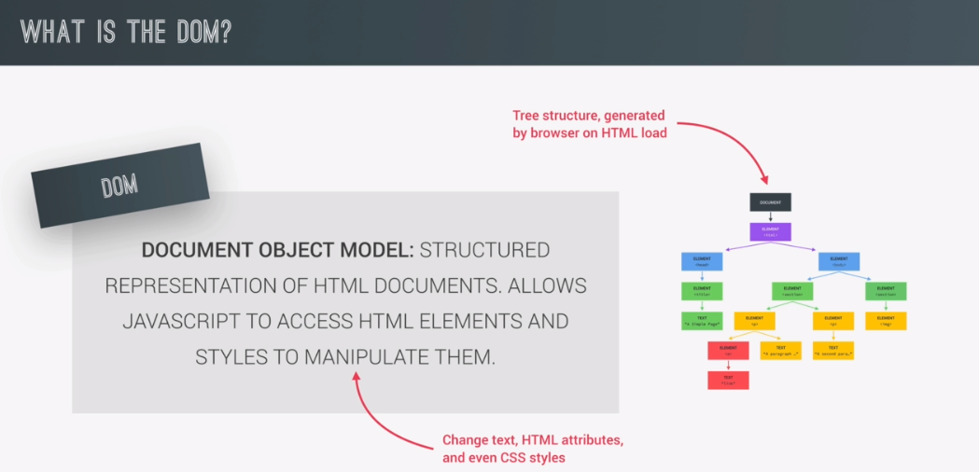

The DOM is generated automatically by the browser as soon as our .html object is created. Dom is represented by a tree structure, inside of which each html<element> exists as its own object.

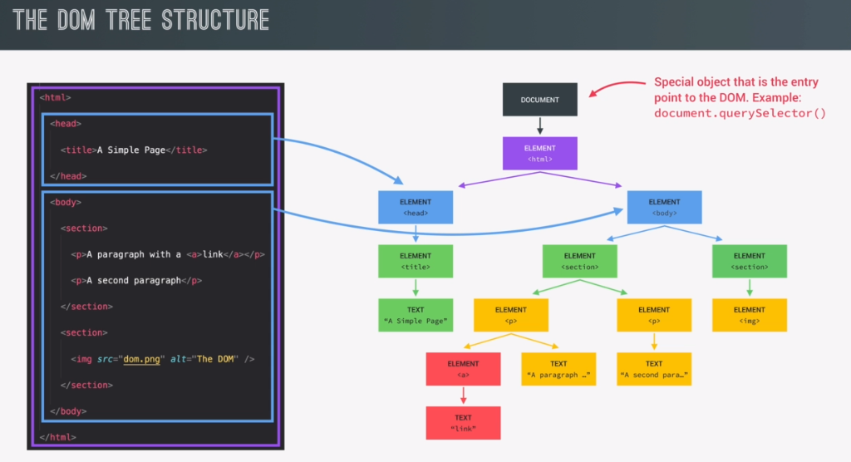DOCUMENT object is refered to as the entry point object because it is the object on the top of the DOM hierarchy and itself is the first object that we can reach. Document’s first child element will be the <html> object, while the <html> object itself has two child elements <body> and <head> objects. These objects are on the same tree/level and as such they are sibling elements.

We can see the global html in purple, and it’s two <body> and <head> children colored the same blue (being as they are siblings) whatever is located(nested) inside <body> or <head> is the child element of it’s parent. So without further drawing out of the child element structure, on the left, you can check and infer the child/sibling elements from the html and it’s related diagram tree as presented above.

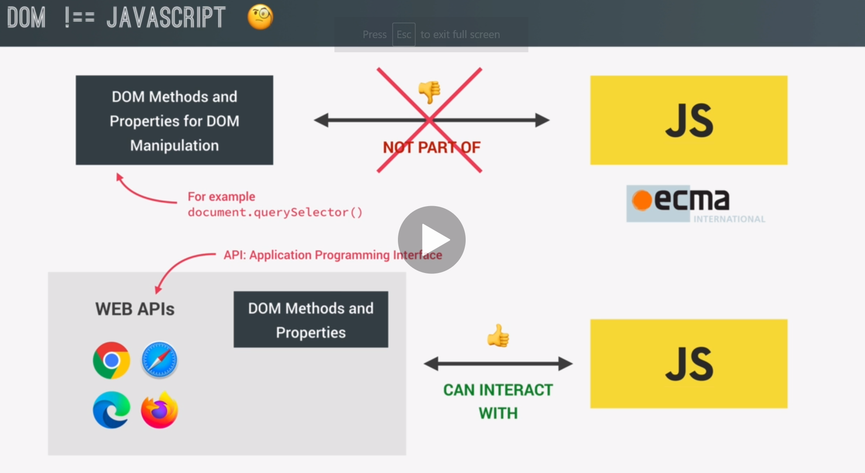

Note that DOM methods and properties are not JavaScript. They are though a par of Web Aplication Programming Interfaces (APIs), and they themselves are designed in such a way as to be accessable through javascript, and then have the resulting API manipulation display and get rendered within the browser.

Web APIs are written in JavaScript and as such are available for us to use their javascript methods.

There is also a very specific standard that DOM manipulation has to implement, which means that all browsers using the DocumentObjectModels, have their DOM manipulation work in the very same way, following the same standard across all browsers.

# Functions behaving as values

A function with a return value will itself, when envoked();, act just like that value, just as if it were a variable representing the specific value that it stores. Functions and variables both may return a value stored at a certain location(addres) and because of that they may both fundamentally behave as the very value that they return.

It is because of this that we can assign values to variables using functions

***Let sum = calcSum(num1, num2);***

Or as arguments inside other functions

***Let sum = calcSum(calcSum(num1, 0), num2);***

# **GUESS THE NUMBER (PROJECT)**

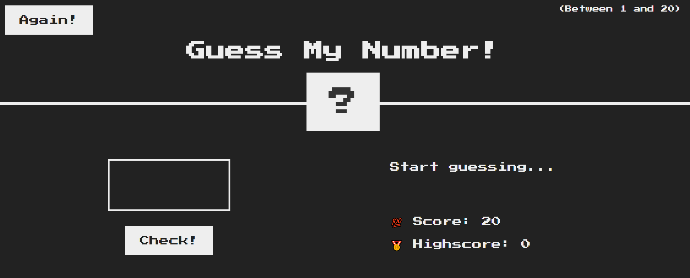

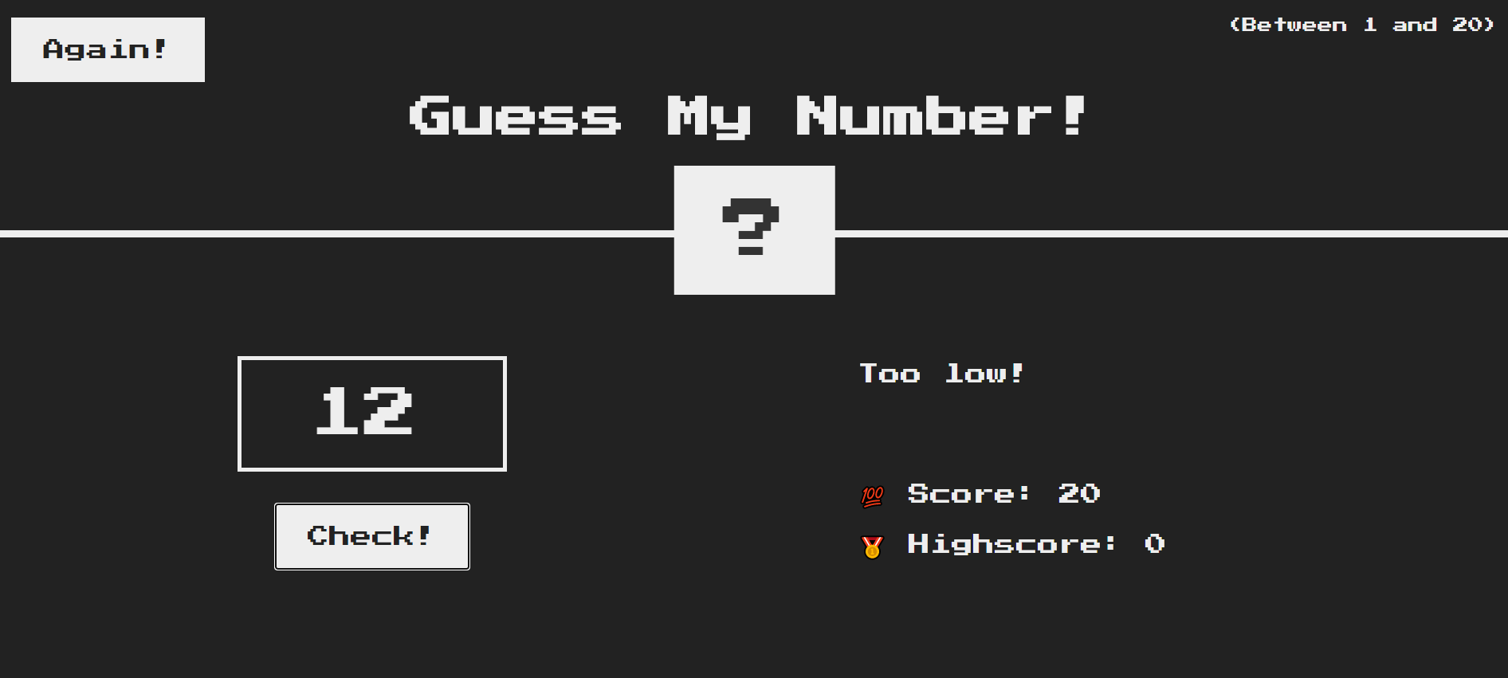Create a game that let’s the user input any number, trying to guess a random generated number between 1 and 20. Each time the user guesses his score is detracted by 1. Guessing correctly with a score of 20, means that you got the correct number on the first try (pure dumb luck). High score field keeps the tally of your highest achieved score during the session. Pressing the “Again!”button resets the the entire page, but remembers your highscore. It is the button you press if you want to play again after guessing correctly.

Example runs, so that you can see the project in action:

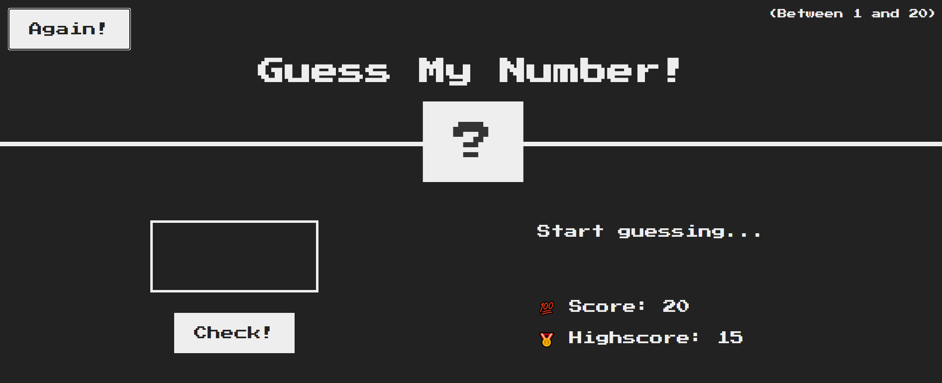

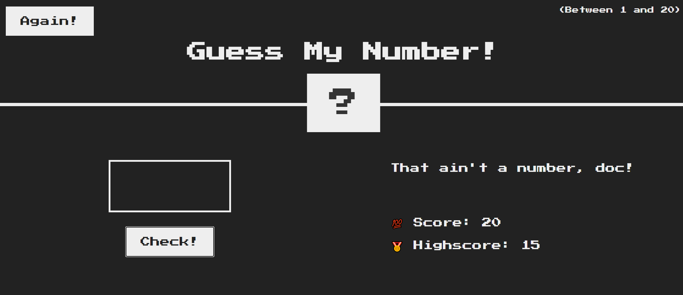After pressing “Check!” without entering a number:

Notice that between the “Again” sessions, the lhighScore has a persistent value and is tracked throughout all games (before reloading the browser) while the score resets back to 20 on each new game.

Additional note: If the score drops to zero, the game needs to reset. Just like pressing the again button

PS: Try to change the background color for the correct guess to a terrible shade of green! Naturally reseting it back to its previous color upon pressing the “Again!” button.

Below, a new game and a correct guess unrelated to the examples above, purely to show the horrendous change in color we should be aiming for.

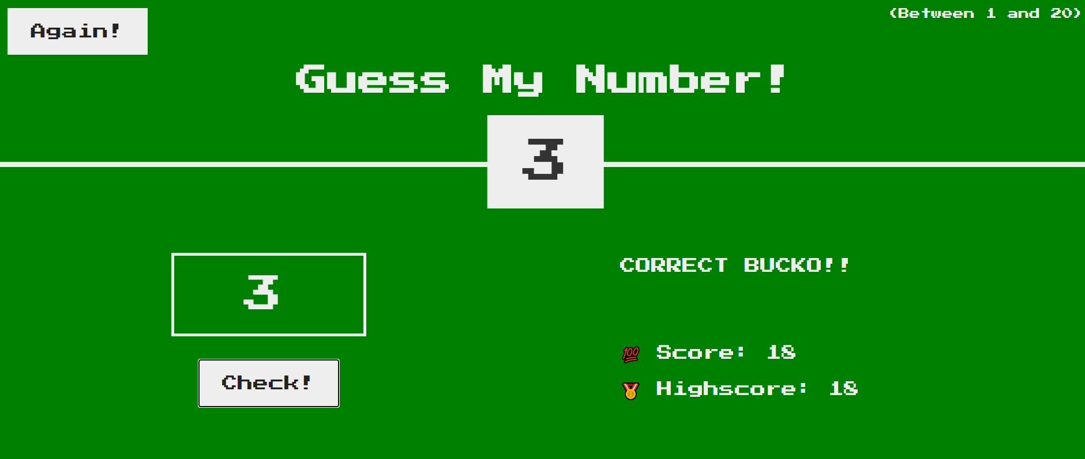

**//My Javascript Solution–It works ^^**

"use strict";

/////////THE CODE ITSELF

let secretNumber = Math.trunc(Math.random() * 20 + 1);

//--first we generate a random number:

const message = document.querySelector(".message");

//<button class="btn check">Check!</button>

const check = document.querySelector(".check");

//<span class="score">20</span></p>

const score = document.querySelector(".score");

//<span class="highscore">0</span>c

const highScore = document.querySelector(".highscore");

//<button class="btn again">Again!</button>

const again = document.querySelector(".again");

const secretNumberHandle = document.querySelector(".number");

//--Next we store the userInput variable

//we store the users input value from the

//<input type="number" class="guess" /> element

// in the "userInput" variable

let userInput = Number(document.querySelector(".guess").value);

let scoreValue = 20;

let highScoreValue = 0;

check.addEventListener("click", function () {

  userInput = Number(document.querySelector(".guess").value);

  if (scoreValue === 0) {

    playAgain(); //if the score drops to 0 the game resets

  }

  if (!userInput) {

    message.textContent = "That ain't a number, doc!";

  } else if (userInput === secretNumber) {

    message.textContent = "CORRECT BUCKO!!";

    document.querySelector("body").style.background = "green";

    score.textContent = scoreValue;

    secretNumberHandle.textContent = secretNumber;

    if (scoreValue > highScoreValue) {

      highScoreValue = scoreValue;

      highScore.textContent = highScoreValue;

    }

  } else if (userInput > secretNumber) {

    message.textContent = "Too high!";

    score.textContent = scoreValue--;

  } else if (userInput < secretNumber) {

    message.textContent = "Too low!";

    score.textContent = scoreValue--;

  }

});

again.addEventListener("click", function () {

  playAgain();

});

const playAgain = function () {

  scoreValue = 20;

  score.textContent = scoreValue;

  secretNumber = Math.trunc(Math.random() * 20 + 1);

  message.textContent = "Start guessing...";

  secretNumberHandle.textContent = "?";

  //we empty the <input type="number" class="guess" />

  //value property, so the user starts again with a

  //blank input field

  document.querySelector(".guess").value = "";

  document.querySelector("body").style.backgroundColor = " #222";

## Manipulating CSS styles through JAVASCRIPT

Note that when we access “style” properties of a DOM element, we can only get access to our linked .html page, and javascript has no access to **.css** stylesheet. How do we modify the css for our html elements, then? Well the htmlHandle.style property accesses the inline style attribute of an html element, as is demonstrated in the following code:

**<body style=”whatever we set the property to in javascript”>**

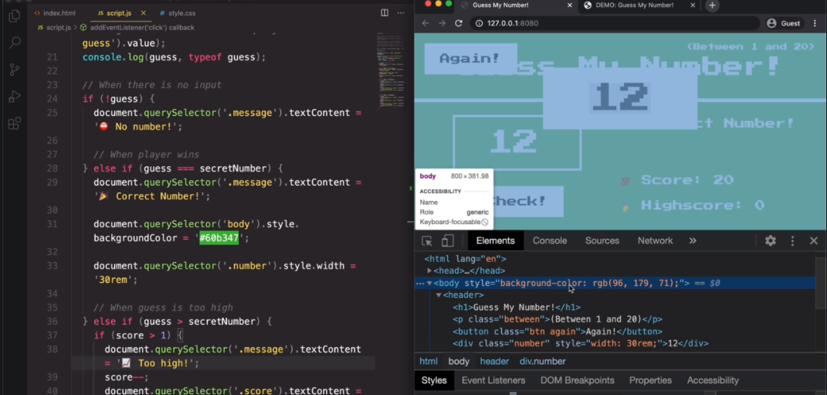

Note on the image above that when we use **htmlHandle.style** property, we are in fact setting an inline style for the targeted <html element>. This is why javascript styles can overwrite the css styles, and they do so without ever changing or accessing the css.style stylesheet.

Note that the values assigned to the style property always have to be a “string”.

## The DRY Principle (**D**on’t.**R**epeat.**Y**ourself)

The dry principle maintains a clean code, wherein it pressuposes that all the code snippets that get repeated should rather be turned into a separate function, themselves.

**Why are duplicate/repeated codes bad?**

**Answer:** When we want to change a functionality, if said functionality that we are attempting to change is written and re-written several times throughout the code, we would need to make the same changes in every single place where that type of code is written. While if that code were to have been placed in a function, and the function envoked throughout the code (instead of hard-coding writing its functionality throughout the entire code) we would only need to make the changes in one place. Namely, within the function declaration where the functionality is stored. In other words…

* **If the code is repeated**, but then needs to be modified, you will have to modifiy it as many times as it was repeated in code.
* **If the code was stored as a function**, then envoked multiple times. You would only have to change it once, within the main function declaration.

## **REFACTORING THE CODE**

It basically means re-structuring the code so, but in a way that keeps its previous functionality. Usually this means applying the DRY principle, and making a working code super neat and tidy. So the idea is to remove duplicate or “almost-duplicate/similar” code, and create functions or more linear structures (a single if/else block or similar)for them instead.

**Code before refactoring:**

"use strict";

/////////THE CODE ITSELF

//declaring our (State) variables

//the variables that track the state of our application and

//transfer that data to our javaScript.

let secretNumber = Math.trunc(Math.random() * 20 + 1);

let score = 20;

let highScore = 0;

//creating an event listener

document.querySelector(".check").addEventListener("click", function () {

  const guess = Number(document.querySelector(".guess").value);

  console.log(guess, typeof guess, secretNumber);

  //typeof -> will return the datatype of the variable coming

  //after it.

  //when there is no input

  if (!guess) {

    document.querySelector(".message").textContent = "Not a number!";

    //When the player wins

  } else if (guess === secretNumber) {

    document.querySelector(".message").textContent = "Correct number!";

    document.querySelector("body").style.background = "#60b347";

    document.querySelector(".number").style.width = "300px";

    document.querySelector(".number").textContent = secretNumber;

    //stores and displays the highscore if the current score is better

    if (score > highScore) {

      highScore = score;

      document.querySelector(".highscore").textContent = highScore;

    }

    //When the guess is too low

  } else if (guess > secretNumber) {

    //below, we decrement and check if the score is zero at the same time

    if (score-- > 1) {

      document.querySelector(".score").textContent = score;

      document.querySelector(".message").textContent = "Too high!";

      //When the player loses

    } else {

      score = 0;

      document.querySelector("body").style.background = "crimson";

      document.querySelector(".score").textContent = score;

      document.querySelector(".message").textContent = "You lose!";

    }

    //When the guess is too high

  } else if (guess < secretNumber) {

    //below, we decrement and check if the score is zero at the same time

    if (score-- > 1) {

      document.querySelector(".score").textContent = score;

      document.querySelector(".message").textContent = "Too low!";

      //When the player loses

    } else {

      score = 0;

      document.querySelector("body").style.background = "crimson";

      document.querySelector(".score").textContent = score;

      document.querySelector(".message").textContent = "You lose!";

    }

  }

});

//Creating an event listener on the "Again!" button

document.querySelector(".again").addEventListener("click", function () {

  //The event handler function will reset the game parameters

  document.querySelector(".message").textContent = "start guessing...";

  document.querySelector(".number").textContent = "?";

  document.querySelector("body").style.background = "#222";

  document.querySelector(".guess").value = ""; //the empty string represents none value

  //remember that all <input> elements accept a "string" value.

  score = 20;

  document.querySelector(".score").textContent = score;

  secretNumber = Math.trunc(Math.random() * 20 + 1);

});

**//AS YOU CAN SEE THERE IS A LOT OF REPEATED CODE PRIOR TO REFACTORING**

### **Ternary Operator**

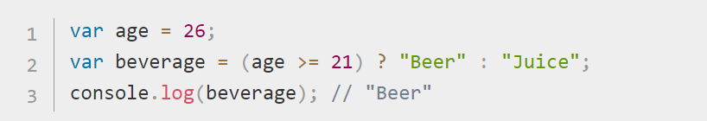

It is very useful when refactoring complex if/else statements, notice that accepts three arguments, the condition, and two values. **Value1(condittion == true), Value2(Condittion == false)**

displayMessage(guess > secretNumber ? "Too high" : "Too low");

      //Notice how above we can in fact use ternary operator as a string argument

      //within a function, mui mui interesante, no?

It works because the result of the terniary operator will be either a single output string with the value of “Too high” or “Too low”, the function accepting a single argument: displayMessage(messageString);

In the non refactored code above, we have noticed that we have two reoccuring if/else statements if (score > highScore) {

      highScore = score;

      document.querySelector(".highscore").textContent = highScore;

    }

    //When the guess is too low

  } else if (guess > secretNumber) {

    //below, we decrement and check if the score is zero at the same time

    if (score-- > 1) {

      document.querySelector(".score").textContent = score;

      document.querySelector(".message").textContent = "Too high!";

      //When the player loses

    } else {

      score = 0;

      document.querySelector("body").style.background = "crimson";

      document.querySelector(".score").textContent = score;

      document.querySelector(".message").textContent = "You lose!";

    }

    //When the guess is too high

  } else if (guess < secretNumber) {

    //below, we decrement and check if the score is zero at the same time

    if (score-- > 1) {

      document.querySelector(".score").textContent = score;

      document.querySelector(".message").textContent = "Too low!";

      //When the player loses

    } else {

      score = 0;

      document.querySelector("body").style.background = "crimson";

      document.querySelector(".score").textContent = score;

      document.querySelector(".message").textContent = "You lose!";

    }

  }

One statement executes basically the same code if the guess is **smaller** than **secretNumber** and the other statement executes said code if the guess is **larger**  than **secretNumber.** The only difference between the **if(>)** and **if(<)** statement blocks is that one outputs a string “Too high” while the other “Too low!”, while their codes are otherwise identical.

To streamline and refactor this code snippet we first have to Notice how (<) or (>) can basically mean the same thing, namely **(<) && (>) == (!==),** they can simply be stated to mean “**different !==”**

This Means that we can exchange the:

**if(x >secretNumber)** and **if(x < secretNumber**) to **if(x!==secretNumber)**

But then, remember that each of our if statement blocks were assigning a **different** input string value to the **same** output variable, how are we going to create a condition that still allows us to do that. Don’t fret, the code below shall set the’ free:

**outputVariable** = x > secretNumber ? “**Too high**” : “**Too low**”; //Ti’s by humble “if/else” ternary operator.

**The fully refactored code snippet below:**

if (guess !== secretNumber) {

    //below, we decrement and check if the score is zero at the same time

    if (score-- > 1) {

      document.querySelector(".score").textContent = score;

      document.querySelector(".message").textContent =

        guess > secretNumber ? "Too high" : "Too low";

      //above we used he ternary operator

      //When the player loses

    } else {

//if the score is 0

      score = 0;

      document.querySelector("body").style.background = "crimson";

      document.querySelector(".score").textContent = score;

      document.querySelector(".message").textContent = "You lose!";

    }

}

**Next we are going to look for repeated codes that can be refactored into functions, highlighted gray**

"use strict";

/////////THE CODE ITSELF

//declaring our (State) variables

//the variables that track the state of our application and

//transfer that data to our javaScript.

let secretNumber = **Math.trunc(Math.random() * 20 + 1);**

let score = 20;

let highScore = 0;

//creating an event listener

document.querySelector(".check").addEventListener("click", function () {

  const guess = Number(document.querySelector(".guess").value);

  console.log(guess, typeof guess, secretNumber);

  //typeof -> will return the datatype of the variable coming

  //after it.

  //when there is no input

  if (!guess) {

    document.querySelector(".message").textContent = "Not a number!";

    //When the player wins

  } else if (guess === secretNumber) {

    document.querySelector(".message").textContent = "Correct number!";

    document.querySelector("body").style.background = "#60b347";

    document.querySelector(".number").style.width = "300px";

    document.querySelector(".number").textContent = secretNumber;

    //stores and displays the highscore if the current score is better

    if (score > highScore) {

      highScore = score;

      document.querySelector(".highscore").textContent = highScore;

    }

    //When the guess is too low

  }

  //when guess is wrong

  else if (guess !== secretNumber) {

    //below, we decrement and check if the score is zero at the same time

    if (score-- > 1) {

      document.querySelector(".score").textContent = score;

      document.querySelector(".message").textContent =

        guess > secretNumber ? "Too high" : "Too low";

      //above we used he ternary operator

      //When the player loses

    } else {

      //if the score is 0

      score = 0;

      document.querySelector("body").style.background = "crimson";

      document.querySelector(".score").textContent = score;

      document.querySelector(".message").textContent = "You lose!";

    }

  }

});

//Creating an event listener on the "Again!" button

document.querySelector(".again").addEventListener("click", function () {

  //The event handler function will reset the game parameters

  document.querySelector(".message").textContent = "start guessing...";

  document.querySelector(".number").textContent = "?";

  document.querySelector("body").style.background = "#222";

  document.querySelector(".guess").value = ""; //the empty string represents none value

  //remember that all <input> elements accept a "string" value.

  score = 20;

  document.querySelector(".score").textContent = score;

  secretNumber = Math.trunc(Math.random() * 20 + 1);

});

**(".message").textContent = “various Text” Code snippet**

Notice that we will replace all the various string assignments to the same handle of: document.querySelector(".message").textContent= “startGuessing”/”too high”/”Too low”/”Correct!!”…  code snippets with a function that takes a string argument and assigns it to the text content of a “ .message” class element:

const displayMessage = function (*message*) {

  document.querySelector(".message").textContent = message;

};

So now to assign a new message we simply write: displayMessage(*“Correct!”*);

**//COURSE SOLUTION**

**JAVASCRIPT**

"use strict";

/////////THE CODE ITSELF

//declaring our (State) variables

//the variables that track the state of our application and

//transfer that data to our javaScript.

let secretNumber = Math.trunc(Math.random() * 20 + 1);

let score = 20;

let highScore = 0;

const displayMessage = function (*message*) {

  document.querySelector(".message").textContent = message;

};

//creating an event listener

document.querySelector(".check").addEventListener("click", function () {

  const guess = Number(document.querySelector(".guess").value);

  console.log(guess, typeof guess, secretNumber);

  //typeof -> will return the datatype of the variable coming

  //after it.

  //when there is no input

  if (!guess) {

    document.querySelector(".message").textContent = "Not a number!";

    //When the player wins

  } else if (guess === secretNumber) {

    displayMessage("Correct number!");

    document.querySelector("body").style.background = "#60b347";

    document.querySelector(".number").style.width = "300px";

    document.querySelector(".number").textContent = secretNumber;

    //stores and displays the highscore if the current score is better

    if (score > highScore) {

      highScore = score;

      document.querySelector(".highscore").textContent = highScore;

    }

    //When the guess is too low

  }

  //when guess is wrong

  else if (guess !== secretNumber) {

    //below, we decrement and check if the score is zero at the same time

    if (score-- > 1) {

      document.querySelector(".score").textContent = score;

      displayMessage(guess > secretNumber ? "Too high" : "Too low");

      //Notice how above we can in fact use ternary operator as a string argument

      //within a function, mui mui interesante, no?

      //When the player loses

    } else {

      //if the score is 0

      score = 0;

      document.querySelector("body").style.background = "crimson";

      document.querySelector(".score").textContent = score;

      displayMessage("You lose!");

    }

  }

});

//Creating an event listener on the "Again!" button

document.querySelector(".again").addEventListener("click", function () {

  //The event handler function will reset the game parameters

  displayMessage("start guessing...");

  document.querySelector(".number").textContent = "?";

  document.querySelector("body").style.background = "#222";

  document.querySelector(".guess").value = ""; //the empty string represents none value

  //remember that all <input> elements accept a "string" value.

  score = 20;

  document.querySelector(".score").textContent = score;

  secretNumber = Math.trunc(Math.random() * 20 + 1);

});

**HTML SOLUTION**

<!DOCTYPE html>

<html lang="en">

  <head>

    <meta charset="UTF-8" />

    <meta name="viewport" content="width=device-width, initial-scale=1.0" />

    <meta http-equiv="X-UA-Compatible" content="ie=edge" />

    <link rel="stylesheet" href="styles.css" />

    <title>Guess My Number!</title>

  </head>

  <body>

    <header>

      <h1>Guess My Number!</h1>

      <p class="between">(Between 1 and 20)</p>

      <button class="btn again">Again!</button>

      <div class="number">?</div>

    </header>

    <main>

      <section class="left">

        <input type="number" class="guess" />

        <button class="btn check">Check!</button>

      </section>

      <section class="right">

        <p class="message">Start guessing...</p>

        <p class="label-score">💯 Score: <span class="score">20</span></p>

        <p class="label-highscore">

          🥇 Highscore: <span class="highscore">0</span>

        </p>

      </section>

    </main>

    <script src="script.js"></script>

  </body>

</html>

**CSS SOLUTION**

@import url("https://fonts.googleapis.com/css?family=Press+Start+2P&display=swap");

* {

  margin: 0;

  padding: 0;

  box-sizing: inherit;

}

html {

  font-size: 62.5%;

  box-sizing: border-box;

}

body {

  font-family: "Press Start 2P", sans-serif;

  color: #eee;

  background-color: #222;

  /* background-color: #60b347; */

}

/* LAYOUT */

header {

  position: relative;

  height: 35vh;

  border-bottom: 7px solid #eee;

}

main {

  height: 65vh;

  color: #eee;

  display: flex;

  align-items: center;

  justify-content: space-around;

}

.left {

  width: 52rem;

  display: flex;

  flex-direction: column;

  align-items: center;

}

.right {

  width: 52rem;

  font-size: 2rem;

}

/* ELEMENTS STYLE */

h1 {

  font-size: 4rem;

  text-align: center;

  position: absolute;

  width: 100%;

  top: 52%;

  left: 50%;

  transform: translate(-50%, -50%);

}

.number {

  background: #eee;

  color: #333;

  font-size: 6rem;

  width: 15rem;

  padding: 3rem 0rem;

  text-align: center;

  position: absolute;

  bottom: 0;

  left: 50%;

  transform: translate(-50%, 50%);

}

.between {

  font-size: 1.4rem;

  position: absolute;

  top: 2rem;

  right: 2rem;

}

.again {

  position: absolute;

  top: 2rem;

  left: 2rem;

}

.guess {

  background: none;

  border: 4px solid #eee;

  font-family: inherit;

  color: inherit;

  font-size: 5rem;

  padding: 2.5rem;

  width: 25rem;

  text-align: center;

  display: block;

  margin-bottom: 3rem;

}

.btn {

  border: none;

  background-color: #eee;

  color: #222;

  font-size: 2rem;

  font-family: inherit;

  padding: 2rem 3rem;

  cursor: pointer;

}

.btn:hover {

  background-color: #ccc;

}

.message {

  margin-bottom: 8rem;

  height: 3rem;

}

.label-score {

  margin-bottom: 2rem;

}

# **MODAL WINDOW PROJECT**

**THE PROJECT:**

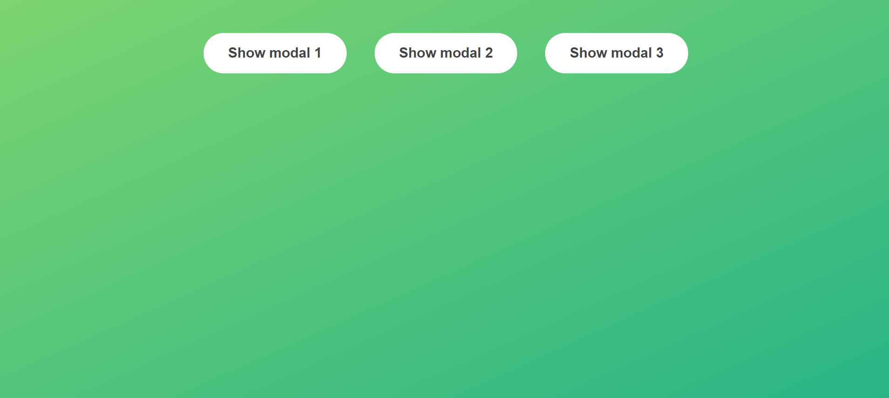

**Create a webpage like the one above. Note that when the user clicks on any of the buttons, a modal window should appear on the center of the screen. The background should be blurred, and the user needs to be able to close the modal window by either clicking on the (x) icon on the corner of the window, or by pressing the “ESC” key.**

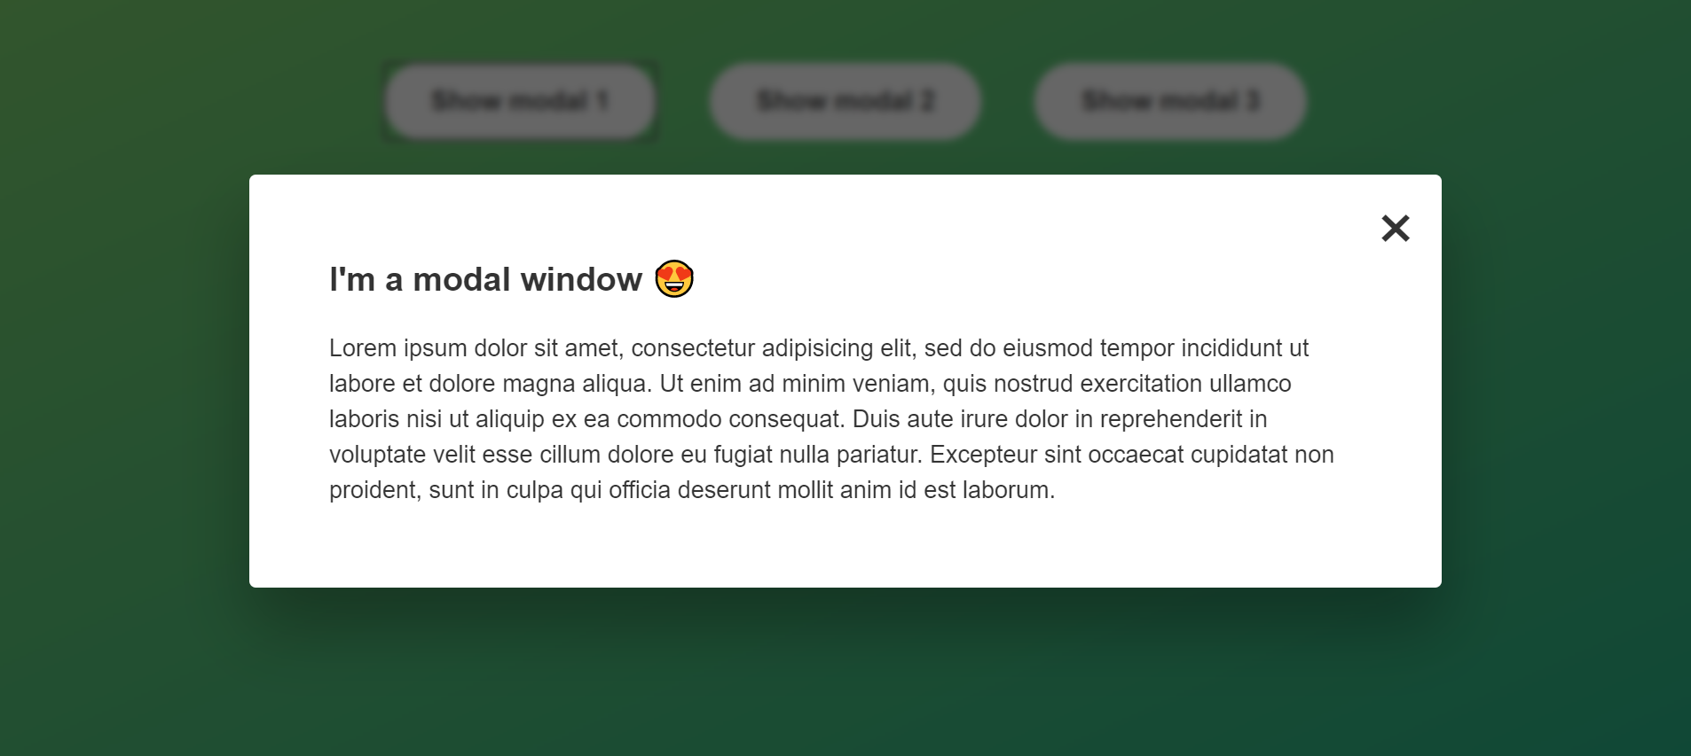

**MODAL WINDOW STARTER CODE:**

**HTML:**

<!DOCTYPE html>

<html lang="en">

  <head>

    <meta charset="UTF-8" />

    <meta name="viewport" content="width=device-width, initial-scale=1.0" />

    <meta http-equiv="X-UA-Compatible" content="ie=edge" />

    <link rel="stylesheet" href="styles.css" />

    <title>Modal window</title>

  </head>

  <body>

    <button class="show-modal">Show modal 1</button>

    <button class="show-modal">Show modal 2</button>

    <button class="show-modal">Show modal 3</button>

    <div class="modal hidden">

      <button class="close-modal">&times;</button>

      <h1>I'm a modal window 😍</h1>

      <p>

        Lorem ipsum dolor sit amet, consectetur adipisicing elit, sed do eiusmod

        tempor incididunt ut labore et dolore magna aliqua. Ut enim ad minim

        veniam, quis nostrud exercitation ullamco laboris nisi ut aliquip ex ea

        commodo consequat. Duis aute irure dolor in reprehenderit in voluptate

        velit esse cillum dolore eu fugiat nulla pariatur. Excepteur sint

        occaecat cupidatat non proident, sunt in culpa qui officia deserunt

        mollit anim id est laborum.

      </p>

    </div>

    <div class="overlay hidden"></div>

    <script src="script.js"></script>

  </body>

</html>

**CSS:**

* {

  margin: 0;

  padding: 0;

/*we remove the default margins and padding from all our elements*/

  box-sizing: inherit;

/*we give all our elements the ability to inherit the value of this property */

}

html {

  font-size: 62.5%;

  box-sizing: border-box;

/*we assign “border-box” property value to the html global-parent element*/

}

body {

  font-family: sans-serif;

  color: #333;

  line-height: 1.5;

  height: 100vh;

  position: relative;

  display: flex;

  align-items: flex-start;

  justify-content: center;

  background: linear-gradient(to top left, #28b487, #7dd56f);

}

.show-modal {

  font-size: 2rem;

  font-weight: 600;

  padding: 1.75rem 3.5rem;

  margin: 5rem 2rem;

  border: none;

  background-color: #fff;

  color: #444;

  border-radius: 10rem;

  cursor: pointer;

}

.close-modal {

 /*we are positioning the(x)button on our modal window*/

  position: absolute;

  top: 1.2rem;

  right: 2rem;

  font-size: 5rem;

  color: #333;

  cursor: pointer;

  border: none;

  background: none}

h1 {

  font-size: 2.5rem;

  margin-bottom: 2rem;

}

p {

  font-size: 1.8rem;

}

/* -------------------------- */

/* CLASSES TO MAKE MODAL WORK */

.hidden {

  display: none;

}

.modal {

/*we want to position our element absolute*/

  /*relative to our viewport (body)*/

  /*positioned halfway from the top and halfway from the left*/

  /*this sets it up in the center of our screen*/

  position: absolute;

  top: 50%;

  left: 50%;

  transform: translate(-50%, -50%);

  width: 70%;

/*makes width of the element to always adjust to 70% of the screen*/

  background-color: white;

  padding: 6rem;

  border-radius: 5px;

  box-shadow: 0 3rem 5rem rgba(0, 0, 0, 0.3);

  z-index: 10;

/*z-index forces the element to the top of the page*/

}

.overlay {

  position: absolute;

  top: 0;

  left: 0;

  width: 100%;

  height: 100%;

/*Note that setting the width and height will not */

  /*guarantee that our element will display where we want it to*/

  /*This is why we position our element absolute, left:0,top:0*/

  background-color: rgba(0, 0, 0, 0.6);

  backdrop-filter: blur(3px);

  z-index: 5;}

 /*this positions the overlay above the background(index 0)*/

  /*and below the modal-window(index 10)*/

# **MODAL WINDOW PROJECT LESSONS::**

# The conventional way of changing styles using JAVASCRIPT

"use strict";

const modal = document.querySelector(".modal");

const overlay = document.querySelector(".overlay");

const btnCloseModal = document.querySelector(".close-modal");

const btnsOpenModal = document.querySelectorAll(".show-modal");

for (let i = 0; i < btnsOpenModal.length; i++)

  btnsOpenModal[i].addEventListener("click", function () {

    modal.classList.remove("hidden");

    overlay.classList.remove("hidden");

  });

btnCloseModal.addEventListener("click", function (*e*) {

  modal.classList.add("hidden");

  overlay.classList.add("hidden");

});

//Note that the most common and prevalent method

// of changing styles using JAVASCRIPT is by

//removing or adding Classes to elements

//this is very useful because classes represent

//an agregate of many css rules

// making class addition and removal on <html elements>

//the most efficient use of code, whereby we write

//css class rules once, and then insert that class

// or remove it, wherever wee need to change and apply

// that specific class style on our html element, using

//javascript.

In summary, by adding and removing classes(using handles in Javascript) from our <html> elements, we change their entire css style (as it is defined for the added/removed class in the style.css)

### ***Placing a namedFunction instead of a callbackFunction***

**(Exporting the anonymus event handler function**

**into a function of it's own)**

//event handler example:

btnCloseModal.addEventListener("click", function (*e*) {

  modal.classList.add("hidden");

  overlay.classList.add("hidden");

});

//--Now we want to export(define) the event-handler function

//outisde of the addEventListener(); method.

const closeModal = function () {

  modal.classList.add("hidden");

  overlay.classList.add("hidden");

};

//--Then we want to call the function we've just defined

//  as an argument, instead of the anonymous event handler

//  function in the .addEventListener(); method:

////////////////THE CORRECT WAY///////////////////

btnCloseModal.addEventListener("click", closeModal);

//this will work the same way as our original code below:

const closeModal = function () {

  modal.classList.add("hidden");

  overlay.classList.add("hidden");

};

///////////////////////////////////////////////////

////////////////THE INCORRECT WAY//////////////////

btnCloseModal.addEventListener("click", closeModal());

//The code above will not work the same way at all,

//because we are immediatelly calling the closeModal()

// function. We simply want to assing the location of

// the function to the EventListener, and let it call

// the function on its own. Note that whenever we write

// So in the event-listener's second parameter is not a

// function address, but the whole executed operation.

//IN SHORT: Note that adding a function call

// within the .addEventListener('event', namedFunction()); method

//Immediatelly calls/execute that named function when it

// adds an event listener to the element, regardless if

// the stated event was triggered or not.

///////////////////////////////////////////////////////////////////

//GOOD EXAMPLES:

//So, if we wish to add a separate nammed-function instead of an anonymous callback

// inside a method argument, we don't call that function in the argument, we just

// state the name of the function we wish our method to use, for it to work.

let array = [1, 2, 3];

let writeHello = function () {

  console.log("Hello!");

};

array.forEach(writeHello);

//instead of usinig the normal forEach(): callback function:

// array.forEach(function(){console.log(‘hello’);});

### **Very brief example of how not to pass a named function into a callback function method argument:**

btnCloseModal.addEventListener("click", closeModal());

//above the “closeModal()” function will be executed by javascript as soon as it

//executes that line of code. (as soon as it sets the event listener to the object

// it will also execute the “closeModal()” function.

//That is why we ill be passing just the name of the function(its address), so we //declare the function name ( and don’t call it) letting javascript itself

//call the function, when the specified event is triggered

## **THE ENTIRE COURSE JAVASCRIPT SOLUTION**

"use strict";

//Here we grab our event handles.

const modal = document.querySelector(".modal");

const overlay = document.querySelector(".overlay");

const btnCloseModal = document.querySelector(".close-modal");

const btnsOpenModal = document.querySelectorAll(".show-modal");

const body = document.querySelector("body");

//Here we create our functions

const openModal = function () {

  modal.classList.remove("hidden");

  overlay.classList.remove("hidden");

};

const closeModal = function () {

  modal.classList.add("hidden");

  overlay.classList.add("hidden");

};

for (let i = 0; i < btnsOpenModal.length; i++)

  btnsOpenModal[i].addEventListener("click", openModal);

//here we passed the closedModal function expression

//instead of an anonymous callback function

// into the second addEventListener() argument,

// just like in the above example with the openModal

btnCloseModal.addEventListener("click", closeModal);

//Adding an event listener to close the modal window on

// pressing the "ESC" key.

//By using the event listener on the "document" object

// we make sure that the event is listened for globally

// that is, anywhere on the website

document.addEventListener("keydown", function (*e*) {

  //If the "ESC" key was hit, and the modal does not(!) contain the "hidden class"

  if (e.key === "Escape" && !modal.classList.contains("hidden")) {

    {

      closeModal(); //then close the modal window

    }

  }

});

# **THE PIG GAME PROJECT**

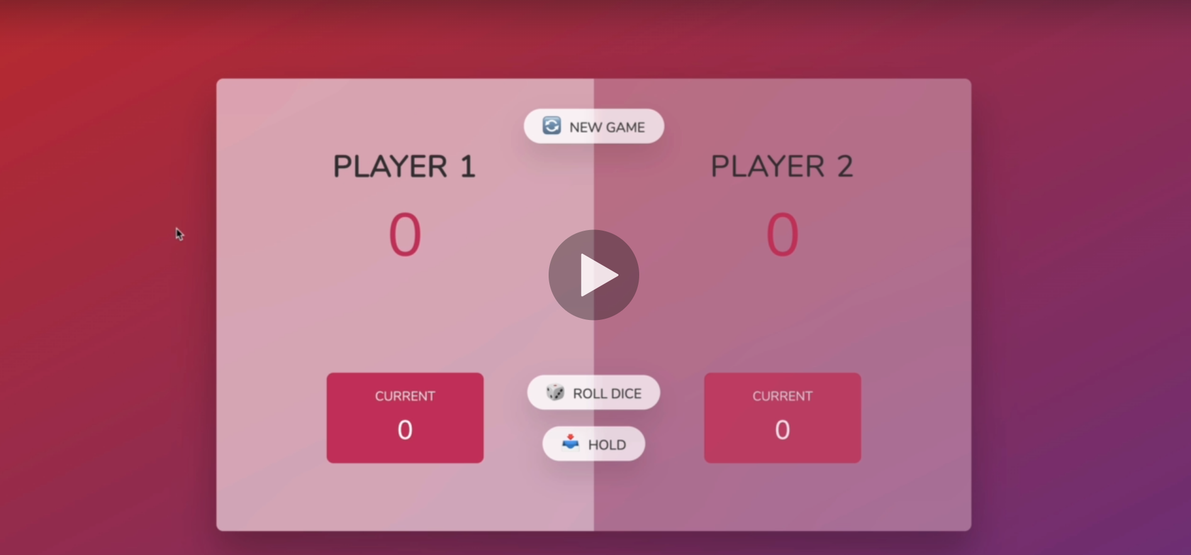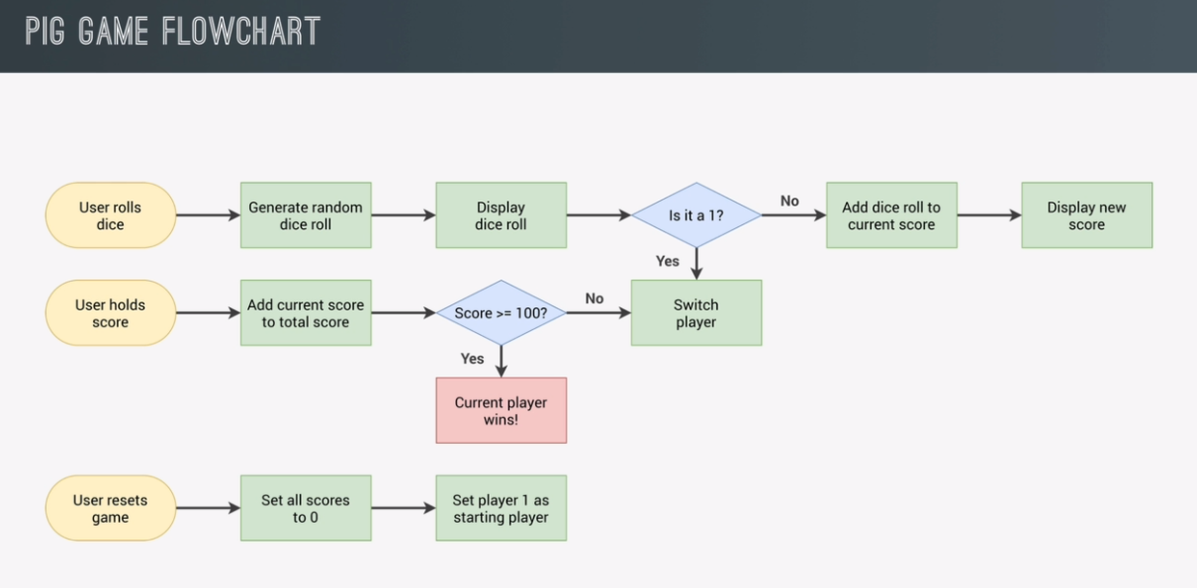

## **PROJECT LESSONS:**

### **The difference between specific selectors and query selectors**

const score0 = document.querySelector('#score--0');

const score1 = document.getElementById("score--1");

Seeing how both of these selectors are being used for the purpose of returning an element handle using its ID property, we can ask ourselves, why would we prefer to use and remember a specifically named method like “getElementById()” when we can use, and for the same purpose, the querySelector() method.

The short answer is that specific methods for getting element handles are better optimized and hence faster, for those cases where we have very large programs and housands of selectors working within them. Transitioning from querySelector to getElementByClass/Id/TagName is best reserved for refactoring.

**MY JAVASCRIPT SOLUTION**

"use strict";

for (let i = 0; i < 5; i++) {

  console.log("for loop");

}

let j = 0;

while (j < 5) {

  console.log("for loop");

  j++;

}

//SELECTING HANDLES FOR HTML elements/////////////////////////////////

const player0Name_handle = document.querySelector("#name--0");

const player1Name_handle = document.querySelector("#name--1");

//total scores

const score0_handle = document.querySelector("#score--0");

const score1_handle = document.getElementById("score--1");

//current scores

const currentScore0_handle = document.getElementById("current--0");

const currentScore1_handle = document.getElementById("current--1");

const dice_handle = document.querySelector(".dice");

//buttons

const btnNew_handle = document.querySelector(".btn--new");

const btnRoll_handle = document.querySelector(".btn--roll");

const btnHold_handle = document.querySelector(".btn--hold");

//PLAYER OBJECT INITIALIZATION//////////////////////////////

let player0 = {

  playerName: player0Name_handle,

  playerCurrentScore: currentScore0_handle,

  playerTotalScoreDisplay: score0_handle,

  totalScore: 0,

};

let player1 = {

  playerName: player1Name_handle,

  playerCurrentScore: currentScore1_handle,

  playerTotalScoreDisplay: score1_handle,

  totalScore: 0,

};

//GLOBAL VARIABLES////////////////////////////////////////

let currentScore;

let currentPlayer; //(currentPlayer)tracks the current player and stores a player object

//STARTING CONDITIONS/////////////////////////////////////

score0_handle.textContent = 0; //javascript will automatically

score1_handle.textContent = 0; //convert these numbers to strings

dice_handle.classList.add("hidden");

currentScore = 0; //This tracks the current score of a player.

currentPlayer = player0; //setting player0 to be our default first/player

document.querySelector(".player--0").classList.add("current"); //styling player0 as currentPlayer

///////////////////////////////////////////////////////////

//ROLLING THE DICE FUNCTIONALITY///////////////////////////

btnRoll_handle.addEventListener("click", function () {

  //1.generate random dice roll

  const diceRoll = Math.trunc(Math.random() * 6) + 1;

  console.log(diceRoll); //check roll value

  //2.Display dice

  dice_handle.classList.remove("hidden");

  dice_handle.src = `images/dice-${diceRoll}.png`;

  //3.Adding score too our current player

  if (diceRoll != 1) {

    //Add diceroll to the current score.

    currentScore += diceRoll;

    currentPlayer.playerCurrentScore.textContent = currentScore;

  } else {

    //On rolling (1)Reset and display current score to 0

    currentScore = 0;

    currentPlayer.playerCurrentScore.textContent = currentScore;

    //--switch players.

    if (currentPlayer === player0) {

      currentPlayer = player1;

      //adding the current-style to our current player

      document.querySelector(".player--1").classList.add("current");

      //removing the current-style from our previous player

      document.querySelector(".player--0").classList.remove("current");

    } else {

      currentPlayer = player0;

      //adding the current-style to our current player

      document.querySelector(".player--0").classList.add("current");

      //removing the current-style from our previous player

      document.querySelector(".player--1").classList.remove("current");

    }

  }

});

//HOLDING THE SCORE FUNCTIONALITY//////////////////////////

btnHold_handle.addEventListener("click", function () {

  //--Add the global current-score to local player.total-score

  currentPlayer.totalScore += currentScore;

  currentPlayer.playerTotalScoreDisplay.textContent = currentPlayer.totalScore;

  //--Clear current score global variable back to 0};

  currentScore = 0;

  //--Update the display for player Current score to 0

  currentPlayer.playerCurrentScore.textContent = 0;

  //--check if the current player won?

  //didHeWin()-function returns(true -> if a player won) or (false-> if no players won)

  if (!didHeWin()) {

    //switches on the next player if nobody won.

    //--switch player

    if (currentPlayer === player0) {

      currentPlayer = player1;

      //adding the current-style to our current player

      document.querySelector(".player--1").classList.add("current");

      //removing the current-style from our previous player

      document.querySelector(".player--0").classList.remove("current");

      //--Setting the player--active style

    } else {

      currentPlayer = player0;

      //adding the current-style to our current player

      document.querySelector(".player--0").classList.add("current");

      //removing the current-style from our previous player

      document.querySelector(".player--1").classList.remove("current");

    }

  } else {

    //Disables the roll button

    btnRoll_handle.classList.add("hidden");

  }

});

///////////////////////////////////////////////////////////

//WINING CONDITION FUNCTIONALITY

let didHeWin = function () {

  //Returns true if one of the players won

  //Returns false if none of the players won.

  if (player0.totalScore >= 60) {

    /*

      <section class="player player--0 player--active">

      <h2 class="name" id="name--0">Player 1</h2>

      */

    player0.playerName.textContent = "Winner!";

    document.querySelector(".player--0").classList.add("player--winner");

    return true;

  } else if (player1.totalScore >= 60) {

    player1.playerName.textContent = "Winner!";

    document.querySelector(".player--1").classList.add("player--winner");

    return true;

  } else {

    return false; }

**COURSE JAVASCRIPT SOLUTION**

"use strict";

//SELECTING HANDLES FOR HTML elements/////////////////////////////////

//player handles

const player0_handle = document.querySelector(".player--0");

const player1_handle = document.querySelector(".player--1");

const player0Name_handle = document.querySelector("#name--0");

const player1Name_handle = document.querySelector("#name--1");

//total scores

const score0_handle = document.querySelector("#score--0");

const score1_handle = document.getElementById("score--1");

//current scores

const currentScore0_handle = document.getElementById("current--0");

const currentScore1_handle = document.getElementById("current--1");

const dice_handle = document.querySelector(".dice");

//buttons

const btnNew_handle = document.querySelector(".btn--new");

const btnRoll_handle = document.querySelector(".btn--roll");

const btnHold_handle = document.querySelector(".btn--hold");

//GLOBAL VARIABLES//////////////////////////////

let totalScores; //tallies scores for each player

let currentScore;

let activePlayer; /*1/0 so that their names correspond the totalScore indexes*/

//"playing" acts as a "state-variable" and is used to define the current global state of the game

let playing;

//we can also declare them in all in a single line:

// let totalScores, currentScore, activePlayer, playing

//INITIALIZE GLOBAL VARIABLES AND INITIAL STATE/////////////

start_restart(); //This method initializes/restarts game state

////////////////////////////////////////////////////////////

//USER FUNCTIONS////////////////////////////////////////////

function switchPlayer() {

  //--Reseting the current score to zero

  //for both the previous and the next player

  currentScore = 0;

  document.getElementById(

    `current--${activePlayer}`

  ).textContent = currentScore;

  activePlayer = activePlayer === 0 ? 1 : 0;

  //if the active player is zero then change him into 1

  //otherwise set active player to zero.

  //--SWITCHING the player--active class

  player0_handle.classList.toggle("player--active");

  //removes the class if it exists

  player1_handle.classList.toggle("player--active");

  //adds the class if it does not exist

}

function start_restart() {

  //GLOBAL VARIABLE INITALIZATION //////////////////////////

  totalScores = [0, 0]; //tallies scores for each player

  currentScore = 0;

  activePlayer = 0; /*1/0 so that their names correspond the totalScore indexes*/

  //"playing" acts as a "state-variable" and is used to define the current global state of the game

  playing = true;

  //User visible display (re)initialization

  score0_handle.textContent = 0; //javascript will automatically

  score1_handle.textContent = 0; //convert these numbers to strings

  currentScore0_handle.textContent = 0;

  currentScore1_handle.textContent = 0;

  dice_handle.classList.add("hidden");

  //Remove the winner styles

  player1_handle.classList.remove("player--winner");

  player0_handle.classList.remove("player--winner");

  //Set up a new active player, and remove the old one

  player1_handle.classList.remove("player--active");

  player0_handle.classList.add("player--active");

  //You don't have to worry if the classes are there or not

  //when using .add(); and .remove(); methods ^______^

  //Note that if a class is already there .add(); method

  // will simply do nothing, and won't add a second one

  //also if the class is already removed, the .remove();

  // method will also simply do nothing, and won't send an erro

}

///////////////////////////////////////////////////////////

///////////////////////EVENT LISTENERS////////////////////

//ROLLING THE DICE FUNCTIONALITY///////////////////////////

btnRoll_handle.addEventListener("click", function () {

  //The code will only execute if the game is still (on!)

  if (playing) {

    //1.generate random dice roll

    const diceRoll = Math.trunc(Math.random() * 6) + 1;

    console.log(diceRoll); //check roll value

    //2.Display dice

    dice_handle.classList.remove("hidden");

    dice_handle.src = `images/dice-${diceRoll}.png`;

    //3.Adding score too our current player

    if (diceRoll != 1) {

      //Add diceroll to the current score.

      currentScore += diceRoll;

      document.getElementById(

        `current--${activePlayer}`

      ).textContent = currentScore;

    } else {

      //SWITCHING TO THE NEXT PLAYER

      switchPlayer();

    }

  }

});

///////////////////////////////////////////////////////////

btnHold_handle.addEventListener("click", function () {

  if (playing) {

    //1.Add a current score to the active player total score

    totalScores[activePlayer] += currentScore;

    //sums the current score with the total score for the active player([0]/[1])

    //display the total score for the current player

    document.querySelector(`#score--${activePlayer}`).textContent =

      totalScores[activePlayer];

    //2.Check if the player's score is over 100

    if (totalScores[activePlayer] >= 10) {

      //Disable the game from playing further

      playing = false;

      //Hide the Button

      dice_handle.classList.add("hidden");

      //assign a winner class to the player

      document

        .querySelector(`.player--${activePlayer}`)

        .classList.add("player--winner");

      document

        .querySelector(`.player--${activePlayer}`)

        .classList.remove("player--active");

    }

    switchPlayer();

  }

});

///////////////////////////////////////////////////////////

btnNew_handle.addEventListener("click", start_restart);

**HTML SOLUTON**

<!DOCTYPE html>

<html lang="en">

  <head>

    <meta charset="UTF-8" />

    <meta name="viewport" content="width=device-width, initial-scale=1.0" />

    <meta http-equiv="X-UA-Compatible" content="ie=edge" />

    <link rel="stylesheet" href="styles.css" />

    <title>Pig Game</title>

  </head>

  <body>

    <main>

      <!--First Player-->

      <section class="player player--0 player--active">

        <h2 class="name" id="name--0">Player 1</h2>

        <p class="score" id="score--0">43</p>

        <div class="current">

          <p class="current-label">Current</p>

          <p class="current-score" id="current--0">0</p>

        </div>

      </section>

      <!--Second player-->

      <section class="player player--1">

        <h2 class="name" id="name--1">Player 2</h2>

        <p class="score" id="score--1">24</p>

        <div class="current">

          <p class="current-label">Current</p>

          <p class="current-score" id="current--1">0</p>

        </div>

      </section>

      <img src="images/dice-5.png" alt="Playing dice" class="dice" />

      <button class="btn btn--new">🔄 New game</button>

      <button class="btn btn--roll">🎲 Roll dice</button>

      <button class="btn btn--hold">📥 Hold</button>

    </main>

    <script src="script.js"></script>

  </body>

</html>

**CSS Solution**

@import url("https://fonts.googleapis.com/css2?family=Nunito&display=swap");

* {

  margin: 0;

  padding: 0;

  box-sizing: inherit;

}

html {

  font-size: 62.5%;

  box-sizing: border-box;

}

body {

  font-family: "Nunito", sans-serif;

  font-weight: 400;

  height: 100vh;

  color: #333;

  background-image: linear-gradient(to top left, #753682 0%, #bf2e34 100%);

  display: flex;

  align-items: center;

  justify-content: center;

}

/* LAYOUT */

main {

  position: relative;

  width: 100rem;

  height: 60rem;

  background-color: rgba(255, 255, 255, 0.35);

  backdrop-filter: blur(200px);

  filter: blur();

  box-shadow: 0 3rem 5rem rgba(0, 0, 0, 0.25);

  border-radius: 9px;

  overflow: hidden;

  display: flex;

}

.player {

  flex: 50%;

  padding: 9rem;

  display: flex;

  flex-direction: column;

  align-items: center;

  transition: all 0.75s;

}

/* ELEMENTS */

.name {

  position: relative;

  font-size: 4rem;

  text-transform: uppercase;

  letter-spacing: 1px;

  word-spacing: 2px;

  font-weight: 300;

  margin-bottom: 1rem;

}

.score {

  font-size: 8rem;

  font-weight: 300;

  color: #c7365f;

  margin-bottom: auto;

}

.player--active {

  background-color: rgba(255, 255, 255, 0.4);

}

.player--active .name {

  font-weight: 700;

}

.player--active .score {

  font-weight: 400;

}

.player--active .current {

  opacity: 1;

}

.current {

  background-color: #c7365f;

  opacity: 0.8;

  border-radius: 9px;

  color: #fff;

  width: 65%;

  padding: 2rem;

  text-align: center;

  transition: all 0.75s;

}

.current-label {

  text-transform: uppercase;

  margin-bottom: 1rem;

  font-size: 1.7rem;

  color: #ddd;

}

.current-score {

  font-size: 3.5rem;

}

/* ABSOLUTE POSITIONED ELEMENTS */

.btn {

  position: absolute;

  left: 50%;

  transform: translateX(-50%);

  color: #444;

  background: none;

  border: none;

  font-family: inherit;

  font-size: 1.8rem;

  text-transform: uppercase;

  cursor: pointer;

  font-weight: 400;

  transition: all 0.2s;

  background-color: white;

  background-color: rgba(255, 255, 255, 0.6);

  backdrop-filter: blur(10px);

  padding: 0.7rem 2.5rem;

  border-radius: 50rem;

  box-shadow: 0 1.75rem 3.5rem rgba(0, 0, 0, 0.1);

}

.btn::first-letter {

  font-size: 2.4rem;

  display: inline-block;

  margin-right: 0.7rem;

}

.btn--new {

  top: 4rem;

}

.btn--roll {

  top: 39.3rem;

}

.btn--hold {

  top: 46.1rem;

}

.btn:active {

  transform: translate(-50%, 3px);

  box-shadow: 0 1rem 2rem rgba(0, 0, 0, 0.15);

}

.btn:focus {

  outline: none;

}

.dice {

  position: absolute;

  left: 50%;

  top: 16.5rem;

  transform: translateX(-50%);

  height: 10rem;

  box-shadow: 0 2rem 5rem rgba(0, 0, 0, 0.2);

}

.player--winner {

  background-color: #2f2f2f;

}

.player--winner .name {

  font-weight: 700;

  color: #c7365f;

}

.hidden {

  display: none;

}